**COMPUTER NETWORKS**

**III B. Tech I semester**

**Prepared by**

**Dr.DBK Kamesh Miss.V.Vijaya**

**Professor Asst.Professor**

**Miss.L.C.UshaMaheshwari Mrs.Gayathri**

**Asst.Professor Asst.Professor**

**DEPARTMENT OF COMPUTER SCIENCE AND ENGINEERING**

**MALLAREDDY ENGINEERING COLLEGE FOR WOMEN**

## (Autonomous Institution-UGC, Govt. of India)

### Accredited by NBA & NAAC with ‘A’ Grade, UGC, Govt. of India NIRF Indian Ranking, Accepted by MHRD, Govt. of India

**Rank Band (6th-25th) by ARIIA, Accepted by MHRD, Govt. of India Approved by AICTE, Affiliated to JNTUH, ISO 9001:2015 Certified Institution**

**Platinum Rated by AICTE-CII Survey, AAAA+ Rated by Digital Learning Magazine, AAA+ Rated by Careers 360, National Ranking-Top 100 Rank band by Outlook Magazine, 3rd Rank by CSR, National Ranking-Top 100 Rank band by Times News Magazine,**

**141 Rank by India Today-Best Engineering Colleges of India Rankings-2020.**

## Maisammaguda, Dhulapally, Secunderabad, Kompally-500100.

**2022 – 2023**

# Malla Reddy Engineering College for Womenþÿ

## (Autonomous Institution, UGC Govt. of India )

**Permanently Affiliated to JNTUH, Approved by AICTE, ISO 9001:2015 Certified Institution**

**NIRF-India Ranking - 2018, Accepted by MHRD, Govt. of India Accredited by NBA and NAAC with ‘A’ Grade**

Maisammaguda, Dhulapally, Secunderabad - 500 100.

**DEPARTMENT OF COMPUTER SCIENCE AND ENGINEERING**

| **Program Outcomes** | | |
| --- | --- | --- |
| **PO1** | **Engineering knowledge** | An ability to apply knowledge of Mathematics (including Probability & Statistics and Mathematical Foundation of Computer Science), Science, and Engineering. |
| **PO2** | **Problem analysis** | An ability to design and conduct experiments, as well as to analyze and interpret data including hardware and software components |
| **PO3** | **Design & development**  **of solutions** | An ability to design a complex computing system or process to meet desired specifications and needs. |
| **PO4** | **Conduct investigations of complex problems** | An ability to identify, formulates, analyze, design and solve engineering problems. |
| **PO5** | **Modern tool usage** | An ability to use the techniques, skills, and modern engineering tools necessary for engineering practice |
| **PO6** | **The engineer and society** | An ability to understanding of professional, health, safety, legal, cultural and social responsibilities. |
| **PO7** | **Environment and Sustainability** | The broad education necessary to understand the impact of engineering solutions in a global, economic, environmental and demonstrate the knowledge need for sustainable development. |
| **PO8** | **Ethics** | Apply ethical principles, responsibility and norms of the engineering practice. |
| **PO9** | **Individual and team**  **work** | An ability to function on multi- disciplinary teams. |
| **PO10** | **Communication** | An ability to communicate and present effectively. |
| **PO11** | **Project management and finance** | An ability to use the modern engineering tools, techniques, skills and management principles to do work as a member and leader in a team, to manage projects in multi- disciplinary environments |
| **PO12** | **Life-long learning** | A Recognition of the need for, and an ability to engage in, to resolve contemporary issues and acquire lifelong learning. |

## Course Name: COMPUTER NETWORKS

**Course Code: 2005PC11**

### Course Objectives:

* To introduce the fundamental various types of computer networks.
* To demonstrate the TCP/IP and OSI models with merits and demerits.
* To explore the various layers of OSI Model.
* To introduce UDP and TCP Models.
* To introduce Encryption Security Mechanism

### Course Outcomes:

* Students should be understand and explore the basics of Computer Networks and various Protocols. She will be in a position to understand the World Wide Web concepts.
* Students will be in a position to administrate a network and flow of information further he/she can understand easily the concepts of network security, Mobile and Adhoc networks.

**Mapping of Course outcome with Program Outcomes**

| **Cours e** | **PO 1** | **PO 2** | **PO 3** | **PO 4** | **PO 5** | **PO 6** | **PO7** | **PO 8** | **PO9** | **PO1 0** | **PO1 1** | **PO1 2** |
| --- | --- | --- | --- | --- | --- | --- | --- | --- | --- | --- | --- | --- |
| **Outcom** |  |  |  |  |  |  |  |  |  |  |  |  |
| **e** |  |  |  |  |  |  |  |  |  |  |  |  |
| **CO1** | **3** | **3** | **3** |  | **3** |  |  |  |  |  | **1** | **3** |
| **CO2** | **3** | **3** | **3** | **2** |  | **2** |  | **1** |  |  |  | **2** |

**3 – High**

**2 – Medium**

**1 - Low**

**MALLA REDDY ENGINEERING COLLEGE FOR WOMEN**

**(2005PC11) COMPUTER NETWORKS**

### UNIT – I

Data Communications: Components – Direction of Data flow – Networks – Components and Categories – Types of Connections – Topologies –Protocols and Standards – ISO / OSI model, Physical layer: Transmission modes, Multiplexing, Transmission Media, Switching, Circuit Switched Networks, Datagram Networks and Virtual Circuit Networks.

### UNIT – II

Data link layer: Introduction, Framing, and Error – Detection and Correction – Parity – LRC– CRC Hamming code, Flow and Error Control, Noiseless Channels, Noisy Channels, HDLC, Point to Point Protocols. 111 Medium Access sub layer: ALOHA, CSMA/CD, LAN– Ethernet IEEE 802.3, IEEE 802.5 – IEEE 802.11, Random access, Controlled access

### UNIT – III

Network layer: Logical Addressing, Internetworking, Tunneling, Address mapping, ICMP, IGMP, Forwarding, Uni-Cast Routing Protocols, Multicast Routing Protocols.

### UNIT – IV

Transport Layer: Process to Process Delivery, UDP and TCP protocols, Data Traffic, Congestion, Congestion Control, QoS, Integrated Services, Differentiated Services, QoS in Switched Networks.

### UNIT – V

Application Layer: Domain name space, DNS in internet, electronic mail, SMTP, FTP, WWW, HTTP, SNMP, Security – PGP - SSH

### TEXT BOOKS:

1. Data Communications and Networking, Behrouz A. Forouzan, Fourth Edition TMH, 2006.
2. Computer Networks, Andrew S Tanenbaum, 4th Edition. Pearson Education, PHI.

### REFERENCES:

1. Data communications and Computer Networks, P.C .Gupta, PHI.
2. An Engineering Approach to Computer Networks, S. Keshav, 2nd Edition, Pearson Education.
3. Understanding communications and Networks, 3rd Edition, W.A. Shay, Cengage Learning.
4. Computer Networking: A Top-Down Approach Featuring the Internet. James F. Kurose & Keith W. Ross, 3 rd Edition, Pearson Education.
5. Data and Computer Communication, William Stallings, Sixth Edition, Pearson Education, 2000

| **S.No** | **Title** | **Page No.** |
| --- | --- | --- |
| **Unit – I (Data Communications)** | | |
| 1.1 | Components | 1 |
| 1.2 | Direction of Data flow | 3 |
| 1.3 | Networks | 4 |
| 1.4 | Components and Categories | 5 |
| 1.5 | Types of Connections | 14 |
| 1.6 | Topologies | 15 |
| 1.7 | Protocols And Standards | 20 |
| 1.8 | Example Networks such as ATM, Frame Relay, ISDN | 28 |
| 1.9 | Transmission modes | 31 |
| 1.10 | Multiplexing | 34 |
| 1.11 | Transmission Media | 40 |
| 1.12 | Switching | 42 |
| 1.13 | Circuit-Switched Networks | 43 |
| 1.14 | Datagram Networks | 45 |
| 1.15 | Virtual-Circuit Networks | 47 |
| **Tutorial Questions** | | 53 |
| **Assignment Questions** | | 53 |
| **Important Questions** | | 54 |
| **Objective Questions** | | 55 |
| **Fill In The Blanks** | | 56 |
| **Unit – II (Data link layer & Medium Access sub layer)** | | |
| 2.1 | Introduction | 57 |
| 2.2 | Framing | 58 |
| 2.3 | Error – Detection and Correction – Parity – LRC – CRC , Hamming code | 61 |
| 2.4 | Flow and Error Control | 71 |
| 2.5 | Noiseless Channels, Noisy Channels | 73 |
| 2.6 | High-level Data Link Control (HDLC) | 76 |
| 2.7 | POINT-TO-POINT PROTOCOL (PPP) | 80 |
| 2.8 | ALOHA | 81 |
| 2.9 | Carrier Sensed Multiple Access (CSMA) | 84 |
| 2.10 | IEEE 802.3(Ethernet) | 90 |
| 2.11 | IEEE 802.5 (Token Ring) | 91 |
| 2.12 | IEEE 802.11(wireless LAN) | 93 |
| 2.13 | Random access, Controlled access | 95 |
| **Tutorial Questions** | | 100 |

| **Assignment Questions** | | 100 |
| --- | --- | --- |
| **Important Questions** | | 101 |
| **Objective Questions** | | 101 |
| **Fill In The Blanks** | | 103 |
| **UNIT – III (Network layer )** | | |
| 3.1 | Logical Addressing | 104 |
| 3.2 | Internetworking | 108 |
| 3.3 | Tunneling | 110 |
| 3.4 | Address Mapping | 111 |
| 3.5 | Internet Control Message Protocol (ICMP) | 112 |
| 3.6 | Internet Group Management Protocol (IGMP) | 116 |
| 3.7 | Forwarding | 117 |
| 3.8 | Uni-Cast Routing Protocols | 119 |
| 3.9 | Multicast Routing Protocols | 126 |
| **Tutorial Questions** | | 128 |
| **Assignment Questions** | | 128 |
| **Important Questions** | | 128 |
| **Objective Questions** | | 129 |
| **Fill In The Blanks** | | 131 |
| **UNIT – IV (Transport Layer )** | | |
| 4.1 | Process to Process Delivery | 132 |
| 4.2 | UDP and TCP protocols | 135 |
| 4.3 | Data Traffic | 147 |
| 4.4 | Congestion | 149 |
| 4.5 | Congestion Control | 150 |
| 4.6 | Quality of service (QoS) | 153 |
| 4.7 | Integrated Services | 154 |
| 4.8 | Differentiated Services | 156 |
| 4.9 | QoS in Switched Networks | 157 |
| **Tutorial Questions** | | 159 |
| **Assignment Questions** | | 159 |
| **Important Questions** | | 160 |
| **Objective Questions** | | 160 |
| **Fill In The Blanks** | | 161 |
| **UNIT-V (Application Layer)** | | |
| 5.1 | Domain name space | 162 |
| 5.2 | DNS in internet | 164 |

| 5.3 | Electronic Mail | 166 |
| --- | --- | --- |
| 5.4 | Simple Mail Transfer Protocol (SMTP) | 172 |
| 5.5 | File Transfer Protocol (FTP) | 173 |
| 5.6 | World Wide Web (WWW) | 176 |
| 5.7 | Hypertext Transfer Protocol (HTTP) | 178 |
| 5.8 | Simple Network Management Protocol (SNMP) | 181 |
| 5.9 | Security: PGP | 182 |
| 5.10 | Security: SSH | 184 |
| **Tutorial Questions** | | 186 |
| **Assignment Questions** | | 186 |
| **Important Questions** | | 187 |
| **Objective Questions** | | 187 |
| **Fill in the Blanks** | | 188 |
| **Internal Question papers** | | 190 |
| **External Question papers (February 2021 included)** | | 193 |
| **References** | | 201 |

### INTRODUCTION :

**UNIT -I**

**Data Communications & Physical layer**

**Data Communication:** When we communicate, we are sharing information. This sharing can be local or remote. Between individuals, local communication usually occurs face to face, while remote communication takes place over distance.

**Data communications** (DC) is the process of using computing and communication technologies to transfer **data** from one place to another, and vice versa. It enables the movement of electronic or digital **data** between two or more nodes, regardless of geographical location, technological medium or **data** contents.

### Components:

A data communications system has five components (see Figure 1.1).

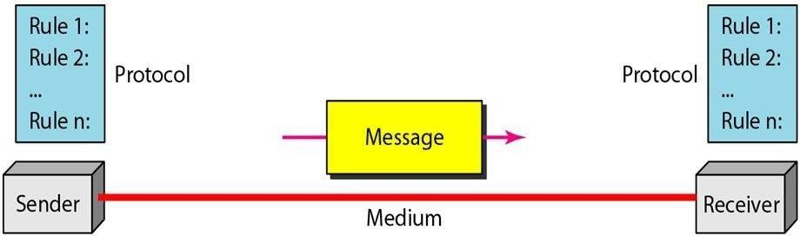

*Figure 1.1 Five components of data communication*

1. Message. The message is the information (data) to be communicated. Popular forms of information include text, numbers, pictures, audio, and video.
2. Sender. The sender is the device that sends the data message. It can be a computer, workstation, telephone handset, video camera, and so on.
3. Receiver. The receiver is the device that receives the message. It can be a computer, workstation, telephone handset, television, and so on.
4. Transmission medium. The transmission medium is the physical path by which a message travels from sender to receiver. Some examples of transmission media include twisted-pair wire, coaxial cable, fiber-optic cable, and radio waves
5. Protocol. A protocol is a set of rules that govern data communications. It represents an agreement between the communicating devices. Without a protocol, two devices may be connected but not communicating, just as a person speaking French cannot be understood by a person who speaks only Japanese.

### Data Representation:

Information today comes in different forms such as text, numbers, images, audio, and video.

#### Text:

In data communications, text is represented as a bit pattern, a sequence of bits (Os or Is). Different sets of bit patterns have been designed to represent text symbols. Each set is called a code, and the process of representing symbols is called coding. Today, the prevalent coding system is called Unicode, which uses 32 bits to represent a symbol or character used in any language in the world. The American Standard Code for Information Interchange (ASCII), developed some decades ago in the United States, now constitutes the first 127 characters in Unicode and is also referred to as Basic Latin.

#### Numbers:

Numbers are also represented by bit patterns. However, a code such as ASCII is not used to represent numbers; the number is directly converted to a binary number to simplify mathematical operations. Appendix B discusses several different numbering systems.

#### Images:

Images are also represented by bit patterns. In its simplest form, an image is composed of a matrix of pixels (picture elements), where each pixel is a small dot. The size of the pixel depends on the *resolution.* For example, an image can be divided into 1000 pixels or 10,000 pixels. In the second case, there is a better representation of the image (better resolution), but more memory is needed to store the image. After an image is divided into pixels, each pixel is assigned a bit pattern. The size and the value of the pattern depend on the image. For an image made of only black and- white dots (e.g., a chessboard), a I-bit pattern is enough to represent a pixel. If an image is not made of pure white and pure black pixels, you can increase the size of the bit pattern to include gray scale. For example, to show four levels of gray scale, you can use 2-bit patterns. A black pixel can be represented by 00, a dark gray pixel by 01, a light gray pixel by 10, and a white pixel by 11. There are several methods to represent color images. One method is called RGB, so called because each color is made of a combination of three primary colors: *red,* green, and blue. The intensity of each color is measured, and a bit pattern is assigned to it. Another method is called YCM, in which a color is made of a combination of three other primary colors: yellow, cyan, and magenta.

#### Audio:

Audio refers to the recording or broadcasting of sound or music. Audio is by nature different from text, numbers, or images. It is continuous, not discrete. Even when we use a

microphone to change voice or music to an electric signal, we create a continuous signal. In Chapters 4 and 5, we learn how to change sound or music to a digital or an analog signal.

#### Video:

Video refers to the recording or broadcasting of a picture or movie. Video can either be produced as a continuous entity (e.g., by a TV camera), or it can be a combination of images, each a discrete entity, arranged to convey the idea of motion. Again we can change video to a digital or an analog signal.

### Direction of Data flow

Communication between two devices can be simplex, half-duplex, or full-duplex as shown in Figure 1.2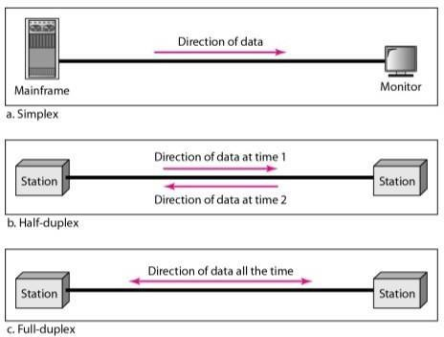

*Figure 1.2 Dataflow (simplex, half-duplex, and full-duplex)*

#### Simplex:

In simplex mode, the communication is unidirectional, as on a one-way street. Only one of the two devices on a link can transmit; the other can only receive (see Figure a). Keyboards and traditional monitors are examples of simplex devices. The keyboard can only introduce input; the monitor can only accept output. The simplex mode can use the entire capacity of the channel to send data in one direction.

#### Half-Duplex:

In half-duplex mode, each station can both transmit and receive, but not at the same time. When one device is sending, the other can only receive, and vice versa The half-duplex mode is like a one-lane road with traffic allowed in both directions.

When cars are traveling in one direction, cars going the other way must wait. In a half- duplex transmission, the entire capacity of a channel is taken over by whichever of the two devices is transmitting at the time. Walkie-talkies and CB (citizens band) radios are both half- duplex systems. The half-duplex mode is used in cases where there is no need for communication in both directions at the same time; the entire capacity of the channel can be utilized for each direction.

#### Full-Duplex:

In full-duplex both stations can transmit and receive simultaneously (see Figure c). The full-duplex mode is like a two-way street with traffic flowing in both directions at the same time. In full-duplex mode, signals going in one direction share the capacity of the link: with signals going in the other direction. This sharing can occur in two ways: Either the link must contain two physically separate transmission paths, one for sending and the other for receiving; or the capacity of the channel is divided between signals traveling in both directions. One common example of full-duplex communication is the telephone network. When two people are communicating by a telephone line, both can talk and listen at the same time. The full-duplex mode is used when communication in both directions is required all the time. The capacity of the channel, however, must be divided between the two directions.

### NETWORKS

A network is a set of devices (often referred to as *nodes)* connected by communication links. A node can be a computer, printer, or any other device capable of sending and/or receiving data generated by other nodes on the network.

### Distributed Processing

Most networks use distributed processing, in which a task is divided among multiple computers. Instead of one single large machine being responsible for all aspects of a process, separate computers (usually a personal computer or workstation) handle a subset.

### Network Criteria

A network must be able to meet a certain number of criteria. The most important of these are performance, reliability, and security.

#### Performance:

Performance can be measured in many ways, including transit time and response time. Transit time is the amount of time required for a message to travel from one device to another. Response time is the elapsed time between an inquiry and a response. The performance of a network depends on a number of factors, including the number of users, the type of transmission medium, the capabilities of the connected hardware, and the efficiency of the software. Performance is often evaluated by two networking metrics: throughput and delay. We often need more throughput and less delay. However, these two criteria are often contradictory. If we try to send more data to the network, we may increase throughput but we increase the delay because of traffic congestion in the network.

#### Reliability:

In addition to accuracy of delivery, network reliability is measured by the frequency of failure, the time it takes a link to recover from a failure, and the network's robustness in a catastrophe.

#### Security:

Network security issues include protecting data from unauthorized access, protecting data from damage and development, and implementing policies and procedures for recovery from breaches and data losses.

### Components and Categories

Computer network components include the key parts that are required to install a network. In [computer network](http://cloudcomputingnet.com/computer-network/) technology, there are numerous types of networks that vary from simple to complex level.

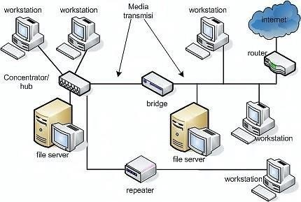

*Figure 1.3 Components of Networks*

These hardware components involve cable, Hub, Switch, NIC (network interface card), modem and router. Some of the components can be removed without effect subject to the type of network. For instance, in a [wireless network,](http://cloudcomputingnet.com/computer-network/) cables and hubs are not necessary.

The essential computer network components necessary for a simple computer network, usually called [LAN (local area network),](http://cloudcomputingnet.com/computer-network-range-and-adoption/) are to share resources on that network. Sharing of equipment like printers, [scanners,](http://www.amazon.com/gp/search/ref%3Das_li_qf_sp_sr_il_tl?ie=UTF8&camp=1789&creative=9325&index=aps&keywords=scanners&linkCode=as2&tag=ibi08-20&linkId=ZLXSDEBPIAQPNMAL) fax machines, copiers, [storage drives,](http://www.amazon.com/gp/search/ref%3Das_li_qf_sp_sr_il_tl?ie=UTF8&camp=1789&creative=9325&index=aps&keywords=storage%20drives&linkCode=as2&tag=ibi08-20&linkId=HZ4PCDEKYANRMKXN) network connection and other resources is the key rationale of computer network.

**Major computer network components:**

Computer network involves the following components and devices (some are optional):-

* Network Interface Card (NIC)
* Hub
* Switches
* Router
* Modem
* Cables and connectors
* Software
* Servers

### Network Interface Card:

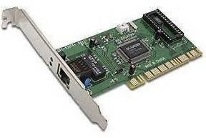

*Figure 1.4 Network Interface Card*

A stand-alone NIC used in a [desktop computer Network adapter or NIC](http://www.amazon.com/gp/search/ref%3Das_li_qf_sp_sr_il_tl?ie=UTF8&camp=1789&creative=9325&index=aps&keywords=desktop%20computer&linkCode=as2&tag=ibi08-20&linkId=IYB66OLWHJ6N446L) is a device which allows a computer to communicate with other computer/network. By means of a unique hardware addresses ([MAC address](https://en.wikipedia.org/wiki/MAC_address)) programmed on the card chip, the data-link protocol uses these addresses to detect other systems on the network so that it can transfer data to the correct destination via the wired or wireless network.

There are two forms of network cards: wired and wireless. The wired NIC employs cables and connectors as a medium to transfer data, while in the [wireless card,](http://www.amazon.com/gp/product/B00TQEX7AQ/ref%3Das_li_tl?ie=UTF8&camp=1789&creative=390957&creativeASIN=B00TQEX7AQ&linkCode=as2&tag=ibi08-20&linkId=L6TD3BVRKB6CU5OY) the connection is made using antenna that uses radio wave technology. All current laptop computers are integrated with

wireless NIC in addition to the wired adapter. There is also a portable USB based adapter that can be plugged into the USB port of the computer.

Network Interface card, one of the key [computer network components,](http://cloudcomputingnet.com/computer-network-components/) comes with different speeds of 10Mbps, 100Mbps and 1000Mbps, etc. Current standard network cards are made with Gigabit (1000Mbps) connection speed which supports slower speeds such as 10Mbps and 100Mbps as well. However, the actual transmission speed is determined by the LAN speed.

### Network Hub:

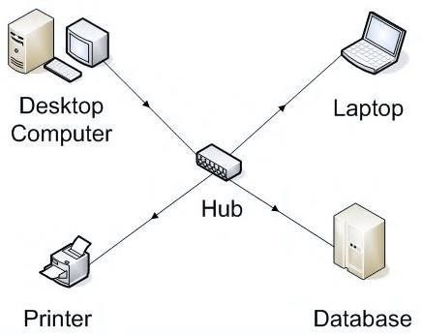

*Figure 1.5 Network Hub*

[Hub](http://www.amazon.com/gp/search/ref%3Das_li_qf_sp_sr_tl?ie=UTF8&camp=1789&creative=9325&index=aps&keywords=network%20hub&linkCode=ur2&tag=ibi08-20&linkId=FRECRWMHQWNN7BVR) is a network component that divides a network connection like a central dissemination centre for multiple devices. When a computer request information from a network or a particular computer, it transmits the request to the hub through a cable. The hub receives the request and broadcasts it to the entire network. Each device in the network would then work out if the broadcast data is for them or just drop it if it is not. This consumes more bandwidth on the network and limits the amount of communication.Currently Hubs are almost obsolete and superseded by more advanced network communication equipment such as Switches and Routers. **Network Switches:**

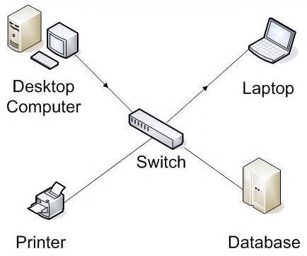

*Figure 1.6 Network Switches*

[Switch](http://www.amazon.com/gp/search/ref%3Das_li_qf_sp_sr_il_tl?ie=UTF8&camp=1789&creative=9325&index=aps&keywords=network%20switch&linkCode=as2&tag=ibi08-20&linkId=HYVREESLQBP76EPH) is like a smart Hub made in with advanced features like the ability to form tables that keep updated about all the computer or device and on which switch port it is on. Using the physical device addresses in each incoming messages, it delivers the message to the correct destination or port. Nevertheless both switch and hub have similar features: Several RJ-45 ports, power supply and connection lights.

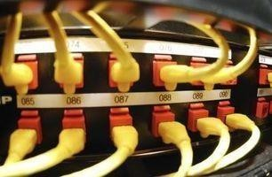

*Figure 1.7 Switch*

Switches do not broadcast the received message to entire network like the Hub but rather before transmitting, it analyses which system or port should the message be transmitted to. The switch connects the source and destination directly which increases the speed of the network.Switching technology aids to ease congestion on a network and is usually used for networks of ten or more devices.

### Network Router:

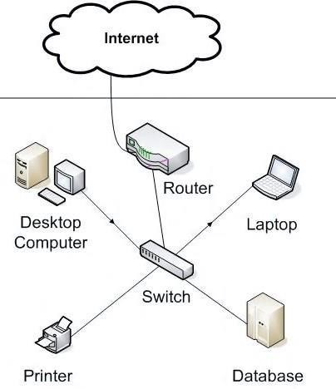

*Figure 1.8 Network Router*

A Router is the network component that is employed to connect a LAN to an internet connection. Routers are similarly employed to link one local area network (LAN) to another, often across long distances through commercial carriers.

[Routers](http://www.amazon.com/gp/search/ref%3Das_li_qf_sp_sr_il_tl?ie=UTF8&camp=1789&creative=9325&index=aps&keywords=network%20router&linkCode=as2&tag=ibi08-20&linkId=VUPWNAYN45HYTNUI) are actually smart switches in that they are conscious of other networks. They can dynamically update their routing information, discovering when a route to a network is down and finding if another route is accessible.

Generally, routers include a switch which means that it can be used as a switch as well. The router portion links the network to the Internet and the switch portion allows the computers to communicate with each other and to the internet. The choice of wired or wireless routers is influenced by on the physical setting, speed and cost.

**Network Modems:** An analogue or digital modem allows connection to the internet over the existing telephone line. These types of modem are not usually integrated with a computer motherboard but come as separate devices which can be installed on the PCI slots found on motherboard or a standalone device. A modem is not required for LAN, but needed for internet connection via dial-up and [DSL.](https://en.wikipedia.org/wiki/Digital_subscriber_line)

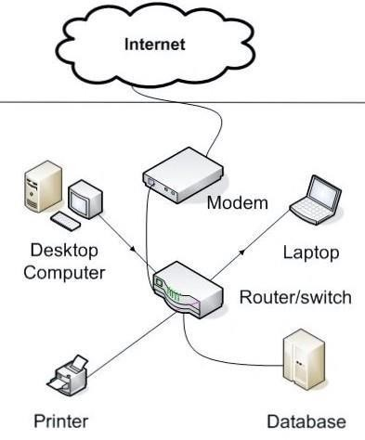

*Figure 1.9 Network Modems*

### Broadband Network Modem

A [broadband modem](http://www.amazon.com/gp/search/ref%3Das_li_qf_sp_sr_il_tl?ie=UTF8&camp=1789&creative=9325&index=aps&keywords=broadband%20network%20modem&linkCode=as2&tag=ibi08-20&linkId=KWX5BZMJOLTSZDT6) is utilised to yield a high speed Internet connection provided by an ISP (Internet Service Provider). The high speed connection can be DSL (Digital Subscriber Line) from a telephone company or cable (cable modem) from a cable television provider.

[Cellular modem](http://www.amazon.com/gp/product/B00316WHJ2/ref%3Das_li_tl?ie=UTF8&camp=1789&creative=390957&creativeASIN=B00316WHJ2&linkCode=as2&tag=ibi08-20&linkId=RAKJJK4ZC5HUDORS) is employed when the cellular data mobile network (3G and above) is used to access the internet, usually provided by cellular mobile operators.

Fiber Broadband Modem is used to achieve even higher speed connection, in the Gigabits range to the internet via optical fiber network.

**Network Cables and Connectors** The networking devices will not work well unless they are connected to each other which is done via different media. Cable is one transmission media which can transmit communication signals. The wired network topology uses special type of cable to link computers on a network.

There are several transmission media types, some of which are listed below.

### Twisted pair wire:

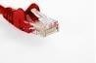

*Figure 1.10 Twisted pair wire*

The most universal cable media is commonly named [Ethernet cabling](http://www.amazon.com/gp/search/ref%3Das_li_qf_sp_sr_il_tl?ie=UTF8&camp=1789&creative=9325&index=aps&keywords=Ethernet%20cable&linkCode=as2&tag=ibi08-20&linkId=BULGEEF2XZOPUNV3) and it is categorised as Category 1, 2, 3, 4, 5, 5E, 6 and 7. The categories 5E, 6 and 7 are meant for high-speed that can transmit 1Gbps or more.

### Coaxial cable

[Coaxial cable](http://www.amazon.com/gp/search/ref%3Das_li_qf_sp_sr_il_tl?ie=UTF8&camp=1789&creative=9325&index=aps&keywords=Coaxial%20cable&linkCode=as2&tag=ibi08-20&linkId=NTS2NIDV4ELXMA3I) is similar to TV installation cable and it is more costly than twisted-pair cable, however provides high data transmission speed.

### Fiber - optic cable

[Optical fiber](http://www.amazon.com/gp/search/ref%3Das_li_qf_sp_sr_il_tl?ie=UTF8&camp=1789&creative=9325&index=aps&keywords=Fiber-optic%20cable&linkCode=as2&tag=ibi08-20&linkId=OOWJVDZDRQQ76II6) is a high-speed cable which transmits data via light beams (uses laser or LED light instead of electrical pulses) in glass bound fibers. Even though it offers higher data speed compared to the other cables, fibre optics is very costly making the purchase and installation at the governmental or large enterprise level.

### Wireless

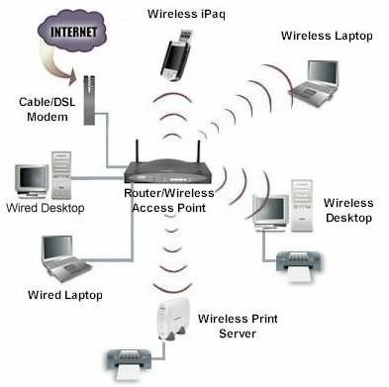

*Figure 1.11 Wireless Network*

Wireless has become prevalent in homes and small offices owing to the ease and low cost of setting up a network. The “media” in this case is the air, through which the wireless NICs transmit radio signals carrying data. The most widespread wireless protocol is acknowledged as [WIFI.](https://en.wikipedia.org/wiki/Wi-Fi)

### Network Software:

Software is the intelligence that instructs all the network components to operate together. The most prevalent network software employs what is known as the TCP/IP protocol suite or stack. The suite is structured from actual layers of software, each having its own function. Using the

seven-layer [OSI reference model](https://en.wikipedia.org/wiki/OSI_model) — Physical, Data Link, Network, Transport, Session, Presentation and Application — as the starting point, the Internet model has four layers — Link, Internet, Transport and Application — combining several of the seven OSI layers into the other layers. All heterogeneous computer systems can communicate with each other using the same set of rules provided by the suite, irrespective of variation in hardware or operating systems.

### Network Servers

[Servers](http://www.amazon.com/gp/search/ref%3Das_li_qf_sp_sr_il_tl?ie=UTF8&camp=1789&creative=9325&index=aps&keywords=network%20server&linkCode=as2&tag=ibi08-20&linkId=L4RCLWRUP4EBTYSO) are digital banks for mass storage of data. Networks use servers to hold the data users may wish to access and also to offer storage space. For instance, on the Internet, email providers utilise their servers to store the messages users send while web hosts use servers to hold all of the data that a web page displays to visitors.

### Categories of Networks-Local Area Networks (LAN):

Local area networks, generally called LANs, are privately-owned networks within a single building or campus of up to a few kilometres in size. They are widely used to connect personal computers and workstations in company offices and factories to share resources (e.g., printers) and exchange information. LANs are distinguished from other kinds of networks by three characteristics:

1. Their size, (2) Their transmission technology, and (3)Their topology.

LANs are restricted in size, which means that the worst-case transmission time is bounded and known in advance. Knowing this bound makes it possible to use certain kinds of designs that would not otherwise be possible. It also simplifies network management. LANs may use a transmission technology consisting of a cable to which all the machines are attached, like the telephone company party lines once used in rural areas.

Traditional LANs run at speeds of 10 Mbps to 100 Mbps, have low delay (microseconds or nanoseconds), and make very few errors. Newer LANs operate at up to 10 Gbps Various topologies are possible for broadcast LANs. Figure1 shows two of them. In a bus (i.e., a linear cable) network, at any instant at most one machine is the master and is allowed to transmit. All other machines are required to refrain from sending. An arbitration mechanism is needed to resolve conflicts when two or more machines want to transmit simultaneously. The arbitration mechanism may be centralized or distributed. IEEE 802.3, popularly called Ethernet, for example, is a bus-based broadcast network with decentralized control, usually operating at 10 Mbps to 10 Gbps. Computers on an Ethernet can transmit whenever they want to; if two or more packets collide, each computer just waits a random time and tries again later.

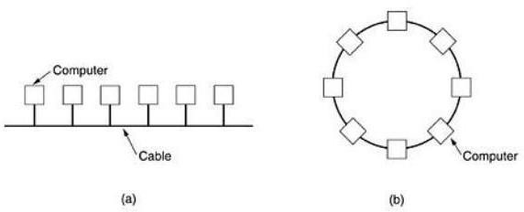

*Fig 1.12: Two broadcast networks . (a) Bus. (b) Ring.*

A second type of broadcast system is the ring. In a ring, each bit propagates around on its own, not waiting for the rest of the packet to which it belongs. Typically, each bit circumnavigates the entire ring in the time it takes to transmit a few bits, often before the complete packet has even been transmitted. As with all other broadcast systems, some rule is needed for arbitrating simultaneous accesses to the ring. Various methods, such as having the machines take turns, are in use. IEEE 802.5 (the IBM token ring), is a ring-based LAN operating at 4 and 16 Mbps. FDDI is another example of a ring network.

### Metropolitan Area Network (MAN):

A metropolitan area network, or MAN, covers a city. The best-known example of a MAN is the cable television network available in many cities. This system grew from earlier community antenna systems used in areas with poor over-the-air television reception. In these early systems, a large antenna was placed on top of a nearby hill and signal was then piped to the subscribers' houses. At first, these were locally-designed, ad hoc systems.

Then companies began jumping into the business, getting contracts from city governments to wire up an entire city. The next step was television programming and even entire channels designed for cable only. Often these channels were highly specialized, such as all news, all sports, all cooking, all gardening, and so on. But from their inception until the late 1990s, they were intended for television reception only. To a first approximation, a MAN might look something like the system shown in Fig1.13. In this figure both television signals and Internet are fed into the centralized head end for subsequent distribution to people's homes. Cable television is not the only MAN. Recent developments in high-speed wireless Internet access resulted in another MAN, which has been standardized as IEEE 802.16.

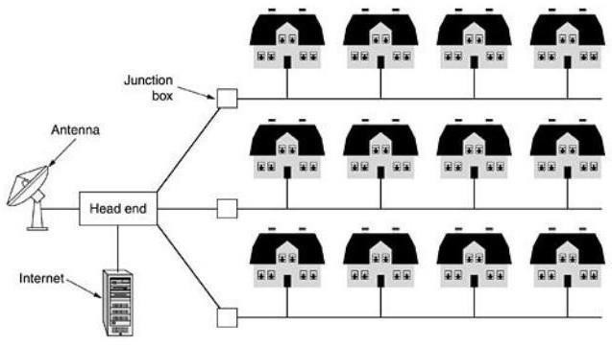

*Fig 1.13 : Metropolitan area network based on cable TV.*

A MAN is implemented by a standard called DQDB (Distributed Queue Dual Bus) or IEEE 802.16. DQDB has two unidirectional buses (or cables) to which all the computers are attached.

### Wide Area Network (WAN).

A wide area network, or WAN, spans a large geographical area, often a country or continent. It contains a collection of machines intended for running user (i.e., application) programs. These machines are called as hosts. The hosts are connected by a communication subnet, or just subnet for short. The hosts are owned by the customers (e.g., people's personal computers), whereas the communication subnet is typically owned and operated by a telephone company or Internet service provider. The job of the subnet is to carry messages from host to host, just as the telephone system carries words from speaker to listener.

Separation of the pure communication aspects of the network (the subnet) from the application aspects (the hosts), greatly simplifies the complete network design. In most wide area networks, the subnet consists of two distinct components: transmission lines and switching elements. Transmission lines move bits between machines. They can be made of copper wire, optical fiber, or even radio links. In most WANs, the network contains numerous transmission lines, each one connecting a pair of routers. If two routers that do not share a transmission line wish to communicate, they must do this indirectly, via other routers. When a packet is sent from one router to another via one or more intermediate routers, the packet is received at each intermediate router in its entirety, stored there until the required output line is free, and then forwarded. A subnet organized according to this principle is called a store-and-forward orpacket- switched subnet. Nearly all wide area networks (except those using satellites) have store- and- forward subnets. When the packets are small and all the same size, they are often calledcells.

The principle of a packet-switched WAN is so important. Generally, when a process on some host has a message to be sent to a process on some other host, the sending host first cuts the message into packets, each one bearing its number in the sequence. These packets are then injected into the network one at a time in quick succession. The packets are transported individually over the network and deposited at the receiving host, where they are reassembled into the original message and delivered to the receiving process. A stream of packets resulting from some initial message is illustrated in Fig1.14.

In this figure, all the packets follow the route ACE, rather than ABDE or ACDE. In some networks all packets from a given message must follow the same route; in others each packed is routed separately. Of course, if ACE is the best route, all packets may be sent along it, even if each packet is individually routed.

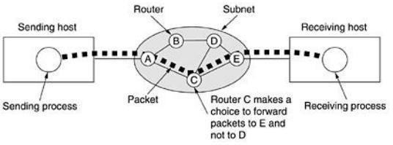

*Fig 1.14 : A stream of packets from sender to receiver.*

Not all WANs are packet switched. A second possibility for a WAN is a satellite system. Each router has an antenna through which it can send and receive. All routers can hear the output from the satellite, and in some cases they can also hear the upward transmissions of their fellow routers to the satellite as well. Sometimes the routers are connected to a substantial point-to-point subnet, with only some of them having a satellite antenna. Satellite networks are inherently broadcast and are most useful when the broadcast property is important.

### Types of Connections:

*Type of Connection*

A network is two or more devices connected through links. A link is a communications pathway that transfers data from one device to another. For visualization purposes, it is simplest to imagine any link as a line drawn between two points. For communication to occur, two devices must be connected in some way to the same link at the same time. There are two possible

types of connections: point-to-point and multipoint.

### Point-to-Point

A point-to-point connection provides a dedicated link between two devices. The entire capacity of the link is reserved for transmission between those two devices. Most point-to-point connections use an actual length of wire or cable to connect the two ends, but other options, such as microwave or satellite links, are also possible. When you change television channels by infrared remote control, you are establishing a point-to-point connection between the remote control and the television's control system.

### Multipoint

A multipoint (also called multi drop) connection is one in which more than two specific devices share a single link. In a multipoint environment, the capacity of the channel is shared, either spatially or temporally. If several devices can use the link simultaneously, it is a *spatially shared* connection. If users must take turns, it is a *timeshared* connection.

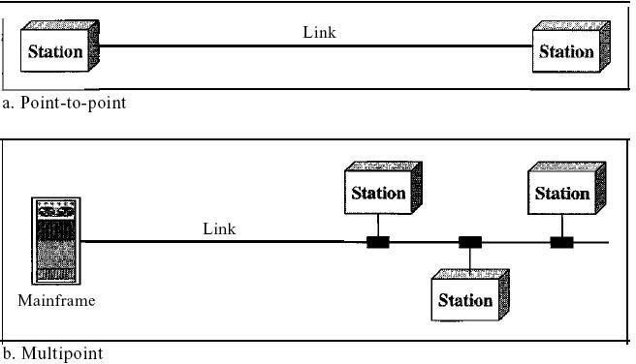

*Fig 1.15: Types of connections: point-to-point and multipoint*

### Topologies:

The term *physical topology* refers to the way in which a network is laid out physically. One or more devices connect to a link; two or more links form a topology. The topology of a network is the geometric representation of the relationship of all the links and linking devices (usually called nodes) to one another. There are four basic topologies possible: mesh, star, bus, and ring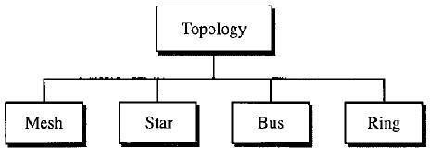

*Fig 1.15: Categories of topology*

**Mesh:** In a mesh topology, every device has a dedicated point-to-point link to every other device. The term *dedicated* means that the link carries traffic only between the two devices it connects. To find the number of physical links in a fully connected mesh network with *n* nodes, we first consider that each node must be connected to every other node. Node 1 must be connected to *n* - I nodes, node 2 must be connected to *n* – 1 nodes, and finally node *n* must be connected to *n* - 1 nodes. We need *n(n* - 1) physical links. However, if each physical link allows communication in both directions (duplex mode), we can divide the number of links by 2.In other words, we can say that in a mesh topology, we need *n(n* -1) /2 duplex-mode links.

To accommodate that many links, every device on the network must have *n* – 1 input/output

*(VO)* ports to be connected to the other *n* - 1 stations.

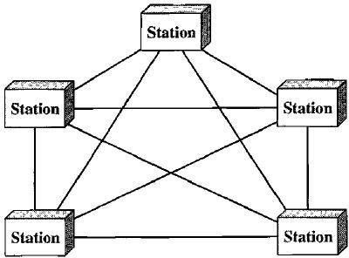

*Fig 1.16: A fully connected mesh topology (five devices)*

Advantages:

* 1. The use of dedicated links guarantees that each connection can carry its own data load, thus eliminating the traffic problems that can occur when links must be shared by multiple devices.
  2. A mesh topology is robust. If one link becomes unusable, it does not incapacitate the entire system. Third, there is the advantage of privacy or security. When every message travels along a dedicated line, only the intended recipient sees it. Physical boundaries prevent other users from gaining access to messages. Finally, point-to-point links make fault identification and fault isolation easy. Traffic can be routed to avoid links with suspected problems. This facility enables the network manager to discover the precise location of the fault and aids in finding its cause and solution.

Disadvantages:

1. Disadvantage of a mesh are related to the amount of cabling because every device must be connected to every other device, installation and reconnection are difficult.
2. Second, the sheer bulk of the wiring can be greater than the available space (in walls, ceilings, or floors) can accommodate. Finally, the hardware required to connect each link (I/O ports and cable) can be prohibitively expensive.

For these reasons a mesh topology is usually implemented in a limited fashion, for example, as a backbone connecting the main computers of a hybrid network that can include several other topologies.

**Star Topology:** In a star topology, each device has a dedicated point-to-point link only to a central controller, usually called a hub. The devices are not directly linked to one another. Unlike a mesh topology, a star topology does not allow direct traffic between devices. The controller acts as an exchange: If one device wants to send data to another, it sends the data to the controller, which then relays the data to the other connected device .

A star topology is less expensive than a mesh topology. In a star, each device needs only one link and one I/O port to connect it to any number of others. This factor also makes it easy to install and reconfigure. Far less cabling needs to be housed, and additions, moves, and deletions involve only one connection: between that device and the hub.

Other advantages include robustness. If one link fails, only that link is affected. All other links remain active. This factor also lends itself to easy fault identification and fault isolation. As long as the hub is working, it can be used to monitor link problems and bypass defective links.

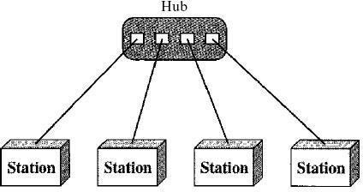

*Fig 1.17: A star topology connecting four stations*

One big disadvantage of a star topology is the dependency of the whole topology on one single point, the hub. If the hub goes down, the whole system is dead. Although a star requires far less cable than a mesh, each node must be linked to a central hub. For this reason, often more cabling is required in a star than in some other topologies (such as ring or bus).

### Bus Topology:

The preceding examples all describe point-to-point connections. A **bus topology,** on the other hand, is multipoint. One long cable acts as a **backbone** to link all the devices in a network

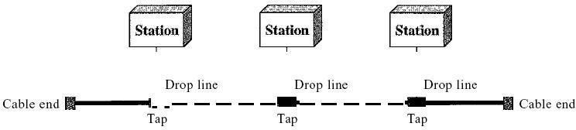

*Fig 1.18: A bus topology connecting three stations*

Nodes are connected to the bus cable by drop lines and taps. A drop line is a connection running between the device and the main cable. A tap is a connector that either splices into the main cable or punctures the sheathing of a cable to create a contact with the metallic core. As a signal travels along the backbone, some of its energy is transformed into heat. Therefore, it becomes weaker and weaker as it travels farther and farther. For this reason there is a limit on the number of taps a bus can support and on the distance between those taps.

Advantages of a bus topology include ease of installation. Backbone cable can be laid along the most efficient path, then connected to the nodes by drop lines of various lengths. In this way, a bus uses less cabling than mesh or star topologies. In a star, for example, four network devices in the same room require four lengths of cable reaching all the way to the hub. In a bus, this redundancy is eliminated. Only the backbone cable stretches through the entire facility. Each drop line has to reach only as far as the nearest point on the backbone.

Disadvantages include difficult reconnection and fault isolation. A bus is usually designed to be optimally efficient at installation. It can therefore be difficult to add new devices. Signal reflection at the taps can cause degradation in quality. This degradation can be controlled by limiting the number and spacing of devices connected to a given length of cable. Adding new devices may therefore require modification or replacement of the backbone.

In addition, a fault or break in the bus cable stops all transmission, even between devices on the same side of the problem. The damaged area reflects signals back in the direction of origin, creating noise in both directions.

Bus topology was the one of the first topologies used in the design of early local area networks. Ethernet LANs can use a bus topology, but they are less popular.

Ring Topology In a ring topology, each device has a dedicated point-to-point connection with only the two devices on either side of it. A signal is passed along the ring in one direction, from device to device, until it reaches its destination. Each device in the ring incorporates a repeater. When a device receives a signal intended for another device, its repeater regenerates the bits and passes them along

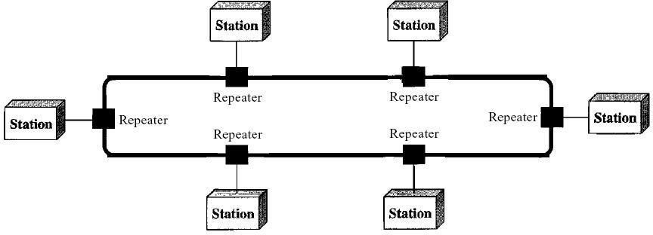

*Fig 1.19: A ring topology connecting six stations*

A ring is relatively easy to install and reconfigure. Each device is linked to only its immediate neighbors (either physically or logically). To add or delete a device requires changing only two connections. The only constraints are media and traffic considerations (maximum ring length and number of devices). In addition, fault isolation is simplified. Generally in a ring, a signal is circulating at all times. If one device does not receive a signal within a specified period, it can issue an alarm. The alarm alerts the network operator to the problem and its location.

However, unidirectional traffic can be a disadvantage. In a simple ring, a break in the ring (such as a disabled station) can disable the entire network. This weakness can be solved by using a dual ring or a switch capable of closing off the break. Ring topology was prevalent when IBM introduced its local-area network Token Ring. Today, the need for higher-speed LANs has made this topology less popular. Hybrid Topology A network can be hybrid. For example, we can have a main star topology with each branch connecting several stations in a bus topology as shown in Figure 1.20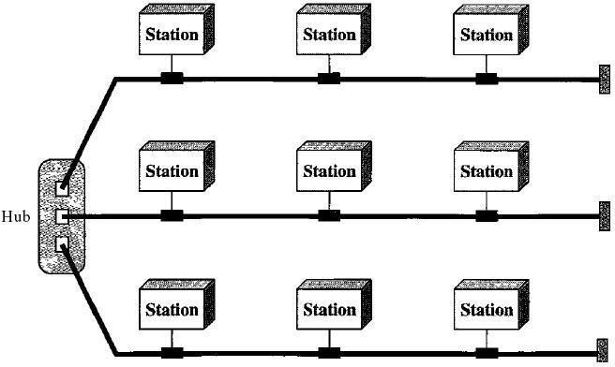

*Fig 1.20: A hybrid topology: a star backbone with three bus networks*

### PROTOCOLS AND STANDARDS

**Protocols**:

In computer networks, communication occurs between entities in different systems. An entity is anything capable of sending or receiving information. However, two entities cannot simply send bit streams to each other and expect to be understood. For communication to occur, the entities must agree on a protocol. A protocol is a set of rules that govern data communications. A protocol defines what is communicated, how it is communicated, and when it is communicated.

The key elements of a protocol are syntax, semantics, and timing

* Syntax. The term *syntax* refers to the structure or format of the data, meaning the order in which they are presented. For example, a simple protocol might expect the first 8 bits of data to be the address of the sender, the second 8 bits to be the address of the receiver, and the rest of the stream to be the message itself.
* Semantics. The word *semantics* refers to the meaning of each section of bits. How is a particular pattern to be interpreted, and what action is to be taken based on that interpretation? For example, does an address identify the route to be taken or the final destination of the message?
* Timing. The term *timing* refers to two characteristics: when data should be sent and how fast they can be sent. For example, if a sender produces data at 100 Mbps but the receiver can process data at only 1 Mbps, the transmission will overload the receiver and some data will be lost.

**Standards**: Standards are essential in creating and maintaining an open and competitive market for equipment manufacturers and in guaranteeing national and international interoperability of data and telecommunications technology and processes. Standards provide guidelines to manufacturers, vendors, government agencies, and other service providers to ensure the kind of interconnectivity necessary in today's marketplace and in international communications.

Data communication standards fall into two categories: *de facto* (meaning "by fact" or "by convention") and *de jure* (meaning "by law" or "by regulation").

* De facto. Standards that have not been approved by an organized body but have been adopted as standards through widespread use are de facto standards. De facto standards are often established originally by manufacturers who seek to define the functionality of a new product or technology.
* De jure. Those standards that have been legislated by an officially recognized body are de jure standards.

**LAYERED TASKS:** We use the concept of layers in our daily life. As an example, let us consider two friends who communicate through postal mail The process of sending a letter to a friend would be complex if there were no services available from the post office. Below Figure shows the steps in this task.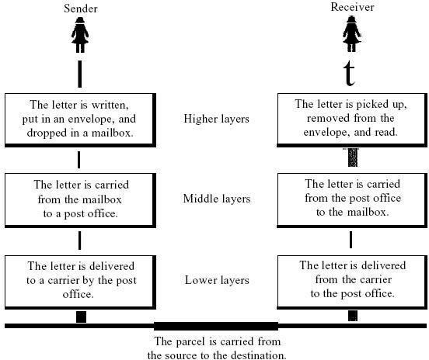

*Fig 1.21: Tasks involved in sending a letter*

Sender, Receiver, and Carrier

In Figure1.21 we have a sender, a receiver, and a carrier that transports the letter. There is a hierarchy of tasks.

*At the Sender Site*

Let us first describe, in order, the activities that take place at the sender site.

* Higher layer. The sender writes the letter, inserts the letter in an envelope, writes the sender and receiver addresses, and drops the letter in a mailbox.
* Middle layer. The letter is picked up by a letter carrier and delivered to the post office.
* Lower layer. The letter is sorted at the post office; a carrier transports the letter.

*0n the Way:* The letter is then on its way to the recipient. On the way to the recipient's local post office, the letter may actually go through a central office. In addition, it may be transported by truck, train, airplane, boat, or a combination of these.

*At the Receiver Site*

* Lower layer. The carrier transports the letter to the post office.
* Middle layer. The letter is sorted and delivered to the recipient's mailbox.
* Higher layer. The receiver picks up the letter, opens the envelope, and reads it.

### The OSI Reference Model:

The OSI model (minus the physical medium) is shown in Fig. This model is based on a proposal developed by the International Standards Organization (ISO) as a first step toward international standardization of the protocols used in the various layers (Day and Zimmermann, 1983). It was revised in 1995(Day, 1995). The model is called the ISO-OSI (Open Systems Interconnection) Reference Model because it deals with connecting open systems—that is, systems that are open for communication with other systems.

The OSI model has seven layers. The principles that were applied to arrive at the seven layers can be briefly summarized as follows:

1. A layer should be created where a different abstraction is needed.
2. Each layer should perform a well-defined function.
3. The function of each layer should be chosen with an eye toward defining internationally standardized protocols.
4. The layer boundaries should be chosen to minimize the information flow across the interfaces.
5. The number of layers should be large enough that distinct functions need not be thrown together in the same layer out of necessity and small enough that the architecture does not become unwieldy.

### The Physical Layer:

The physical layer is concerned with transmitting raw bits over a communication channel. The design issues have to do with making sure that when one side sends a 1 bit, it is received by the other side as a 1 bit, not as a 0 bit.

### The Data Link Layer:

The main task of the data link layer is to transform a raw transmission facility into a line that appears free of undetected transmission errors to the network layer. It accomplishes this task by having the sender break up the input data into data frames (typically a few hundred or a few thousand bytes) and transmits the frames sequentially. If the service is reliable, the receiver confirms correct receipt of each frame by sending back an acknowledgement frame. Another issue that arises in the data link layer (and most of the higher layers as well) is how to keep a fast transmitter from drowning a slow receiver in data. Some traffic regulation mechanism is often needed to let the transmitter know how much buffer space the receiver has at the moment.

Frequently, this flow regulation and the error handling are integrated.

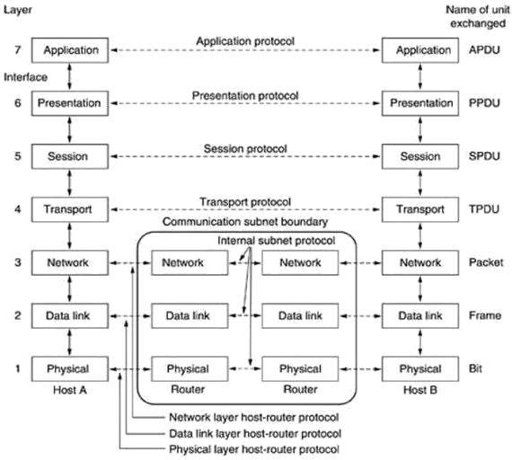

*Fig 1.22: The OSI reference model*

### The Network Layer:

The network layer controls the operation of the subnet. A key design issue is determining how packets are routed from source to destination. Routes can be based on static tables that are ''wired into'' the network and rarely changed. They can also be determined at the start of each conversation, for example, a terminal session (e.g., a login to a remote machine). Finally, they can be highly dynamic, being determined anew for each packet, to reflect the current network load.

If too many packets are present in the subnet at the same time, they will get in one another's way, forming bottlenecks. The control of such congestion also belongs to the network layer. More generally, the quality of service provided (delay, transit time, jitter, etc.) is also a network layer issue.

When a packet has to travel from one network to another to get to its destination, many problems can arise. The addressing used by the second network may be different from the first one. The second one may not accept the packet at all because it is too large. The protocols may differ, and so on. It is up to the network layer to overcome all these problems to allow heterogeneous networks to be interconnected. In broadcast networks, the routing problem is simple, so the network layer is often thin or even nonexistent.

### The Transport Layer:

The basic function of the transport layer is to accept data from above, split it up into smaller units if need be, pass these to the network layer, and ensure that the pieces all arrive correctly at the other end. Furthermore, all this must be done efficiently and in a way that isolates the upper layers from the inevitable changes in the hardware technology. The transport layer also determines what type of service to provide to the session layer, and, ultimately, to the users of the network. The most popular type of transport connection is an error-free point-to-point channel that delivers messages or bytes in the order in which they were sent. However, other possible kinds of transport service are the transporting of isolated messages, with no guarantee about the order of delivery, and the broadcasting of messages to multiple destinations. The type of service is determined when the connection is established.

The transport layer is a true end-to-end layer, all the way from the source to the destination. In other words, a program on the source machine carries on a conversation with a similar program on the destination machine, using the message headers and control messages. In the lower layers, the protocols are between each machine and its immediate neighbors, and not between the ultimate source and destination machines, which may be separated by many routers. **The Session Layer:**

The session layer allows users on different machines to establish sessions between them. Sessions offer various services, including dialog control (keeping track of whose turn it is to transmit), token management (preventing two parties from attempting the same critical operation at the same time), and synchronization (check pointing long transmissions to allow them to continue from where they were after a crash).

### The Presentation Layer:

The presentation layer is concerned with the syntax and semantics of the information transmitted. In order to make it possible for computers with different data representations to communicate, the data structures to be exchanged can be defined in an abstract way, along with a standard encoding to be used ''on the wire.'' The presentation layer manages these abstract data structures

and allows higher-level data structures (e.g., banking records), to be defined and exchanged.

### The Application Layer:

The application layer contains a variety of protocols that are commonly needed by users. One widely-used application protocol is HTTP (Hypertext Transfer Protocol), which is the basis for the World Wide Web. When a browser wants a Web page, it sends the name of the page it wants to the server using HTTP. The server then sends the page back. Other application protocols are used for file transfer, electronic mail, and network news.

**The TCP/IP Reference Model:** The TCP/IP reference model was developed prior to OSI model. The major design goals of this model were,

1. To connect multiple networks together so that they appear as a single network.
2. To survive after partial subnet hardware failures.
3. To provide a flexible architecture.

Unlike OSI reference model, TCP/IP reference model has only 4 layers. They are,

1. Host-to-Network Layer
2. Internet Layer
3. Transport Layer
4. Application Layer

### Host-to-Network Layer:

The TCP/IP reference model does not really say much about what happens here, except to point out that the host has to connect to the network using some protocol so it can send IP packets to it. This protocol is not defined and varies from host to host and network to network.

### Internet Layer:

This layer, called the internet layer, is the linchpin that holds the whole architecture together. Its job is to permit hosts to inject packets into any network and have they travel independently to the destination (potentially on a different network). They may even arrive in a different order than they were sent, in which case it is the job of higher layers to rearrange them, if in-order delivery is desired. Note that ''internet'' is used here in a generic sense, even though this layer is present in the Internet.

The internet layer defines an official packet format and protocol called IP (Internet Protocol). The job of the internet layer is to deliver IP packets where they are supposed to go. Packet routing is clearly the major issue here, as is avoiding congestion. For these reasons, it is reasonable to say that the TCP/IP internet layer is similar in functionality to the OSI network

layer. Fig1.23. shows this correspondence.

### The Transport Layer:

The layer above the internet layer in the TCP/IP model is now usually called the transport layer. It is designed to allow peer entities on the source and destination hosts to carry on a conversation, just as in the OSI transport layer. Two end-to-end transport protocols have been defined here. The first one, TCP (Transmission Control Protocol), is a reliable connection-oriented protocol that allows a byte stream originating on one machine to be delivered without error on any other machine in the internet. It fragments the incoming byte stream into discrete messages and passes each one on to the internet layer. At the destination, the receiving TCP process reassembles the received messages into the output stream. TCP also handles flow control

to make sure a fast sender cannot swamp a slow receiver with more messages than it can handle.

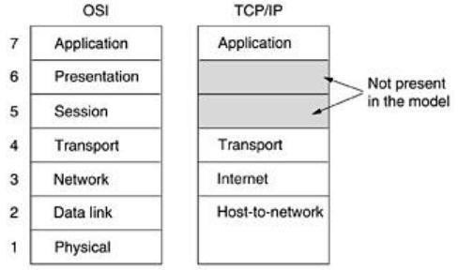

*Fig 1.23: The TCP/IP reference model.*

The second protocol in this layer, UDP (User Datagram Protocol), is an unreliable, connectionless protocol for applications that do not want TCP's sequencing or flow control and wish to provide their own. It is also widely used for one-shot, client-server-type request-reply queries and applications in which prompt delivery is more important than accurate delivery, such as transmitting speech or video. The relation of IP, TCP, and UDP is shown in Fig.1.24. Since the model was developed, IP has been implemented on many other networks.

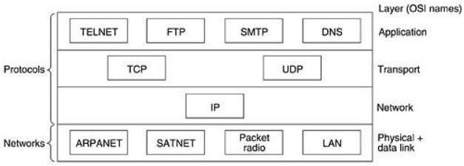

*Fig1.24: Protocols and networks in the TCP/IP model initially.*

### The Application Layer:

The TCP/IP model does not have session or presentation layers. On top of the transport layer is the application layer. It contains all the higher-level protocols. The early ones included virtual terminal (TELNET), file transfer (FTP), and electronic mail (SMTP). The virtual terminal protocol allows a user on one machine to log onto a distant machine and work there. The file transfer protocol provides a way to move data efficiently from one machine to another. Electronic mail was originally just a kind of file transfer, but later a specialized protocol (SMTP) was developed for it. Many other protocols have been added to these over the years: the Domain Name System (DNS) for mapping host names onto their network addresses, NNTP, the protocol for moving USENET news articles around, and HTTP, the protocol for fetching pages on the World Wide Web, and many others.

### Comparison of the OSI and TCP/IP Reference Models:

The OSI and TCP/IP reference models have much in common. Both are based on the concept of a stack of independent protocols. Also, the functionality of the layers is roughly similar. For example, in both models the layers up through and including the transport layer are there to provide an end-to-end, network-independent transport service to processes wishing to communicate. These layers form the transport provider. Again in both models, the layers above transport are application-oriented users of the transport service. Despite these fundamental similarities, the two models also have many differences Three concepts are central to the OSI model:

1. Services. 2. Interfaces. 3. Protocols.

Probably the biggest contribution of the OSI model is to make the distinction between these three concepts explicit. Each layer performs some services for the layer above it. The service definition tells what the layer does, not how entities above it access it or how the layer works. It defines the layer's semantics.

A layer's interface tells the processes above it how to access it. It specifies what the parameters are and what results to expect. It, too, says nothing about how the layer works inside.

Finally, the peer protocols used in a layer are the layer's own business. It can use any protocols it wants to, as long as it gets the job done (i.e., provides the offered services). It can also change them at will without affecting software in higher layers.

The TCP/IP model did not originally clearly distinguish between service, interface, and protocol, although people have tried to retrofit it after the fact to make it more OSI-like. For example, the only real services offered by the internet layer are SEND IP PACKET and **RECEIVE IP PACKET.**

As a consequence, the protocols in the OSI model are better hidden than in the TCP/IP model and can be replaced relatively easily as the technology changes. Being able to make such changes is one of the main purposes of having layered protocols in the first place. The OSI reference model was devised before the corresponding protocols were invented. This ordering means that the model was not biased toward one particular set of protocols, a fact that made it quite general. The downside of this ordering is that the designers did not have much experience with the subject and did not have a good idea of which functionality to put in which layer.

Another difference is in the area of connectionless versus connection-oriented communication. The OSI model supports both connectionless and connection-oriented communication in the network layer, but only connection-oriented communication in the transport layer, where it counts (because the transport service is visible to the users). The TCP/IP model has only one mode in the network layer (connectionless) but supports both modes in the transport layer, giving the users a choice. This choice is especially important for simple request- response protocols.

### Example Networks such as ATM, Frame Relay, ISDN ATM Network:

**Asynchronous Transfer Mode** (**ATM**) also called *cell relay* (*transferring data in cells of a fixed size*) that is operates at the data link layer (Layer 2) of OSI Model over fiber or twisted-pair cable, a high-speed switched network technology based on ITU-T Broadband Integrated Services

Digital Network (B-ISDN) standard, developed by the telecommunications industry to implement the next generation network. ATM was designed for use in WANs such as the public telephone system and corporate data networks, though it has also been applied to create super- fast LANs.

Asynchronous Transfer Mode (ATM) is a high-speed networking standard intended for supporting the voice and data communications. ATM technology is designed for improvement the quality of service and utilization on the high-traffic networks. ATM works on the data link layer over twisted-pair cable or fiber.

ATMs use the asynchronous time-division multiplexing and encode the data into the cells (the small fixed-sized packets). ATM networks have the cells of the fixed size and no routing, so they can easier manage the bandwidth than Ethernet .Concept Draw PRO is a powerful network diagramming and vector drawing software that provides the Computer and Networks solution with wide set of ready-to-use predesigned vector stencils and examples to help you design the ATM Networks quick and easy.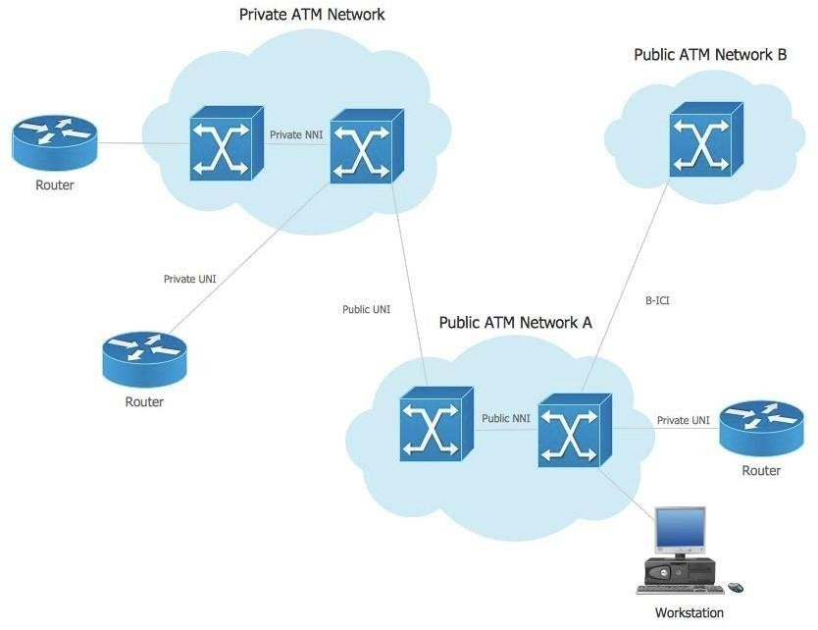

*Fig1.25: Basic ATM Network.*

### Frame Relay Network:

**Frame Relay** is a standardized [wide area network](https://en.wikipedia.org/wiki/Wide_area_network) technology that specifies the [physical](https://en.wikipedia.org/wiki/Physical_layer) and [data link layers](https://en.wikipedia.org/wiki/Data_link_layer) of digital telecommunications channels using a [packet](https://en.wikipedia.org/wiki/Packet_switching) [switching](https://en.wikipedia.org/wiki/Packet_switching) methodology. Originally designed for transport across [Integrated Services Digital](https://en.wikipedia.org/wiki/Integrated_Services_Digital_Network) [Network](https://en.wikipedia.org/wiki/Integrated_Services_Digital_Network) (ISDN) infrastructure, it may be used today in the context of many other network interfaces.

Network providers commonly implement Frame Relay for voice ([VoFR](https://en.wikipedia.org/wiki/VoFR)) and data as an [encapsulation](https://en.wikipedia.org/wiki/Encapsulation_(networking)) technique used between [local area networks](https://en.wikipedia.org/wiki/Local_area_network) (LANs) over a [wide area](https://en.wikipedia.org/wiki/Wide_area_network) [network](https://en.wikipedia.org/wiki/Wide_area_network) (WAN). Each end-user gets a [private line](https://en.wikipedia.org/wiki/Private_line) (or [leased line](https://en.wikipedia.org/wiki/Leased_line)) to a Frame Relay [node.](https://en.wikipedia.org/wiki/Node_(networking)) The Frame Relay network handles the transmission over a frequently changing path transparent to all end-user extensively used WAN protocols. It is less expensive than leased lines and that is one reason for its popularity. The extreme simplicity of configuring user equipment in a Frame Relay network offers another reason for Frame Relay's popularity.

With the advent of [Ethernet](https://en.wikipedia.org/wiki/Ethernet) over fiber optics, [MPLS](https://en.wikipedia.org/wiki/Multiprotocol_Label_Switching), [VPN](https://en.wikipedia.org/wiki/Virtual_private_network) and dedicated [broadband](https://en.wikipedia.org/wiki/Broadband) services such as [cable modem](https://en.wikipedia.org/wiki/Cable_modem) and [DSL,](https://en.wikipedia.org/wiki/Digital_Subscriber_Line) the end may loom for the Frame Relay protocol and encapsulation. However many rural areas remain lacking DSL and cable modem services. In such cases, the least expensive type of non-dial-up connection remains a 64- kbit/s Frame Relay line. Thus a retail chain, for instance, may use Frame Relay for connecting rural stores into their corporate WAN.

Data terminal equipment (DTE), Data circuit-terminating equipment (**DCE**)

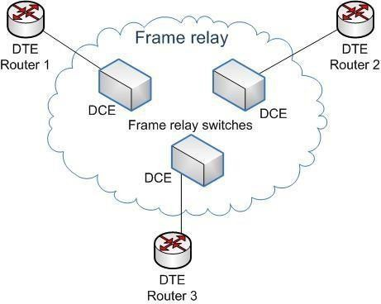

*Fig 1.26: A basic Frame Relay network*

### ISDN Network:

**Integrated Services Digital Network** (**ISDN**) is a set of communication standards for simultaneous [digital](https://en.wikipedia.org/wiki/Digital_data) [transmission](https://en.wikipedia.org/wiki/Digital_data) of voice, video, data, and other network services over the traditional circuits of the [public switched telephone network.](https://en.wikipedia.org/wiki/Public_switched_telephone_network) The key feature of ISDN is that it integrates speech and data on the same lines, adding features that were not available in the [classic](https://en.wikipedia.org/wiki/Plain_old_telephone_service) [telephone system.](https://en.wikipedia.org/wiki/Plain_old_telephone_service) The ISDN standards define several kinds of access interfaces, such as [Basic](https://en.wikipedia.org/wiki/Basic_Rate_Interface) [Rate Interface](https://en.wikipedia.org/wiki/Basic_Rate_Interface) (BRI), [Primary Rate Interface](https://en.wikipedia.org/wiki/Primary_Rate_Interface) (PRI), [Narrowband ISDN](https://en.wikipedia.org/wiki/Narrowband_ISDN) (N-ISDN), and [Broadband ISDN](https://en.wikipedia.org/wiki/Broadband_ISDN) (B-ISDN).

ISDN is a [circuit-switched telephone network](https://en.wikipedia.org/wiki/Circuit_switching) system, which also provides access to [packet switched networks,](https://en.wikipedia.org/wiki/Packet_switched_network) designed to allow digital transmission of voice and [data](https://en.wikipedia.org/wiki/Data) over ordinary [telephone copper wires,](https://en.wikipedia.org/wiki/Twisted_pair) resulting in potentially better voice quality than an analog phone can provide. It offers circuit-switched connections (for either voice or data), and packet- switched connections (for data), in increments of 64 [kilobit](https://en.wikipedia.org/wiki/Kilobit)/s. In some countries, ISDN found major market application for [Internet access,](https://en.wikipedia.org/wiki/Internet_access) in which ISDN typically provides a maximum of 128 kbit/s [bandwidth](https://en.wikipedia.org/wiki/Bandwidth_(computing)) in both upstream and downstream directions. [Channel bonding](https://en.wikipedia.org/wiki/Channel_bonding) can achieve a greater data rate; typically the ISDN B-channels of three or four BRIs (six to eight 64 kbit/s channels) are bonded.

ISDN is employed as the network, data-link and physical layers in the context of the [OSI](https://en.wikipedia.org/wiki/OSI_model) [model](https://en.wikipedia.org/wiki/OSI_model). In common use, ISDN is often limited to usage to [Q.931](https://en.wikipedia.org/wiki/Q.931) and related protocols, which are a set of [signalling protocols](https://en.wikipedia.org/wiki/Signalling_(telecommunications)) establishing and breaking circuit-switched connections, and for advanced [calling features](https://en.wikipedia.org/wiki/Calling_feature) for the user. They were introduced in 1986. In a [videoconference,](https://en.wikipedia.org/wiki/Videoconference) ISDN provides simultaneous voice, video, and text transmission between individual desktop videoconferencing systems and group (room) videoconferencing systems.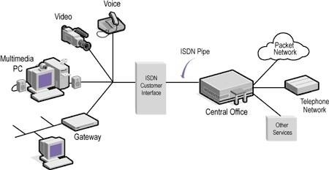

*Fig1.27: ISDN Network.*

**UNIT-I Part II :** Physical layer: Transmission modes, Multiplexing, Transmission Media, Switching, Circuit Switched Networks, Datagram Networks, Virtual Circuit Networks **Transmission modes**:

[Data transmission](https://www.techopedia.com/definition/9756/data-transmission) refers to the process of transferring data between two or more digital devices. Data is transmitted from one device to another in analog or digital format. Basically, data transmission enables devices or components within devices to speak to each other.

Data is transferred in the form of bits between two or more digital devices. There are two methods used to transmit data between digital devices: serial transmission and parallel transmission. Serial data transmission sends data bits one after another over a single channel. Parallel data transmission sends multiple data bits at the same time over multiple channels.

When data is sent or received using [serial data transmission](https://www.reference.com/technology/serial-data-transmission-85a1cf86a6ce29b5), the data bits are organized in a specific order, since they can only be sent one after another. The order of the data bits is important as it dictates how the transmission is organized when it is received. It is viewed as a reliable data transmission method because a data bit is only sent if the previous data bit has already been received.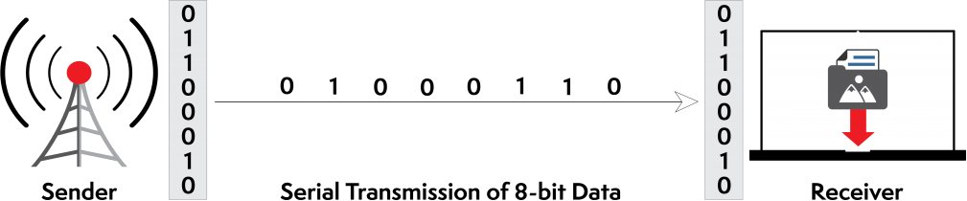

Fig: 1.28 Example of Serial Data Transmission Serial transmission has two classifications: asynchronous and synchronous.

**Asynchronous Serial Transmission:** Data bits can be sent at any point in time. Stop bits and start bits are used between data bytes to synchronize the transmitter and receiver and to ensure that the data is transmitted correctly. The time between sending and receiving data bits is not constant, so gaps are used to provide time between transmissions.

The advantage of using the asynchronous method is that no synchronization is required between the transmitter and receiver devices. It is also a more cost effective method. A disadvantage is that data transmission can be slower, but this is not always the case.

**Synchronous Serial Transmission:** Data bits are transmitted as a continuous stream in time with a master clock. The data transmitter and receiver both operate using a synchronized clock frequency; therefore, start bits, stop bits, and gaps are not used. This means that data moves faster and timing errors are less frequent because the transmitter and receiver time is synced. However, data accuracy is highly dependent on timing being synced correctly between devices. In comparison with asynchronous serial transmission, this method is usually more expensive.

Serial transmission is normally used for long-distance data transfer. It is also used in cases where the amount of data being sent is relatively small. It ensures that data integrity is maintained as it transmits the data bits in a specific order, one after another. In this way, data bits are received in-sync with one another.

When data is sent using [parallel data transmission](http://www.encyclopedia.com/computing/news-wires-white-papers-and-books/serial-and-parallel-transmission), multiple data bits are transmitted over multiple channels at the same time. This means that data can be sent much faster than using serial transmission methods.

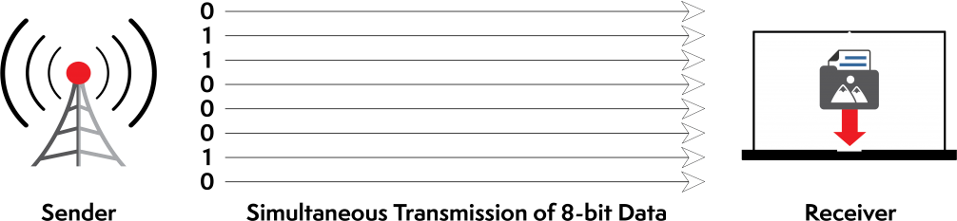

Fig 1.29 :Example of Parallel Data Transmission

Given that multiple bits are sent over multiple channels at the same time, the order in which a bit string is received can depend on various conditions, such as proximity to the data source, user location, and bandwidth availability. Two examples of parallel interfaces can be seen below. In the first parallel interface, the data is sent and received in the correct order. In the second parallel interface, the data is sent in the correct order, but some bits were received faster than others.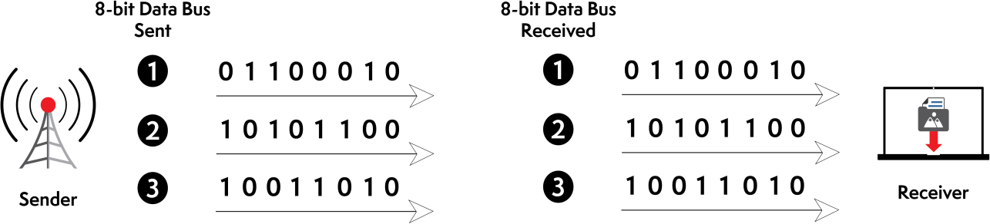

Fig: 1.30 Example of Parallel Transmission – Data Received Correctly

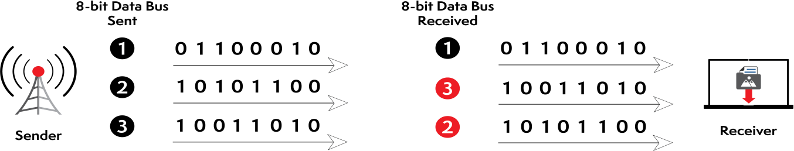

Fig:1.32 Example of Parallel Transmission – Data Received Incorrectly

### Advantages and Disadvantages of Using Parallel Data Transmission

The main advantages of parallel transmission over serial transmission are:

* it is easier to program;
* and data is sent faster.

Although parallel transmission can transfer data faster, it requires more transmission channels than serial transmission. This means that data bits can be out of sync, depending on transfer

distance and how fast each bit loads. A simple of example of where this can be seen is with a voice over IP (VOIP) call when distortion or interference is noticeable. It can also be seen when there is skipping or interference on a video stream.

Parallel transmission is used when:

* a large amount of data is being sent;
* the data being sent is time-sensitive;
* and the data needs to be sent quickly.

A scenario where parallel transmission is used to send data is video streaming. When a video is streamed to a viewer, bits need to be received quickly to prevent a video pausing or buffering. Video streaming also requires the transmission of large volumes of data. The data being sent is also time-sensitive as slow data streams result in poor viewer experience.

### Multiplexing:

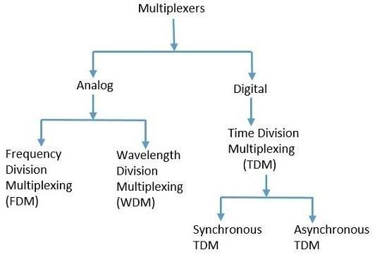

*Fig1.33: Types of Multiplexing*

**Frequency Division Multiplexing:**

In the 20th century, many telephone companies used frequency-division multiplexing for long distance connections to multiplex thousands of voice signals through a coaxial cable system. For shorter distances, cheaper balanced cables were used for various systems like bell systems K-and N-carrier, but they didn’t allow large bandwidths. The FDM is an analog multiplexing that combines analog signals. Frequency division multiplexing is applied when the bandwidth of the link is greater than the combined bandwidth of the signals to be transmitted.

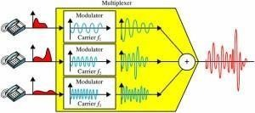

*Fig 1.34 Frequency Division Multiplexing*

In this type of multiplexing, signals are generated by sending different device-modulated carrier frequencies, and these modulated signals are then combined into a single signal that can be transported by the link. To accommodate the modulated signal, the carrier frequencies are separated with enough bandwidth, and these bandwidth ranges are the channels through which different signals travel. These channels can be separated by unused bandwidth. Some of the examples for the time division multiplexing include radio and television signal transmission.

### FDMA:

In frequency-division multiple access (FDMA), the available bandwidth is divided into frequency bands. Each station is allocated a band to send its data. In other words, each band is

Reserved for a specific station, and it belongs to the station all the time. Each station also uses a band pass filter to confine the transmitter frequencies. To prevent station interferences, the allocated bands are separated from one another by small *guard bands. Below f*igure shows the idea of FDMA.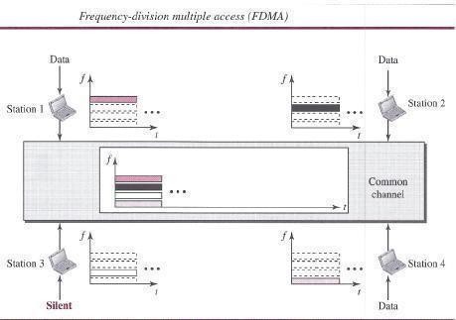

*Fig.1.35* FDMA

FDMA specifies a predetermined frequency band for the entire period of communication. This means that stream data (a continuous flow of data that may not be packetized) can easily be used with FDMA. We will see in Chapter 16 how this feature can be used in cellular telephone systems. We need to emphasize that although FDMA and frequency-division multiplexing (FDM) conceptually seem similar, there are differences between them FDM. The channels that are combined are low-pass. The multiplexer modulates the signals, combines them, and creates a band pass signal. The bandwidth of each channel is shifted by the multiplexer.

FDMA, on the other hand, is an access method in the data-link layer. The data link layer in each station tells its physical layer to make a band pass signal from the data passed to it. The signal must be created in the allocated band. There is no physical multiplexer at the physical layer. The signals created at each station are automatically band pass-filtered. They are mixed when they are sent to the common channel.

### Wavelength Division Multiplexing:

Wavelength division multiplexing (WDM) is a technology in [fiber optic communications](https://www.elprocus.com/basic-elements-of-fiber-optic-communication-system-and-its-working/); and, for the high capacity communication systems, wavelength division multiplexing is the most promising concept. This system uses multiplexer at transmitter to join signals and demultiplexer to split the signals apart, at the receiver end. The purpose of WDM is to combine multiple light sources into a single light source at the multiplexer; and, at the demultiplexer the single light is converted into multiple light sources.

WDM is designed to use the high data rate capability of the fiber optic cable. The data rate of this cable is higher than the metallic transmission cable’s data rate. Conceptually, the wavelength division multiplexing is same as the frequency division multiplexing, except for the transmission through the fiber optic channels wherein the multiplexing and demultiplexing involves optical signals.

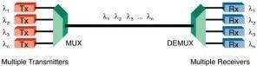

*Fig 1.36 Wavelength Division Multiplexing*

### Time-Division Multiplexing:

Time division multiplexing is a technique used to transmit a signal over a single communication channel by dividing the time frame into slots – one slot for each message signal. Time-division

multiplexing is primarily applied to digital signals as well as analog signals, wherein several low speed channels are multiplexed into high-speed channels for transmission. Based on the time, each low-speed channel is allocated to a specific position, where it works in synchronized mode. At both the ends, i.e., the multiplexer and demultiplexer are timely synchronized and simultaneously switched to the next channel.

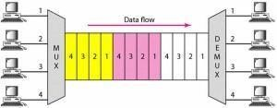

*Fig 1.37 Time-Division Multiplexing*

Time division multiplexing is classifieds into two types:

* + Synchronous time-division multiplexing
  + Asynchronous time-division multiplexing

### Synchronous Time Division Multiplexing:

Synchronous time division multiplexing can be used for both analog and digital signals. In synchronous TDM, the connection of input is connected to a frame. If there are ‘n’ connections, then a frame is divided into ‘n’ time slots – and, for each unit, one slot is allocated – one for each input line. In this synchronous TDM sampling, the rate is same for all the signals, and this sampling requires a common clock signal at both the sender and receiver end. In synchronous TDM, the multiplexer allocates the same slot to each device at all times.

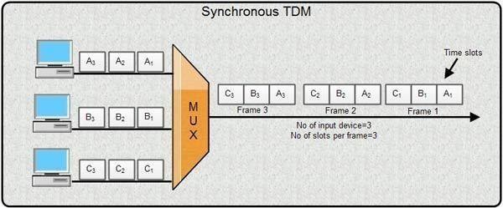

*Fig 1.38* Synchronous TDM

### Asynchronous Time-Division Multiplexing:

In asynchronous time-division multiplexing, the sampling rate is different for different signals, and it doesn’t require a common clock. If the devices have nothing to transmit, then their time

slot is allocated to another device. Designing of a commutator or de-commutator is difficult and the bandwidth is less for time-division multiplexing. This type of time-division multiplexing is used in asynchronous transfer mode networks.

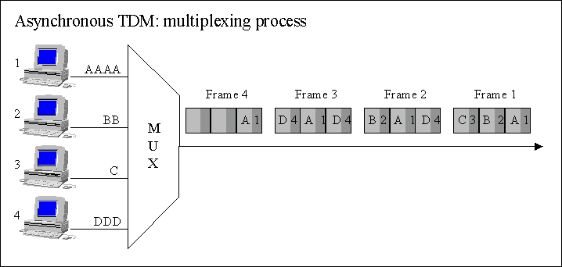

*Fig 1.39 A*synchronous TDM

### TDMA

In time-division multiple access (TDMA), the stations share the bandwidth of the channel in time. Each station is allocated a time slot during which it can send data. Each station transmits its data in its assigned time slot. Below figure shows the idea behind TDMA.

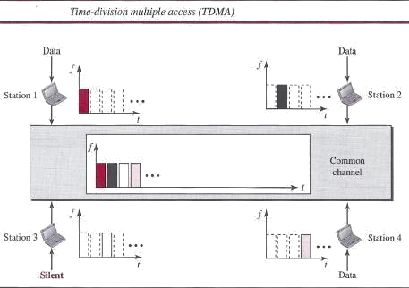

Fig: 1.39 Time –Division Multiple Access

The main problem with TDMA lies in achieving synchronization between the different stations. Each station needs to know the beginning of its slot and the location of its slot. This may be difficult because of propagation delays introduced in the system if the stations are spread over a large area. To compensate for the delays, we can insert *guard times.* Synchronization is normally accomplished by having some synchronization bits (normally referred to as *preamble bits)* at the beginning of each slot. We also need to emphasize that although TDMA and time-division

multiplexing (TDM) conceptually seem the same, there are differences between them. TDM, as, is a physical layer technique that combines the data from slower channels and transmits them by using a faster channel. The process uses a physical multiplexer that interleaves data units from each channel. TDMA, on the other hand, is an access method in the data-link layer. The data-link layer in each station tells its physical layer to use the allocated time slot. There is no physical multiplexer at the physical layer.

### CDMA

Code-division multiple access (CDMA) was conceived several decades ago. Recent advances in electronic technology have finally made its implementation possible. CDMA differs from FDMA in that only one channel occupies the entire bandwidth of the link. It differs from TDMA in that all stations can send data simultaneously; there is no timesharing.

### In CDMA, one channel carries all transmissions simultaneously

#### Analogy

Let us first give an analogy. CDMA simply means communication with different codes. For example, in a large room with many people, two people can talk privately in English if nobody else understands English. Another two people can talk in Chinese if they are the only ones who understand Chinese, and so on. In other words, the common channel, the space of the room in this case, can easily allow communication between several couples, but in different languages (codes).

***Idea:*** Let us assume we have four stations, 1, 2,3, and 4, connected to the' same channel. The data from station 1 are *d1,* from station 2 are *d2,* and so on. The code assigned to the first station is Cj, to the second is *c2,* and so on. We assume that the assigned codes have two properties.

* 1. If we multiply each code by another, we get O.
  2. If we multiply each code by itself, we get 4 (the number ofstations).

With these two properties in mind, let us see how the above four stations can send data using the same common channel, as shown in Figure.

Station 1 multiplies (a special kind of multiplication, as we will see) its data by its code to get *d,.* Cj. Station 2 multiplies its data by its code to get *d2 .* <z- and so on. The data that go on the channel are the sum of all these terms, as shown in the box. Any station that wants to receive data from one of the other three multiplies the data on the channel by the code of the sender. For example, suppose stations 1 and 2 are talking to each other. Station 2 wants to hear what station 1 is saying. It multiplies the data on the channel by C r- the code of station 1.

Because (cI . cI) is 4, but *(c2 .* cl), *(c3 .* cl)' and *(c4 .* cI) are all Os, station 2 divides the result by

4 to get the data from station 1.

***Chips:*** CDMA is based on coding theory. Each station is assigned a code, which is a sequence of numbers called *chips,* as shown in below figure. The codes are for the previous example.

Later in this chapter we show how we chose these sequences. For now, we need to know that we did not choose the sequences randomly; they were carefully selected. They are called *orthogonal sequences* and have the following properties: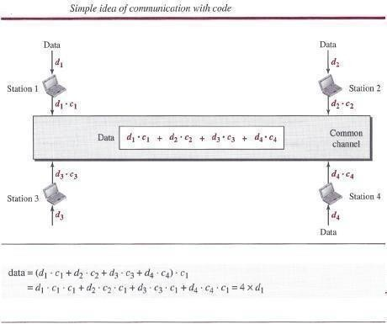

### Fig : 1.40 Code Division Multiple Access Transmission Media:

A transmission medium is a physical path between the transmitter and the receiver i.e it is the channel through which data is sent from one place to another. Transmission Media is broadly classified into the following types:

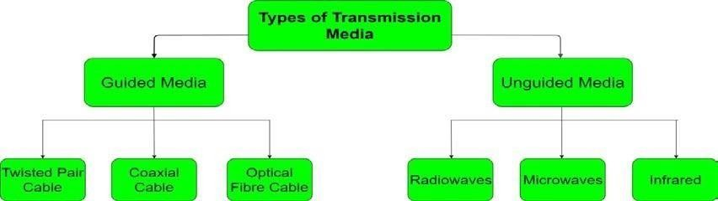

*Fig 1.41 Types Transmission Media*

### Guided Media:

It is also referred to as Wired or Bounded transmission media. Signals being transmitted are directed and confined in a narrow pathway by using physical links.

Features:

High Speed, Secure, Used for comparatively shorter distances

There are 3 major types of Guided Media:

1. **Twisted Pair Cable :** consists of 2 separately insulated conductor wires wound about each other. Generally, several such pairs are bundled together in a protective sheath. They are the most widely used Transmission Media. Twisted Pair is of two types:

**Unshielded Twisted Pair (UTP):** This type of cable has the ability to block interference and does not depend on a physical shield for this purpose. It is used for telephonic applications.

Advantages: Least expensive, Easy to install, High speed capacity

Disadvantages: Susceptible to external interference, Lower capacity and performance in comparison to STP Short distance transmission due to attenuation

**Shielded Twisted Pair (STP):** This type of cable consists of a special jacket to block external interference. It is used in fast-data-rate Ethernet and in voice and data channels of telephone lines.

Advantages: Better performance at a higher data rate in comparison to UTP Eliminates crosstalk, comparatively faster

Disadvantages: Comparatively difficult to install and manufacture, More expensive, Bulky

1. **Coaxial Cable –**It has an outer plastic covering containing 2 parallel conductors each having a separate insulated protection cover. Coaxial cable transmits information in two modes: Baseband mode(dedicated cable bandwidth) and Broadband mode(cable bandwidth is split into separate ranges). Cable TVs and analog television networks widely use Coaxial cables. Advantages:

High Bandwidth, Better noise Immunity, Easy to install and expand, Inexpensive Disadvantages: Single cable failure can disrupt the entire network

1. **Optical Fibre Cable –**It uses the concept of reflection of light through a core made up of glass or plastic. The core is surrounded by a less dense glass or plastic covering called the cladding. It is used for transmission of large volumes of data.

Advantages: Increased capacity and bandwidth, Light weight, Less signal attenuation Disadvantages: Difficult to install and maintain, High cost, Fragile

1. **Unguided Media:** It is also referred to as Wireless or Unbounded transmission media.No physical medium is required for the transmission of electromagnetic signals.

Features: Signal is broadcasted through air, Less Secure, Used for larger distances There are 3 major types of Unguided Media:

1. **Radio waves –** These are easy to generate and can penetrate through buildings. The sending and receiving antennas need not be aligned. Frequency Range:3KHz – 1GHz. AM and FM radios and cordless phones use Radio waves for transmission.

Further Categorized as: (i) Terrestrial and (ii) Satellite.

1. **Microwaves –** It is a line of sight transmission i.e. the sending and receiving antennas need to be properly aligned with each other. The distance covered by the signal is directly proportional to the height of the antenna. Frequency Range:1GHz – 300GHz. These are majorly used for mobile phone communication and television distribution. **(iii) Infrared –** Infrared waves are used for very short distance communication. They cannot penetrate through obstacles. This prevents interference between systems. Frequency Range: 300GHz – 400THz. It is used in TV remotes, wireless mouse, keyboard, printer, etc.

### Switching:

A network is a set of connected devices. Whenever we have multiple devices, we have the problem of how to connect them to make one-to-one communication possible. One solution is to make a point-to-point connection between each pair of devices (a mesh topology) or between a central device and every other device (a star topology). These methods, however, are impractical and wasteful when applied to very large networks. The number and length of the links require too much infrastructure to be cost-efficient, and the majority of those links would be idle most of the time. Other topologies employing multipoint connections, such as a bus, are ruled out because the distances between devices and the total number of devices increase beyond the capacities of the media and equipment.

A better solution is switching. A switched network consists of a series of interlinked nodes, called switches. Switches are devices capable of creating temporary connections between two or more devices linked to the switch. In a switched network, some of these nodes are connected to the end systems (computers or telephones, for example). Others are used only for routing. Figure shows a switched network.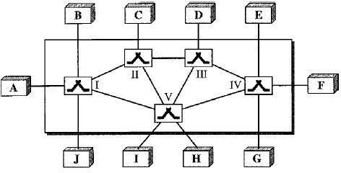

*Fig 1.42 Switched network*

The end systems (communicating devices) are labeled A, B, C, D, and so on, and the switches

are labeled I, II, III, IV, and V. Each switch is connected to multiple links.

#### Taxonomy of switched networks

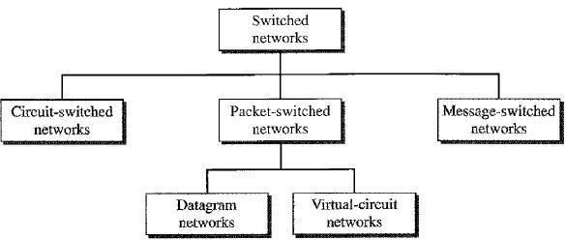

*Fig 1.43 Taxonomy of switched networks*

### CIRCUIT-SWITCHED NETWORKS

A circuit-switched network consists of a set of switches connected by physical links. A connection between two stations is a dedicated path made of one or more links. However, each connection uses only one dedicated channel on each link. Each link is normally divided into *n* channels by using FDM or TDM

Figure1.41 shows a trivial circuit-switched network with four switches and four links. Each link is divided into *n (n* is 3 in the figure) channels by using FDM or TDM.

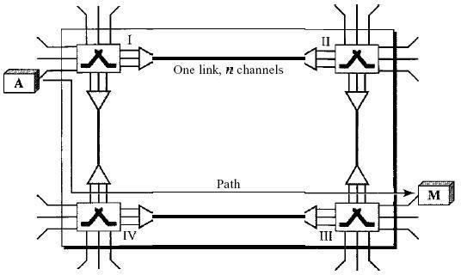

*Fig1.44: A trivial circuit-switched network*

### Three Phases

The actual communication in a circuit-switched network requires three phases: connection setup, data transfer, and connection teardown.

***Setup Phase****:* Before the two parties (or multiple parties in a conference call) can communicate, a dedicated circuit (combination of channels in links) needs to be established. The end systems are normally connected through dedicated lines to the switches, so connection setup means creating dedicated channels between the switches. For example, in Figure, when system A needs to

connect to system M, it sends a setup request that includes the address of system M, to switch I. Switch I finds a channel between itself and switch IV that can be dedicated for this purpose. Switch I then sends the request to switch IV, which finds a dedicated channel between itself and switch III. Switch III informs system M of system A's intention at this time.

In the next step to making a connection, an acknowledgment from system M needs to be sent in the opposite direction to system A. Only after system A receives this acknowledgment is the connection established. Note that end-to-end addressing is required for creating a connection between the two end systems. These can be, for example, the addresses of the computers assigned by the administrator in a TDM network, or telephone numbers in an FDM network.

***Data Transfer Phase****:* After the establishment of the dedicated circuit (channels), the two parties can transfer data.

***Teardown Phase:*** When one of the parties needs to disconnect, a signal is sent to each switch to release the resources.

**Efficiency:** It can be argued that circuit-switched networks are not as efficient as the other two types of networks because resources are allocated during the entire duration of the connection. These resources are unavailable to other connections. In a telephone network, people normally terminate the communication when they have finished their conversation. However, in computer networks, a computer can be connected to another computer even if there is no activity for a long time. In this case, allowing resources to be dedicated means that other connections are deprived. **Delay:** Although a circuit-switched network normally has low efficiency, the delay in this type of network is minimal. During data transfer the data are not delayed at each switch; the resources are allocated for the duration of the connection. Figure 1.42 shows the idea of delay in a circuit- switched network when only two switches are involved. As Figure shows, there is no waiting time at each switch. The total delay is due to the time needed to create the connection, transfer data, and disconnect the circuit.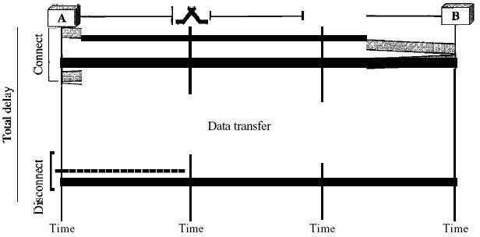

*Fig1.45: Delay in a circuit-switched network*

The delay caused by the setup is the sum of four parts: the propagation time of the source

computer request (slope of the first gray box), the request signal transfer time (height of the first gray box), the propagation time of the acknowledgment from the destination computer (slope of the second gray box), and the signal transfer time of the acknowledgment (height of the second gray box). The delay due to data transfer is the sum of two parts: the propagation time (slope of the colored box) and data transfer time (height of the colored box), which can be very long. The third box shows the time needed to tear down the circuit. We have shown the case in which the receiver requests disconnection, which creates the maximum delay.

### DATAGRAM NETWORKS

In a datagram network, each packet is treated independently of all others. Even if a packet is part of a multipacket transmission, the network treats it as though it existed alone. Packets in this approach are referred to as datagrams.

Datagram switching is normally done at the network layer. We briefly discuss datagram networks here as a comparison with circuit-switched and virtual-circuit switched networks Figure shows how the datagram approach is used to deliver four packets from station A to station X. The switches in a datagram network are traditionally referred to as routers. That is why we use a different symbol for the switches in the figure1.43.

In this example, all four packets (or datagrams) belong to the same message, but may travel different paths to reach their destination. This is so because the links may be involved in carrying packets from other sources and do not have the necessary bandwidth available to carry all the packets from A to X.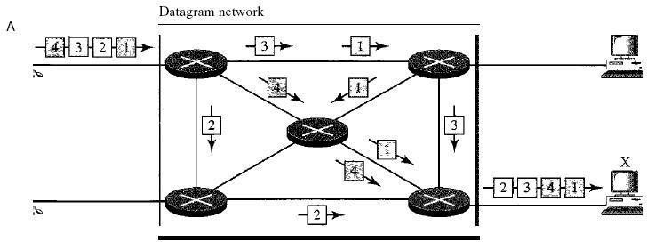

Fig1.46: *A datagram network with four switches (routers)*

This approach can cause the datagrams of a transmission to arrive at their destination out of order with different delays between the packets. Packets may also be lost or dropped because of a lack of resources. In most protocols, it is the responsibility of an upper-layer protocol to reorder the datagrams or ask for lost datagrams before passing them on to the application.

The datagram networks are sometimes referred to as connectionless networks. The term *connectionless* here means that the switch (packet switch) does not keep information about the connection state. There are no setup or teardown phases. Each packet is treated the same by a switch regardless of its source or destination.

**Routing Table:** If there are no setup or teardown phases, how are the packets routed to their destinations in a datagram network? In this type of network, each switch (or packet switch) has a routing table which is based on the destination address. The routing tables are dynamic and are updated periodically. The destination addresses and the corresponding forwarding output ports are recorded in the tables. This is different from the table of a circuit switched network in which each entry is created when the setup phase is completed and deleted when the teardown phase is over. Figure1.44 shows the routing table for a switch.

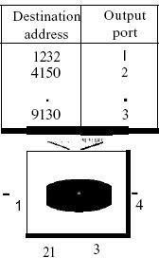

*Fig1.47: Routing table in a datagram network*

***Destination Address:*** Every packet in a datagram network carries a header that contains, among other information, the destination address of the packet. When the switch receives the packet, this destination address is examined; the routing table is consulted to find the corresponding port through which the packet should be forwarded. This address, unlike the address in a virtual- circuit-switched network, remains the same during the entire journey of the packet.

### Efficiency:

The efficiency of a datagram network is better than that of a circuit-switched network; resources are allocated only when there are packets to be transferred. If a source sends a packet and there is a delay of a few minutes before another packet can be sent, the resources can be reallocated during these minutes for other packets from other sources.

### Delay:

There may be greater delay in a datagram network than in a virtual-circuit network. Although there are no setup and teardown phases, each packet may experience a wait at a switch before it is forwarded. In addition, since not all packets in a message necessarily travel through the same

switches, the delay is not uniform for the packets of a message.

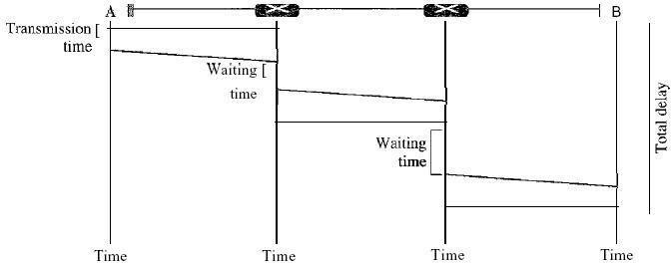

*Fig1.48: Delay in a datagram network*

The packet travels through two switches. There are three transmission times *(3T),* three propagation delays (slopes 3't of the lines), and two waiting times (WI + *w2)'* We ignore the processing time in each switch. The total delay is

Total delay =*3T* + 3t + WI + W2

### VIRTUAL-CIRCUIT NETWORKS:

A virtual-circuit network is a cross between a circuit-switched network and a datagram network. It has some characteristics of both.

1. As in a circuit-switched network, there are setup and teardown phases in addition to the data transfer phase.
2. Resources can be allocated during the setup phase, as in a circuit-switched network, or on demand, as in a datagram network.
3. As in a datagram network, data are packetized and each packet carries an address in the header. However, the address in the header has local jurisdiction (it defines what should be the next switch and the channel on which the packet is being canied), not end-to-end jurisdiction. The reader may ask how the intermediate switches know where to send the packet if there is no final destination address carried by a packet. The answer will be clear when we discuss virtual- circuit identifiers in the next section.
4. As in a circuit-switched network, all packets follow the same path established during the connection.
5. A virtual-circuit network is normally implemented in the data link layer, while a circuit- switched network is implemented in the physical layer and a datagram network in the network layer. But this may change in the future. Figure1.46 is an example of a virtual-circuit network. The network has switches that allow traffic from sources to destinations. A source or destination can be a computer, packet switch, bridge, or any other device that connects other networks.

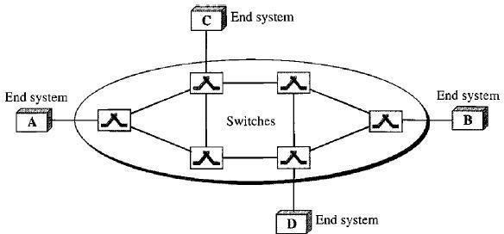

Fig1.49 : *Virtual-circuit network*

**Addressing**: In a virtual-circuit network, two types of addressing are involved: global and local(virtual-circuit identifier).

***Global Addressing:*** A source or a destination needs to have a global address-an address that can be unique in the scope of the network or internationally if the network is part of an international network. However, we will see that a global address in virtual-circuit networks is used only to create a virtual-circuit identifier, as discussed next.

***Virtual-Circuit Identifier****:* The identifier that is actually used for data transfer is called the virtual-circuit identifier (Vel). A vel, unlike a global address, is a small number that has only

switch scope; it is used by a frame between two switches. When a frame arrives at a switch, it has a VCI; when it leaves, it has a different VCl. Figure 1.47 shows how the VCI in a data frame changes from one switch to another. Note that a VCI does not need to be a large number since each switch can use its own unique set of VCls.

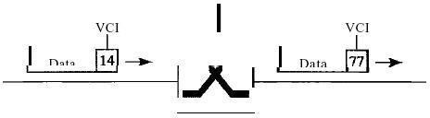

Figure1.50: *Virtual-circuit identifier*

**Three Phases:** As in a circuit-switched network, a source and destination need to go through three phases in a virtual-circuit network: setup, data transfer, and teardown. In the setup phase, the source and destination use their global addresses to help switches make table entries for the connection. In the teardown phase, the source and destination inform the switches to delete the corresponding entry. Data transfer occurs between these two phases. We first discuss the data transfer phase, which is more straightforward; we then talk about the setup and teardown phases. ***Data Transfer Phase:*** To transfer a frame from a source to its destination, all switches need to

have a table entry for this virtual circuit. The table, in its simplest form, has four columns. This means that the switch holds four pieces of information for each virtual circuit that is already set up. We show later how the switches make their table entries, but for the moment we assume that each switch has a table with entries for all active virtual circuits. Figure 2 shows such a switch and its corresponding table. And also shows a frame arriving at port 1 with a VCI of 14. When the frame arrives, the switch looks in its table to find port 1 and a VCI of 14. When it is found, the switch knows to change the VCI to 22 and send out the frame from port 3. Figure 1.48 shows how a frame from source A reaches destination B and how its VCI changes during the trip. Each switch changes the VCI and routes the frame. The data transfer phase is active until the source sends all its frames to the destination. The procedure at the switch is the same for each frame of a message. The process creates a virtual circuit, not a real circuit, between the source and destination.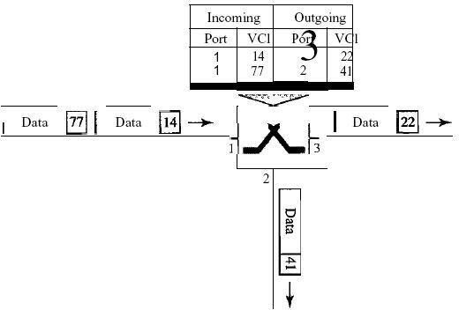

Figure1.51: *Switch and tables in a virtual-circuit network*

***Setup Phase****:* In the setup phase, a switch creates an entry for a virtual circuit. For example, suppose source A needs to create a virtual circuit to B. Two steps are required: the setup request and the acknowledgment

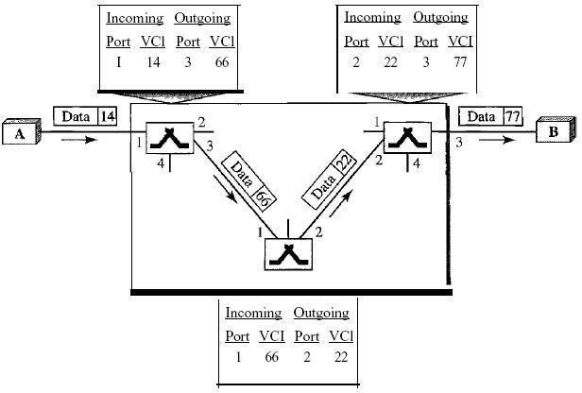

Figure1.52: *Source-to-destination data transfer in a virtual-circuit network*

Setup Request

A setup request frame is sent from the source to the destination.

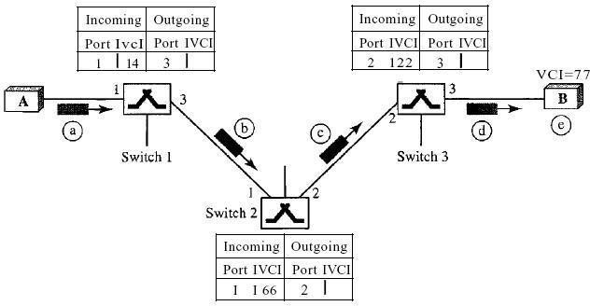

Figure 1.53**:** *Setup request in a virtual-circuit network*

* 1. Source A sends a setup frame to switch 1.
  2. Switch 1 receives the setup request frame. It knows that a frame going from A to B goes out through port 3. How the switch has obtained this information is a point covered in future chapters. The switch, in the setup phase, acts as a packet switch; it has a routing table which is different from the switching table. For the moment, assume that it knows the output port. The switch creates an entry in its table for this virtual circuit, but it is only able to fill three of the four columns. The switch assigns the incoming port (1) and chooses an available incoming VCI (14) and the outgoing port (3). It does not yet know the outgoing VCI, which will be found during the acknowledgment step. The switch then forwards the frame through port 3 to switch 2.
  3. Switch 2 receives the setup request frame. The same events happen here as at switch 1; three columns of the table are completed: in this case, incoming port (l), incoming VCI (66), and outgoing port (2).
  4. Switch 3 receives the setup request frame. Again, three columns are completed: incoming port (2), incoming VCI (22), and outgoing port (3).
  5. Destination B receives the setup frame, and if it is ready to receive frames from A, it assigns a VCI to the incoming frames that come from A, in this case 77. This VCI lets the destination know that the frames come from A, and not other sources.

**Acknowledgment** A special frame, called the acknowledgment frame, completes the entries in the switching tables. Figure 1.51 shows the process.

1. The destination sends an acknowledgment to switch 3. The acknowledgment carries the global source and destination addresses so the switch knows which entry in the table is to be completed. The frame also carries VCI 77, chosen by the destination as the incoming VCI for frames from

A. Switch 3 uses this VCI to complete the outgoing VCI column for this entry. Note that 77 is the incoming VCI for destination B, but the outgoing VCI for switch 3.

1. Switch 3 sends an acknowledgment to switch 2 that contains its incoming VCI in the table, chosen in the previous step. Switch 2 uses this as the outgoing VCI in the table.
2. Switch 2 sends an acknowledgment to switch 1 that contains its incoming VCI in the table, chosen in the previous step. Switch 1 uses this as the outgoing VCI in the table.
3. Finally switch 1 sends an acknowledgment to source A that contains its incoming VCI in the table, chosen in the previous step.
4. The source uses this as the outgoing VCI for the data frames to be sent to destination B.

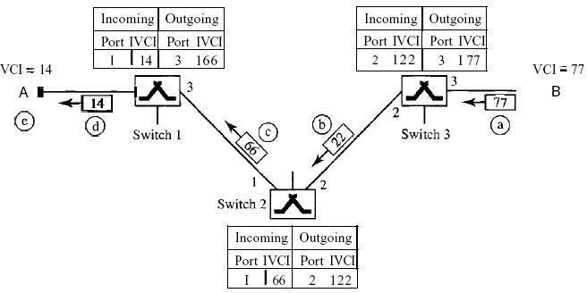

Figure1.54: *Setup acknowledgments in a virtual-circuit network*

#### Teardown Phase

In this phase, source A, after sending all frames to B, sends a special frame called a *teardown*

*request.* Destination B responds with a teardown confirmation frame. All switches delete the corresponding entry from their tables.

### Efficiency:

As we said before, resource reservation in a virtual-circuit network can be made during the setup or can be on demand during the data transfer phase. In the first case, the delay for each packet is the same; in the second case, each packet may encounter different delays. There is one big advantage in a virtual-circuit network even if resource allocation is on demand. The source can check the availability of the resources, without actually reserving it. Consider a family that wants to dine at a restaurant. Although the restaurant may not accept reservations (allocation of the tables is on demand), the family can call and find out the waiting time. This can save the family time and effort.

### Delay in Virtual-Circuit Networks :

In a virtual-circuit network, there is a one-time delay for setup and a one-time delay for teardown. If resources are allocated during the setup phase, there is no wait time for individual packets. Below Figure1.52 shows the delay for a packet traveling through two switches in a virtual-circuit network.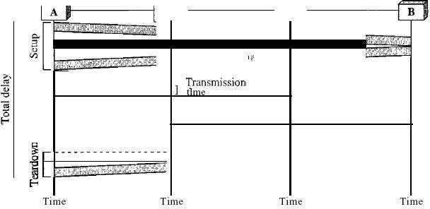

*Fig1.56: Delay in a virtual-circuit network*

The packet is traveling through two switches (routers). There are three transmission times *(3T),* three propagation times (3't), data transfer depicted by the sloping lines, a setup delay (which includes transmission and propagation in two directions), and a teardown delay (which includes transmission and propagation in one direction). We ignore the processing time in each switch. The total delay time is

Total delay = *3T*+ 3't + setup delay + teardown delay

#### TUTORIAL QUESTIONS

1. Consider a 1 km 10Mbps channel. What would be the utilization of this channel when 100 nodes are connected in an Ethernet configuration? If the channel is converted to a ring, running token ring, what would be the utilization of the channel? Assume fixed frame size of 1024 bits in both cases.
2. Describe in detail about the concept of data transmission and its terminology with necessary example?

3) For P = 110011 and M = 1100011, find CRC?

1. For each of the following four networks, discuss the consequences if a connection fails?
   * Six devices arranged in a bus topology
   * Four devices arranged in a ring topology
   * Five devices arranged in a mesh topology
   * Seven devices arranged in a star topology
2. Calculate the hamming distance for each of the following code words?
   * d(10000, 01000)
   * d(10101, 10010)
   * d(1111, 1111)
   * d(0000, 0000)

#### ASSIGNMENT QUESTIONS

1. Describe how are OSI and ISO related to each other?
2. Illustrate some of the factors that determine whether a communication system is a LAN or WAN?
3. List the responsibilities of the data link layer in the Internet mode?
4. Suppose a computer sends a frame to another computer on a bus topology LAN. The physical destination address of the frame is corrupted during the transmission. What happens to the frame? How can the sender be informed about the situation? Explain? List three types of transmission impairment?
5. Distinguish between baseband transmission and broadband transmission?
6. State the categories of networks?
7. With neat diagram ISO/OSI Reference model
8. Define topology and explain the topologies of the network?
9. Distinguish between Circuit Switched Networks, Datagram Networks, Virtual Circuit

Networks.

#### IMPORTANT QUESTIONS

***PART-A-UNIT-I* (2 or 3 marks)**

1. What are the two types of line configuration?
2. Explain about ATM network.
3. Write the advantages of optical fiber over twisted-pair and coaxial cables.
4. What is meant by protocol?
5. What do you meant by framing?
6. Explain about datagram and virtual circuit.
7. What is the purpose of layering?

***PART-B-UNIT-I* (5-10 marks)**

1.Discuss in detail about the layers in OSI model 2.Write any four reasons for using layered protocols.

1. Explain about various transmission media in physical layer with a neat sketch.
2. Explain about Circuit Switched Networks, Datagram Networks, Virtual Circuit Networks. 5.Elaborate different Standards in detail.
3. Explain different Topologies in detail.
4. Explain about ISDN physical layer.
5. Explain the differences between the switching methods.

#### OBJECTIVE QUESTIONS

1. There are Internet service providers.
2. regional
3. local
4. national and international
5. all of the above

### Option D

1. refers to the physical or logical arrangement of a network.
2. Topology
3. Mode of operation
4. Data flow
5. None of the above

### Option A

1. Which topology requires a multipoint connection?
2. Bus
3. Star
4. Mesh
5. Ring

### Option A

1. refers to the structure or format of the data, meaning the order in which they are presented.
2. Semantics
3. Syntax
4. Timing
5. All of the above

### Option B

1. is special-interest groups that quickly test, evaluate, and standardize new technologies.
2. Standards organizations
3. Regulatory agencies
4. Forums
5. All of the above

### Option C

1. This was the first network.
2. CSNET
3. NSFNET
4. ARPANET
5. ANSNET

### Option C

1. is a collection of many separate networks.
2. A WAN
3. An internet
4. A LAN
5. None of the above

### Option B

1. Which topology requires a central controller or hub?
2. Mesh
3. Bus
4. Star
5. Ring

### Option C

1. An unauthorized user is a network issue.
2. Security
3. Reliability
4. Performance
5. All the above

### Option A

1. To handle frames arriving from other protocols, Frame Relay uses a device called a

.

1. MUX
2. VOFR
3. FRAD
4. none of the above

### Option C

#### FILL IN THE BLANKS

1. Transmission media lie the layer.

**Answer**: physical

1. cable can carry signals of higher frequency ranges than cable.

**Answer:** Coaxial; twisted-pair

1. In an optical fiber, the inner core is the cladding.

**Answer:** denser than

1. A(n) medium provides a physical conduit from one device to another.

**Answer:** guided

1. A is a three-layer device that handles packets based on their logical addresses.

**Answer:** router

### Introduction:

**UNIT – II**

**Data link layer & Medium Access sub layer**

Data Link Layer is second layer of OSI Layered Model. This layer is one of the most complicated layers and has complex functionalities and liabilities. Data link layer hides the details of underlying hardware and represents itself to upper layer as the medium to communicate.

Data link layer works between two hosts which are directly connected in some sense. This direct connection could be point to point or broadcast. Systems on broadcast network are said to be on same link. The work of data link layer tends to get more complex when it is dealing with multiple hosts on single collision domain.

Data link layer is responsible for converting data stream to signals bit by bit and to send that over the underlying hardware. At the receiving end, Data link layer picks up data from hardware which are in the form of electrical signals assembles them in a recognizable frame format, and hands over to upper layer.

Data link layer has two sub-layers:

* **Logical Link Control:** It deals with protocols, flow-control, and error control
* **Media Access Control:** It deals with actual control of media Functionsof Data-link Layer
* **Framing:** Data-link layer takes packets from Network Layer and encapsulates them into Frames. Then, it sends each frame bit-by-bit on the hardware. At receiver’ end, data link layer picks up signals from hardware and assembles them into frames.
* **Addressing:** Data-link layer provides layer-2 hardware addressing mechanism. Hardware address is assumed to be unique on the link. It is encoded into hardware at the time of manufacturing.
* **Synchronization:** When data frames are sent on the link, both machines must be synchronized in order to transfer to take place.
* **Error Control:** Sometimes signals may have encountered problem in transition and the bits are flipped. These errors are detected and attempted to recover actual data bits. It also provides error reporting mechanism to the sender.
* **Flow Control:** Stations on same link may have different speed or capacity. Data-link layer ensures flow control that enables both machines to exchange data on same speed.
* **Multi-Access** When host on the shared link tries to transfer the data, it has a high probability of collision. Data-link layer provides mechanism such as CSMA/CD to equip capability of accessing a shared media among multiple Systems.

### Framing:

To provide service to the network layer, the data link layer must use the service provided to it by the physical layer. What the physical layer does is accept a raw bit stream and attempt to deliver it to the destination. This bit stream is not guaranteed to be error free. The number of bits received may be less than, equal to, or more than the number of bits transmitted, and they may have different values. It is up to the data link layer to detect and, if necessary, correct errors. The usual approach is for the data link layer to break the bit stream up into discrete frames and compute the checksum for each frame. When a frame arrives at the destination, the checksum is recomputed. If the newly computed checksum is different from the one contained in the frame, the data link layer knows that an error has occurred and takes steps to deal with it (e.g., discarding the bad frame and possibly also sending back an error report).

Breaking the bit stream up into frames is more difficult than it at first appears. One way to achieve this framing is to insert time gaps between frames, much like the spaces between words in ordinary text. However, networks rarely make any guarantees about timing, so it is possible these gaps might be squeezed out or other gaps might be inserted during transmission. Since it is too risky to count on timing to mark the start and end of each frame, other methods have been devised. We will look at four methods:

1. Character count.
2. Flag bytes with byte stuffing.
3. Starting and ending flags, with bit stuffing.
4. Physical layer coding violations.

The first framing method uses a field in the header to specify the number of characters in the frame. When the data link layer at the destination sees the character count, it knows how many characters follow and hence where the end of the frame is. This technique is shown in Fig.2.1 (a) for four frames of sizes 5, 5, 8, and 8 characters, respectively. The trouble with this algorithm is that the count can be garbled by a transmission error. For example, if the character count of 5 in the second frame of Fig(b) becomes a 7, the destination will get out of synchronization and will be unable to locate the start of the next frame.

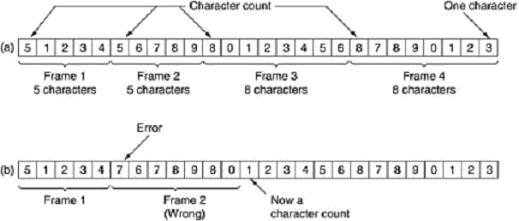

*Fig2.1: A character stream. (a) Without errors. (b) With one error.*

Even if the checksum is incorrect so the destination knows that the frame is bad, it still has no way of telling where the next frame starts. Sending a frame back to the source asking for a retransmission does not help either, since the destination does not know how many characters to skip over to get to the start of the retransmission. For this reason, the character count method is rarely used anymore.

The second framing method gets around the problem of resynchronization after an error by having each frame start and end with special bytes. In the past, the starting and ending bytes were different, but in recent years most protocols have used the same byte, called a flag byte, as both the starting and ending delimiter, as shown in Fig2.2.(a) as FLAG.

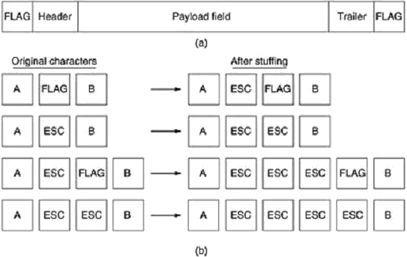

*Fig2.2: (a) A frame delimited by flag bytes (b) Four examples of byte sequences before and after byte stuffing.*

In this way, if the receiver ever loses synchronization, it can just search for the flag byte to find the end of the current frame. Two consecutive flag bytes indicate the end of one frame and start of the next one.

A serious problem occurs with this method when binary data, such as object programs or floating-point numbers, are being transmitted. It may easily happen that the flag byte's bit pattern occurs in the data. This situation will usually interfere with the framing. One way to solve this problem is to have the sender's data link layer insert a special escape byte (ESC) just before each ''accidental'' flag byte in the data. The data link layer on the receiving end removes the escape byte before the data are given to the network layer. This technique is called byte stuffing or character stuffing. Thus, a framing flag byte can be distinguished from one in the data by the absence or presence of an escape byte before it.

Of course, the next question is: What happens if an escape byte occurs in the middle of the data? The answer is that it, too, is stuffed with an escape byte. Thus, any single escape byte is part of an escape sequence, whereas a doubled one indicates that a single escape occurred naturally in the data. Some examples are shown in Fig2.2.(b). In all cases, the byte sequence delivered after de stuffing is exactly the same as the original byte sequence.

The byte-stuffing scheme depicted in Fig. 2.3 is a slight simplification of the one used in the PPP protocol that most home computers use to communicate with their Internet service provider.

A major disadvantage of using this framing method is that it is closely tied to the use of 8- bit characters. Not all character codes use 8-bit characters. For example UNICODE uses 16-bit characters, As networks developed, the disadvantages of embedding the character code length in the framing mechanism became more and more obvious, so a new technique had to be developed to allow arbitrary sized characters.

The new technique allows data frames to contain an arbitrary number of bits and allows character codes with an arbitrary number of bits per character. It works like this. Each frame begins and ends with a special bit pattern, 01111110 (in fact, a flag byte). Whenever the sender's data link layer encounters five consecutive 1s in the data, it automatically stuffs a 0 bit into the outgoing bit stream. This bit stuffing is analogous to byte stuffing, in which an escape byte is stuffed into the outgoing character stream before a flag byte in the data.

When the receiver sees five consecutive incoming 1 bits, followed by a 0 bit, it automatically de stuffs (i.e., deletes) the 0 bit. Just as byte stuffing is completely transparent to the network layer in both computers, so is bit stuffing. If the user data contain the flag pattern,

01111110, this flag is transmitted as 011111010 but stored in the receiver's memory as 01111110.

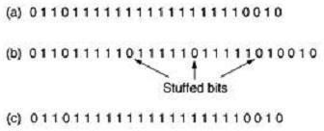

*Figure2.3: Bit stuffing. (a) The original data. (b) The data as they appear on the line. (c) The data as they are stored in the receiver's memory after destuffing.*

With bit stuffing, the boundary between two frames can be unambiguously recognized by the flag pattern. Thus, if the receiver loses track of where it is, all it has to do is scan the input for flag sequences, since they can only occur at frame boundaries and never within the data. The last method of framing is only applicable to networks in which the encoding on the physical medium contains some redundancy. For example, some LANs encode 1 bit of data by using 2 physical bits. Normally, a 1 bit is a high-low pair and a 0 bit is a low-high pair. The scheme means that every data bit has a transition in the middle, making it easy for the receiver to locate the bit boundaries. The combinations high-high and low-low are not used for data but are used for delimiting frames in some protocols.

As a final note on framing, many data link protocols use combination of a character count with one of the other methods for extra safety. When a frame arrives, the count field is used to locate the end of the frame. Only if the appropriate delimiter is present at that position and the checksum is correct is the frame accepted as valid. Otherwise, the input stream is scanned for the next delimiter.

### Error – Detection and Correction – Parity – LRC – CRC, Hamming code:

The data can be corrupted during transmission (from source to receiver). It may be affected by external noise or some other physical imperfections. In this case, the input data is not same as the received output data. This mismatched data is called “Error”.

The data errors will cause loss of important / secured data. Even one bit of change in data may affect the whole system’s performance. Generally the data transfer in digital systems will be in the form of ‘Bit – transfer’. In this case, the data error is likely to be changed in positions of 0 and 1.

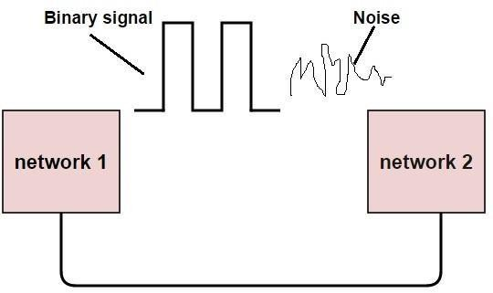

Fig 2.4 Error

#### Types of Errors

In a data sequence, if 1 is changed to zero or 0 is changed to 1, it is called “Bit error”.

There are generally 3 types of errors occur in data transmission from transmitter to receiver. They are

* Single bit errors • Multiple bit errors • Burst errors

**Single Bit Data Errors:** The change in one bit in the whole data sequence, is called “Single bit error”. Occurrence of single bit error is very rare in serial communication system. This type of error occurs only in parallel communication system, as data is transferred bit wise in single line, there is chance that single line to be noisy.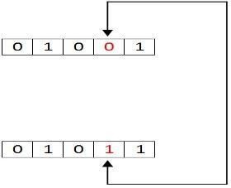

*Fig 2.5 Single Bit Data Errors*

**Multiple Bit Data Errors:** If there is change in two or more bits of data sequence of transmitter to receiver, it is called “Multiple bit error”. This type of error occurs in both serial type and parallel type data communication networks.

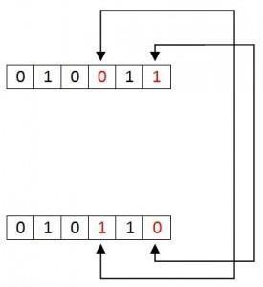

Fig 2.6 Multiple Bit Data Errors

**Burst Errors**

The change of set of bits in data sequence is called “Burst error”. The burst error is calculated in from the first bit change to last bit change.

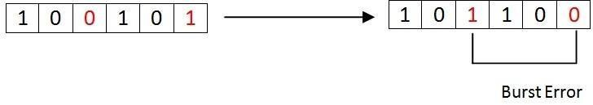

*Fig 2.7* Burst Errors

Here we identify the error form fourth bit to 6th bit. The numbers between 4th and 6th bits are also considered as error. These set of bits are called “Burst error”. These burst bits changes from transmitter to receiver, which may cause a major error in data sequence. This type of errors occurs in serial communication and they are difficult to solve.

**Error Detecting Codes**

In digital communication system errors are transferred from one communication system to another, along with the data. If these errors are not detected and corrected, data will be lost . For effective communication, data should be transferred with high accuracy .This can be achieved by first detecting the errors and then correcting them.

Error detection is the process of detecting the errors that are present in the data transmitted from transmitter to receiver, in a communication system. We use some redundancy codes to detect these errors, by adding to the data while it is transmitted from source (transmitter). These codes are called “Error detecting codes”.

**Types of Error detection**

* + Parity Checking
  + Cyclic Redundancy Check (CRC)
  + Longitudinal Redundancy Check (LRC)
  + Check Sum

**Parity Checking:**

Parity bit means nothing but an additional bit added to the data at the transmitter before transmitting the data. Before adding the parity bit, number of 1’s or zeros is calculated in the data. Based on this calculation of data an extra bit is added to the actual information / data. The addition of parity bit to the data will result in the change of data string size.

This means if we have an 8 bit data, then after adding a parity bit to the data binary string it will become a 9 bit binary data string.

Parity check is also called as “Vertical Redundancy Check (VRC)”.

There is two types of parity bits in error detection, they are 1.Even parity 2.Odd parity

Even Parity: If the data has even number of 1’s, the parity bit is 0. Ex: data is 10000001 -> parity bit 0

Odd number of 1’s, the parity bit is 1. Ex: data is 10010001 -> parity bit 1

Odd Parity: If the data has odd number of 1’s, the parity bit is 0. Ex: data is 10011101 -> parity bit 0

Even number of 1’s, the parity bit is 1. Ex: data is 10010101 -> parity bit 1 NOTE: The counting of data bits will include the parity bit also.

The circuit which adds a parity bit to the data at transmitter is called “Parity generator”. The parity bits are transmitted and they are checked at the receiver. If the parity bits sent at the transmitter and the parity bits received at receiver are not equal then an error is detected. The circuit which checks the parity at receiver is called “Parity checker”.

Messages with even parity and odd parity

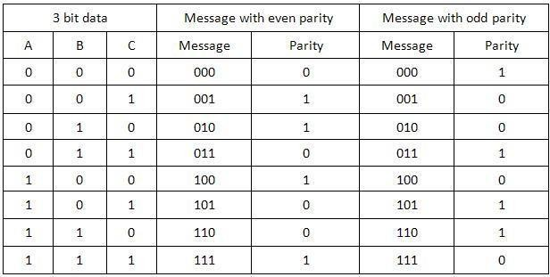

**Cyclic Redundancy Check (CRC):**

* + It is based on addition, CRC is based on binary division.
  + In CRC, a sequence of redundant bits, called cyclic redundancy check bits, are appended to the end of data unit so that the resulting data unit becomes exactly divisible by a second, predetermined binary number.
  + At the destination, the incoming data unit is divided by the same number. If at this step there is no remainder, the data unit is assumed to be correct and is therefore accepted.
  + A remainder indicates that the data unit has been damaged in transit and therefore must be rejected.

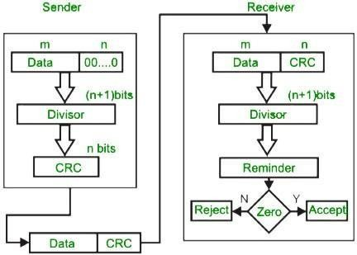

### Example :

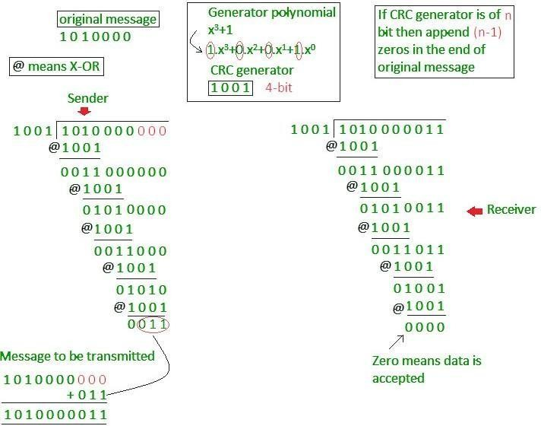

**Longitudinal Redundancy Check (LRC):**In longitudinal redundancy method, a BLOCK of bits are arranged in a table format (in rows and columns) and we will calculate the parity bit for each column separately. The set of these parity bits are also sent along with our original data bits.

Longitudinal redundancy check is a bit by bit parity computation, as we calculate the parity of each column individually.

This method can easily detect burst errors and single bit errors and it fails to detect the 2 bit errors occurred in same vertical slice.

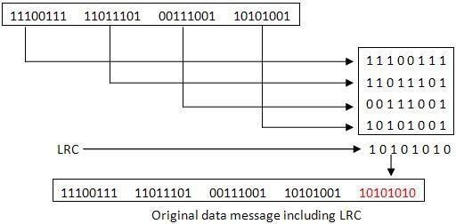

*Fig 2.8 Longitudinal Redundancy Check*

**Check Sum:** The checksum method includes parity bits, check digits and longitudinal redundancy check (LRC). For example, if we have to transfer and detect errors for a long data sequence (also called as Data string) then we divide that into shorter words and we can store the data with a word of same width. For each another incoming bit we will add them to the already stored data. At every instance, the newly added word is called “Checksum”.

* + In checksum error detection scheme, the data is divided into k segments each of m bits.
  + In the sender’s end the segments are added using 1’s complement arithmetic to get the sum. The sum is complemented to get the checksum.
  + The checksum segment is sent along with the data segments.
  + At the receiver’s end, all received segments are added using 1’s complement arithmetic to get the sum. The sum is complemented.
  + If the result is zero, the received data is accepted; otherwise discarded.

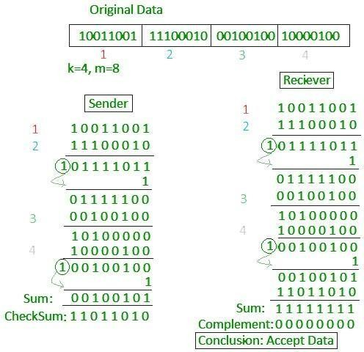

Fig 2.9 Check Sum

### Error-Correcting Codes :( Hamming code)

Hamming code is a set of error-correction codes that can be used to detect and correct the errors that can occur when the data is moved or stored from the sender to the receiver. It is technique developed by R.W. Hamming for error correction.

**Redundant bits –**Redundant bits are extra binary bits that are generated and added to the information-carrying bits of data transfer to ensure that no bits were lost during the data transfer. The number of redundant bits can be calculated using the following formula:

2^r > m + r + 1

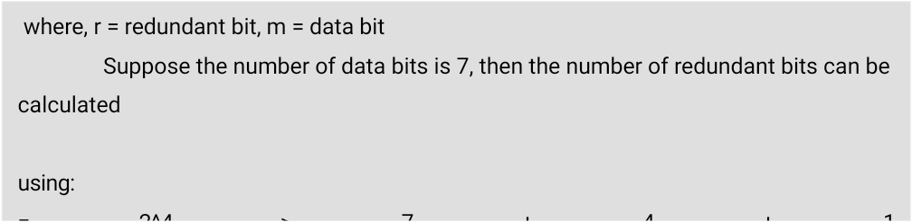

### Parity bits –

A parity bit is a bit appended to a data of binary bits to ensure that the total number of 1’s in the data are even or odd. Parity bits are used for error detection. There are two types of parity bits:

* + Even parity bit:

In the case of even parity, for a given set of bits, the number of 1’s are counted. If that count is odd, the parity bit value is set to 1, making the total count of occurrences of 1’s an even number. If the total number of 1’s in a given set of bits is already even, the parity bit’s value is 0.

* + Odd Parity bit :

In the case of even parity, for a given set of bits, the number of 1’s are counted. If that count is even, the parity bit value is set to 1, making the total count of occurrences of 1’s an odd number. If the total number of 1’s in a given set of bits is already odd, the parity bit’s value is 0.

### General Algorithm of Hamming code –

The Hamming Code is simply the use of extra parity bits to allow the identification of anerror.

* 1. Write the bit positions starting from 1 in binary form (1, 10, 11, 100, etc).
  2. All the bit positions that are a power of 2 are marked as parity bits (1, 2, 4, 8, etc).
  3. All the other bit positions are marked as data bits.
  4. Each data bit is included in a unique set of parity bits, as determined its bit position in binary form.
     1. Parity bit 1 covers all the bits positions whose binary representation includes a 1 in the least significant

position(1, 3, 5, 7, 9, 11, etc).

* + 1. Parity bit 2 covers all the bits positions whose binary representation includes a 1 in the second position from

the least significant bit (2, 3, 6, 7, 10, 11, etc).

* + 1. Parity bit 4 covers all the bits positions whose binary representation includes a 1 in the third position from

the least significant bit (4–7, 12–15, 20–23, etc).

* + 1. Parity bit 8 covers all the bits positions whose binary representation includes a 1 in the fourth position from

the least significant bit bits (8–15, 24–31, 40–47, etc).

* + 1. In general each parity bit covers all bits where the bitwise AND of the parityposition and the bit position is

non-zero.

* 1. Since we check for even parity set a parity bit to 1 if the total number of ones in the positions it checks is odd.
  2. Set a parity bit to 0 if the total number of ones in the positions it checks is even.

### Determining the position of redundant bits:

These redundancy bits are placed at the positions which correspond to the power of 2. As in the above example:

1. The number of data bits = 7
2. The number of redundant bits = 4
3. The total number of bits = 11
4. The redundant bits are placed at positions corresponding to power of 2- 1, 2, 4, and 8

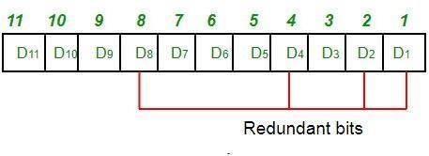

Suppose the data to be transmitted is 1011001, the bits will be placed as follows:

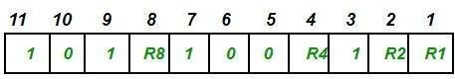

### Determining the Parity bits –

1. R1 bit is calculated using parity check at all the bits positions whose binary representation includes a 1 in the least significant position.

R1: bits 1, 3, 5, 7, 9, 11

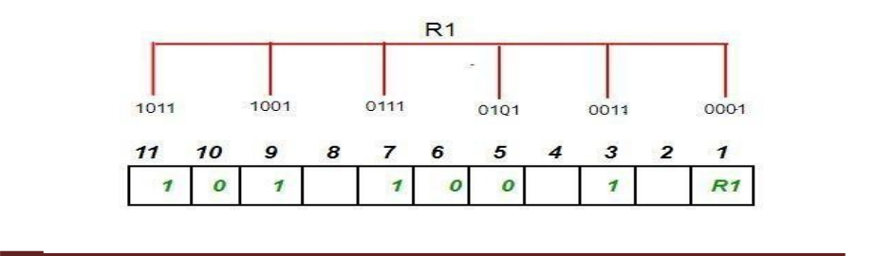

To find the redundant bit R1, we check for even parity. Since the total number of 1’s in all the bit positions corresponding to R1 is an even number the value of R1 (parity bit’s value)

= 0

1. R2 bit is calculated using parity check at all the bits positions whose binary representation includes a 1 in the second position from the least significant bit.

R2: bits 2,3,6,7,10,11

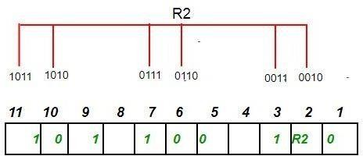

To find the redundant bit R2, we check for even parity. Since the total number of 1’s in all the bit positions corresponding to R2 is an odd number the value of R2(parity bit’s value)=1

1. R4 bit is calculated using parity check at all the bits positions whose binary representation includes a 1 in the third position from the least significant bit.

R4: bits 4, 5, 6, 7

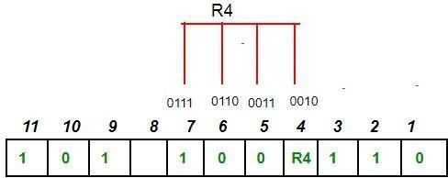

To find the redundant bit R4, we check for even parity. Since the total number of 1’s in all the bit positions corresponding to R4 is an odd number the value of R4(parity bit’s value) = 1

1. R8 bit is calculated using parity check at all the bits positions whose binary representation includes a 1 in the fourth position from the least significant bit.

R8: bit 8,9,10,11

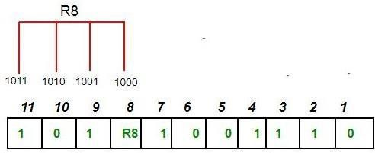

To find the redundant bit R8, we check for even parity. Since the total number of 1’s in all the bit positions corresponding to R8 is an even number the value of R8(parity bit’s value)=0.

Thus, the data transferred is:

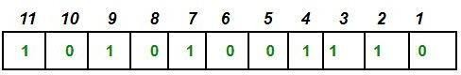

Error detection and correction –

Suppose in the above example the 6th bit is changed from 0 to 1 during data transmission, then it gives new parity values in the binary number:

The bits give the binary number as 0110 whose decimal representation is 6. Thus, the bit 6 contains an error. To correct the error the 6th bit is changed from 1 to 0.

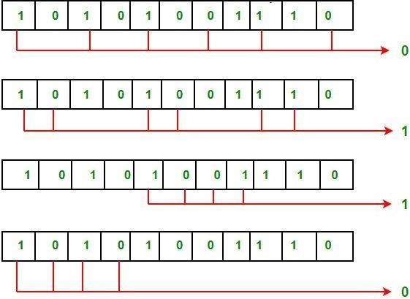

### Flow and Error Control

Data-link layer is responsible for implementation of point-to-point flow and error control mechanism.

**Flow Control:**

When a data frame (Layer-2 data) is sent from one host to another over a single medium, it is required that the sender and receiver should work at the same speed. That is, sender sends at a speed on which the receiver can process and accept the data. What if the speed

(hardware/software) of the sender or receiver differs? If sender is sending too fast the receiver may be overloaded, (swamped) and data may be lost.

Two types of mechanisms can be deployed to control the flow:

* **Stop and Wait:**This flow control mechanism forces the sender after transmitting a data frame to stop and wait until the acknowledgement of the data-frame sent is received.

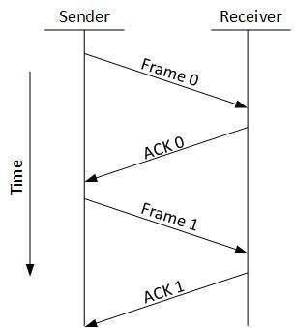

*Fig 2.10 Stop and Wait*

### Sliding Window

In this flow control mechanism, both sender and receiver agree on the number of data- frames after which the acknowledgement should be sent. As we learnt, stop and wait flow control mechanism wastes resources, this protocol tries to make use of underlying resources as much as possible.

**Error Control:**

When data-frame is transmitted, there is a probability that data-frame may be lost in the transit or it is received corrupted. In both cases, the receiver does not receive the correct data- frame and sender does not know anything about any loss. In such case, both sender and receiver are equipped with some protocols which helps them to detect transit errors such as loss of data- frame. Hence, either the sender retransmits the data-frame or the receiver may request to resend the previous data-frame.

Requirements for error control mechanism:

* **Error detection** - The sender and receiver, either both or any, must ascertain that there is some error in the transit.
* **Positive ACK** - When the receiver receives a correct frame, it should acknowledge it.
* **Negative ACK** - When the receiver receives a damaged frame or a duplicate frame, it sends a NACK back to the sender and the sender must retransmit the correct frame.
* **Retransmission:** The sender maintains a clock and sets a timeout period. If an acknowledgement of a data-frame previously transmitted does not arrive before the timeout the sender retransmits the frame, thinking that the frame or it’s acknowledgement is lost in transit.

### Noiseless Channels, Noisy Channels

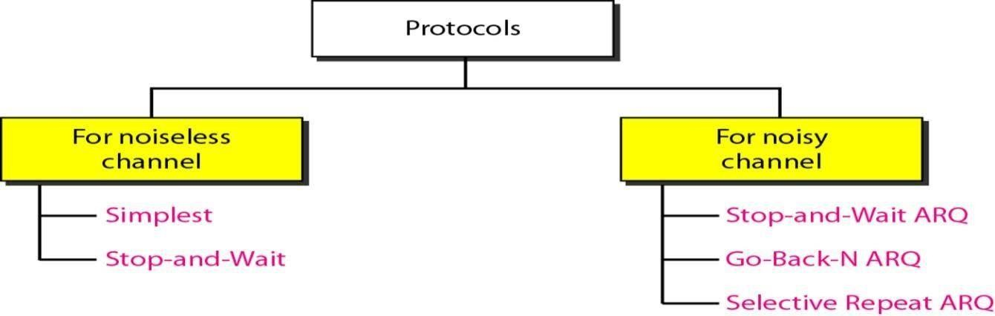

*Fig 2.11 Taxonomy of protocols*

### Noiseless Channel:

An ideal channel in which no frames are lost, duplicated or corrupted is regarded as Noiseless Channel.

### Simplest Protocol:

* In simplest protocol, there is no flow control and error control mechanism. It is a unidirectional protocol in which data frames travel in only one direction (from sender to receiver).
* Also, the receiver can immediately handle any received frame with a processing time that is small enough to be negligible.
* The protocol consists of two distinct procedures: a sender and receiver. The sender runs in the data link layer of the source machine and the receiver runs in the data link layer of the destination machine. No sequence number or acknowledgements are used here.

### Stop and Wait Protocol:

* The simplest retransmission protocol is stop-and-wait.
* Transmitter (Station A) sends a frame over the communication line and then waits for a positive or negative acknowledgement from the receiver (station B).
* If no error occurs in the transmission, station B sends a positive acknowledgement (ACK) to station A.
* Now, the transmitter starts to send the next frame. If frame is received at station B with errors, then a negative acknowledgement (NAK) is sent to station A. In this case, station 'A' must retransmit the old packet in a new frame.
* There is also a possibility that the information frames or ACKs may get lost.
* Then, the sender is equipped with a timer. If no recognizable acknowledgement is received when the timer expires at the end of time out interval, the same frame is sent again.
* The sender which sends one frame and then waits for an acknowledgement before process is known as stop and wait.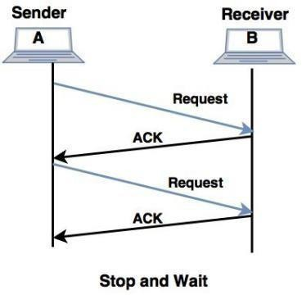

*Fig 2.12 Stop and Wait Protocol*

**Noisy Channels:**

Consider the normal situation of a communication channel that makes errors. Frames may be either damaged or lost completely.

**Stop-and-Wait Automatic Repeat Request:**

* In this method of flow control, the sender sends a single frame to receiver & waits for an acknowledgment.
* The next frame is sent by sender only when acknowledgment of previous frame is received.
* This process of sending a frame & waiting for an acknowledgment continues as long as the sender has data to send.
* To end up the transmission sender transmits end of transmission (EOT) frame.
* The main advantage of stop & wait [protocol](http://ecomputernotes.com/computernetworkingnotes/computer-network/protocol)s is its accuracy. Next frame is transmitted only when the first frame is acknowledged. So there is no chance of frame being lost.
* The main disadvantage of this method is that it is inefficient. It makes the transmission process slow. In this method single frame travels from source to destination and single acknowledgment travels from destination to source. As a result each frame sent and received uses the entire time needed to traverse the link. Moreover, if two devices are distance apart, a lot of time is wasted waiting for ACKs that leads to increase in total transmission time.

**Go-Back-N Automatic Repeat Request: (GBN)**

Stop and wait ARQ mechanism does not utilize the resources at their best. When the acknowledgement is received, the sender sits idle and does nothing. In Go-Back-N ARQ method, both sender and receiver maintain a window.

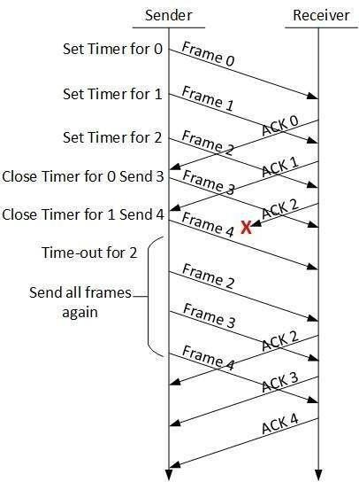

*Fig 2.13 Go-Back-N Automatic Repeat Request*

The sending-window size enables the sender to send multiple frames without receiving the acknowledgement of the previous ones. The receiving-window enables the receiver to receive multiple frames and acknowledge them. The receiver keeps track of incoming frame’s sequence number.

When the sender sends all the frames in window, it checks up to what sequence number it has received positive acknowledgement. If all frames are positively acknowledged, the sender sends next set of frames. If sender finds that it has received NACK or has not receive any ACK for a particular frame, it retransmits all the frames after which it does not receive any positive ACK. **Selective Repeat ARQ**

In Go-back-N ARQ, it is assumed that the receiver does not have any buffer space for its window size and has to process each frame as it comes. This enforces the sender to retransmit all the frames which are not acknowledged.

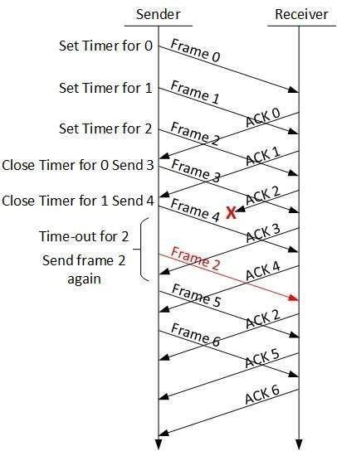

*Fig 2.14 Selective Repeat ARQ*

In Selective-Repeat ARQ, the receiver while keeping track of sequence numbers, buffers the frames in memory and sends NACK for only frame which is missing or damaged.

The sender in this case, sends only packet for which NACK is received.

### High-level Data Link Control (HDLC):

HDLC is a bit-oriented protocol for communication over point - to-point and multipoint links. It implements the Stop-and- Wait protocol we discussed earlier. Although this protocol is more a theoretical issue than practical, most of the concept defined in this protocol is the basis for other practical protocols such as PPP, which we discuss next, or the Ethernet protocol.

Configurations and Transfer Modes HDLC provides two common transfer modes that can be used in different configurations:

Normal response mode (NRM) and Asynchronous balanced mode (ABM) In normal response mode (NRM), the station configuration is unbalanced. We have one primary station and multiple secondary stations. A primary station can send commands; a secondary station can only respond. The NRM is used for both point-to-point and multipoint links, as shown in below

Figure. In ABM, the configuration is balanced. The link is point-to-point, and each station can function as a primary and a secondary (acting as peers) this is the common mode today.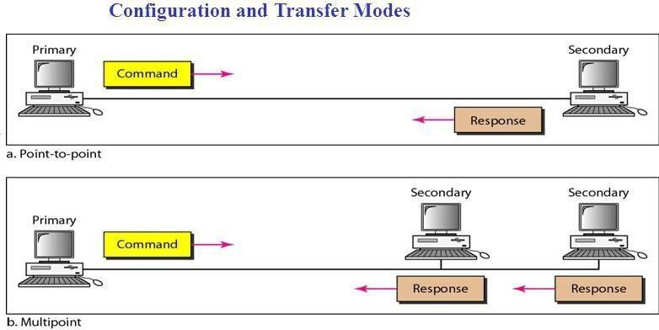

*Fig 2.15 Normal response mode (NRM)*

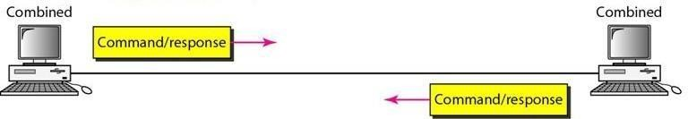

*Fig 2.16 Asynchronous balanced mode (ABM)*

link itself. Each frame in HDLC may contain up to six fields: a beginning flag field, an address field, a control field, an information field, a frame check sequence (FCS) field, and an ending flag field. In multiple-frame transmissions, the ending flag of one frame can serve as the beginning flag of the next frame.

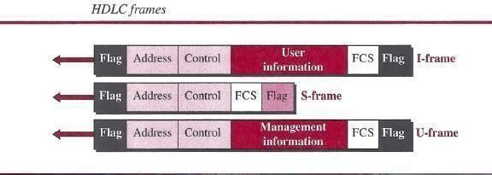

*Fig 2.17 HDLC Frame*

### Let us now discuss the fields and their use in different frame types.

1. D *Flag field.* This field contains synchronization pattern 01111110, which identifies both the beginning and the end of a frame.
2. D *Address field.* This field contains the address of the secondary station. If a primary station created the frame, it contains a *to* address. If a secondary station creates the frame, it contains *a from* address. The address field can be one byte or several bytes long,

depending on the needs of the network.

***Control field****.* The control field is one or two bytes used for flow and error control. ***Information field.*** The information field contains the user's data from the network layer or management information. Its length can vary from one network to another.

***FCS field****.* The frame check sequence (FCS) is the HDLC error detection field. It can contain either a 2- or 4-byte CRC.

The control field determines the type of frame and defines its functionality. So let us discuss the format of this field in detail. The format is specific for the type of frame, as shown in below Figure.

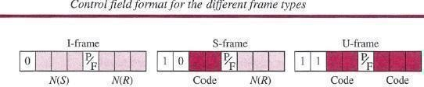

#### Control Field for I-Frames

1. frames are designed to carry user data from the network layer. In addition, they can include flow- and error-control information (piggybacking). The subfields in the control field are used to define these functions. The first bit defines the type. If the first bit of the control field is 0, this means the frame is an I-frame. The next 3 bits, called *N(S),* define the sequence number of the frame. Note that with 3 bits, we can define a sequence number between 0 and 7. The last 3 bits, called *N(R),* correspond to the acknowledgment number when piggybacking is used. The single bit between *N(S)* and *N(R)* is called the *PIF* bit. The *PIF* field is a single bit with a dual purpose. It has meaning only when it is set (bit = 1) and can mean poll or final. It means *poll* when the frame is sent by a primary station to a secondary (when the address field contains the address of the receiver). It means *final* when the frame is sent by a secondary to a primary (when the address field contains the address of the sender).

#### Control Field for S-Frames

Supervisory frames are used for flow and error control whenever piggybacking is either impossible or inappropriate. S-frames do not have information fields. If the first 2 bits of the control field are 10, this means the frame is an S-frame. The last 3 bits, called *N(R),* correspond to the acknowledgment number (ACK) or negative acknowledgment number (NAK), depending

on the type of S-frame. The 2 bits called *code* are used to define the type of S-frame itself. With 2 bits, we can have four types of S-frames, as described below:

* ***Receive ready (RR)*** If the value of the code subfield is 00, it is an RR S-frame. This kind of frame acknowledges the receipt of a safe and sound frame or group of frames. In this case, the value of the *N(R)* field defines the acknowledgment number.
* ***Receive not ready (RNR)*** If the value of the code subfield is 10, it is an RNR S frame. This kind of frame is an RR frame with additional functions. It acknowledges the receipt of a frame or group of frames, and it announces that the

receiver is busy and cannot receive more frames. It acts as a kind of congestion- control mechanism by asking the sender to slow down. The value of *N(R)* is the acknowledgment number.

* ***Reject (REJ)*** If the value of the code subfield is 01, it is an REJ S-frame. This is a NAK frame, but not like the one used for Selective Repeat ARQ. It is a NAK that can be used in *Go-Back-N* ARQ to improve the efficiency of the process by informing the sender, before the sender timer expires, that the last frame is lost or damaged. The value of *N(R)* is the negative acknowledgment number.
* ***Selective reject (SREJ)*** If the value of the code subfield is 11, it is an SREJ S frame. This is a NAK frame used in Selective Repeat ARQ. Note that the HDLC Protocol uses the term *selective reject* instead of *selective repeat.* The value of *N(R)* is the negative acknowledgment number.

#### Control Field or V-Frames

Unnumbered frames are used to exchange session management and control information between connected devices. Unlike S-frames, U-frames contain an information field, but one used for system management information, not user data. As with S-frames, however, much of the information carried by If-frames is contained in codes included in the control field. If-frame codes are divided into two sections: a 2-bit prefix before the *PI* F bit and a 3-bit suffix after the *PIP* bit. Together, these two segments (5 bits) can be used to create up to 32 different types of U- frames.

#### Control Field for V-Frames

Unnumbered frames are used to exchange session management and control information between connected devices. Unlike S-frames, U-frames contain an information field, but one used for system management information, not user data. As with S-frames, however, much of the

information carried by U- frames is contained in codes included in the control field. U-frame codes are divided into two sections: a 2-bit prefix before the *PIP* bit and a 3-bit suffix after the *P/F* bit. Together, these two segments (5 bits) can be used to create up to 32 different types of If- frames.

### POINT-TO-POINT PROTOCOL (PPP)

One of the most common protocols for point-to-point access is the **Point-to-Point Protocol (PPP).** Today, millions of Internet users who need to connect their home computers to the server of an Internet service provider use PPP. The majority of these users have a traditional modem; they are connected to the Internet through a telephone line, which provides the services of the physical layer. But to control and manage the transfer of data, there is a need for a point-to-point protocol at the data-link layer. PPP is by far the most common.

### Services

The designers of PPP have included several services to make it suitable for a point-to point protocol, but have ignored some traditional services to make it simple.

#### Services Provided by PPP

PPP defines the format of the frame to be exchanged between devices. It also defines how two devices can negotiate the establishment of the link and the exchange of data. PPP is designed to accept payloads from several network layers (not only IP). Authentication is also provided in the protocol, but it is optional. The new version of PPP, called *Multilink PPP,* provides connections over multiple links. One interesting feature of PPP is that it provides network address configuration. This is particularly useful when a home user needs a temporary network address to connect to the Internet.

### Framing

**PPP** uses a character-oriented (or byte-oriented) frame. Below figure shows the format of a

**PPP** frame. The description of each field follows:

* ***Flag A*** PPP frame starts and ends with a l-byte flag with the bit pattern 01111110.

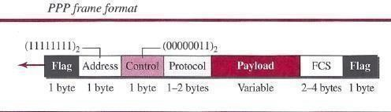

*Fig 2.18 PPP Frame*

o ***Address*** The address field in this protocol is a constant value and set to 11111111 (broadcast address).

* + **D *Control*** *This* field is set to the constant value 00000011 (imitating unnumbered frames in HDLC). As we will discuss later, PPP does not provide any flow control. Error control is also limited to error detection.
  + ***Protocol*** The protocol field defines what is being carried in the data field: either user data or other information. This field is by default 2 bytes long, but the two parties can agree to use only 1 byte.
  + ***Payload field*** This field carries either the user data or other information that we will discuss shortly. The data field is a sequence of bytes with the default of a maximum of 1500 bytes; but this can be changed during negotiation. The data field is byte-stuffed if the flag byte pattern appears in this field. Because there is no field defining the size of the data field, padding is needed if the size is less than the maximum default value or the maximum negotiated value D *FCS.* The frame check sequence (FCS) is simply a 2-byte or 4-byte standard CRC.

#### Byte Stuffing

Since PPP is a byte-oriented protocol, the flag in PPP is a byte that needs to be escaped whenever it appears in the data section of the frame. The escape byte is 01111101, which means that every time the flag like pattern appears in the data, this extra byte is stuffed to tell the receiver that the next byte is not a flag. Obviously, the escape byte itself should be stuffed with another escape byte.

**UNIT-II Part II :** Medium Access sub layer: ALOHA, CSMA/CD, LAN – Ethernet IEEE 802.3, IEEE 802.5 – IEEE 802.11, Random access, Controlled access, Channelization.

### Medium Access sub layer:

**ALOHA:** ALOHA is a system for coordinating and arbitrating access to a shared communication Networks channel. It was developed in the 1970s by Norman Abramson and his colleagues at the University of Hawaii. The original system used for ground based radio broadcasting, but the system has been implemented in satellite communication systems.

A shared communication system like ALOHA requires a method of handling collisions that occur when two or more systems attempt to transmit on the channel at the same time. In the ALOHA system, a node transmits whenever data is available to send. If another node transmits at the same time, a collision occurs, and the frames that were transmitted are lost. However, a node

can listen to broadcasts on the medium, even its own, and determine whether the frames were transmitted.

**Aloha means "Hello".** Aloha is a multiple access [protocol](http://ecomputernotes.com/computernetworkingnotes/computer-network/protocol) at the data link layer and proposes how multiple terminals access the medium without interference or collision. In 1972 Roberts developed a protocol that would increase the capacity of aloha two fold. The Slotted Aloha protocol involves dividing the time interval into discrete slots and each slot interval corresponds to the time period of one frame. This method requires synchronization between the sending nodes to prevent collisions.

There are two different versions of ALOHA

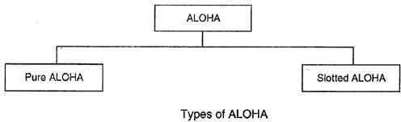

*Fig 2.19 versions of ALOHA*

### Pure ALOHA

* **In** pure ALOHA, the stations transmit frames whenever they have data to send.
* When two or more stations transmit simultaneously, there is collision and the frames are destroyed.

In pure ALOHA, whenever any station transmits a frame, it expects the acknowledgement from the receiver.

* If acknowledgement is not received within specified time, the station assumes that the frame (or acknowledgement) has been destroyed.
* If the frame is destroyed because of collision the station waits for a random amount of time and sends it again. This waiting time must be random otherwise same frames will collide again and again.
* Therefore pure ALOHA dictates that when time-out period passes, each station must wait for a random amount of time before resending its frame. This randomness will help avoid more collisions.
* Figure shows an example of frame collisions in pure ALOHA.

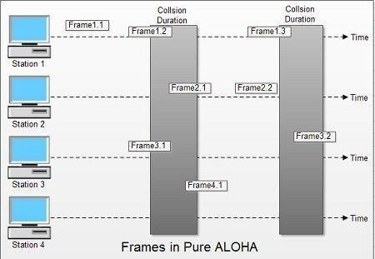

*Fig 2.20 Pure ALOHA*

* In fig there are four stations that .contended with one another for access to shared channel. All these stations are transmitting frames. Some of these frames collide because multiple frames are in contention for the shared channel. Only two frames, frame 1.1 and frame 2.2 survive. All other frames are destroyed.
* Whenever two frames try to occupy the channel at the same time, there will be a collision and both will be damaged. If first bit of a new frame overlaps with just the last bit of a frame almost finished, both frames will be totally destroyed and both will have to be retransmitted.

### Slotted ALOHA

* Slotted ALOHA was invented to improve the efficiency of pure ALOHA as chances of collision in pure ALOHA are very high.
* In slotted ALOHA, the time of the shared channel is divided into discrete intervals called slots.
* The stations can send a frame only at the beginning of the slot and only one frame is sent in each slot.

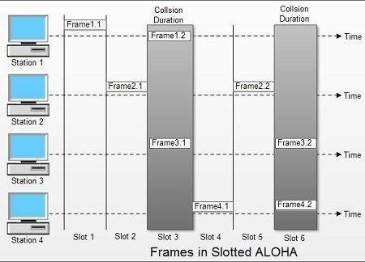

*Fig 2.21 Slotted ALOHA*

* In slotted ALOHA, if any station is not able to place the frame onto the channel at the beginning of the slot *i.e.* it misses the time slot then the station has to wait until the beginning of the next time slot.
* In slotted ALOHA, there is still a possibility of collision if two stations try to send at the beginning of the same time slot as shown in fig.
* Slotted ALOHA still has an edge over pure ALOHA as chances of collision are reduced to one- half.

### Carrier Sensed Multiple Access (CSMA):

CSMA is a network access method used on shared network topologies such as Ethernet to control access to the network. Devices attached to the network cable listen (carrier sense) before transmitting. If the channel is in use, devices wait before transmitting. MA (Multiple Access) indicates that many devices can connect to and share the same network. All devices have equal access to use the network when it is clear.

CSMA [protocol](http://ecomputernotes.com/computernetworkingnotes/computer-network/protocol) was developed to overcome the problem found in ALOHA i.e. to minimize the chances of collision, so as to improve the performance. CSMA protocol is based on the principle of 'carrier sense'. The station senses the carrier or channel before transmitting a frame. It means the station checks the state of channel, whether it is idle or busy. Even though devices attempt to sense whether the network is in use, there is a good chance that two stations will attempt to access it at the same time. On large networks, the transmission time between one end of the cable and another is enough that one station may access the cable even though another has already just accessed it.

The chances of collision still exist because of propagation delay. The frame transmitted by one station takes some time to reach other stations. In the meantime, other stations may sense the channel to be idle and transmit their frames. This results in the collision.

### There Are Three Different Type of CSMA Protocols

(I) I-persistent CSMA

1. Non- Persistent CSMA
2. p-persistent CSMA

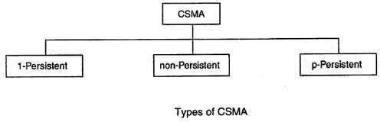

*Fig 2.22 Type of CSMA*

### I-persistent CSMA

* In this method, station that wants to transmit data continuously senses the channel to check whether the channel is idle or busy.
* If the channel is busy, the station waits until it becomes idle.
* When the station detects an idle-channel, it immediately transmits the frame with probability 1. Hence it is called I-persistent CSMA.
* This method has the highest chance of collision because two or more stations may find channel to be idle at the same time and transmit their frames.
* When the collision occurs, the stations wait a random amount of time and start allover again. Drawback of I-persistent
* The propagation delay time greatly affects this protocol. Let us suppose, just after the station I begins its transmission, station 2 also became ready to send its data and senses the channel. If the station I signal has not yet reached station 2, station 2 will sense the channel to be idle and will begin its transmission. This will result in collision.

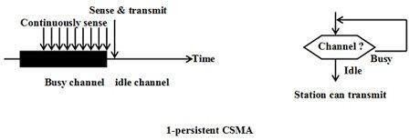

*Fig 2.23 I-persistent CSMA*

Even if propagation delay time is zero, collision will still occur. If two stations became .ready in the middle of third station's transmission, both stations will wait until the transmission of first

station ends and then both will begin their transmission exactly simultaneously. This will also result in collision.

### Non-persistent CSMA

* In this scheme, if a station wants to transmit a frame and it finds that the channel is busy (some other station is transmitting) then it will wait for fixed interval oftime.
* After this time, it again checks the status of the channel and if the channel is.free it will transmit.
* A station that has a frame to send senses the channel.
* If the channel is idle, it sends immediately.
* If the channel is busy, it waits a random amount of time and then senses the channel again.
* In non-persistent CSMA the station does not continuously sense the channel for the purpose of capturing it when it detects the end of previous transmission.

### Advantage of non-persistent

* It reduces the chance of collision because the stations wait a random amount of time. It is unlikely that two or more stations will wait for same amount of time and will retransmit at the same time.

### Disadvantage of non-persistent

* It reduces the efficiency of network because the channel remains idle when there may be stations with frames to send. This is due to the fact that the stations wait a random amount of time after the collision.

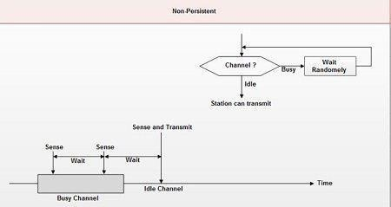

*Fig 2.24* Non-persistent CSMA

### p-persistent CSMA

* This method is used when channel has time slots such that the time slot duration is equal to or greater than the maximum propagation delay time.
* Whenever a station becomes ready to send, it senses the channel.
* If channel is busy, station waits until next slot.
* If channel is idle, it transmits with a probability p.
* With the probability q=l-p, the station then waits for the beginning of the next time slot.
* If the next slot is also idle, it either transmits or waits again with probabilities p and q.
* This process is repeated till either frame has been transmitted or another station has begun transmitting.
* In case of the transmission by another station, the station acts as though a collision has occurred and it waits a random amount of time and starts again.

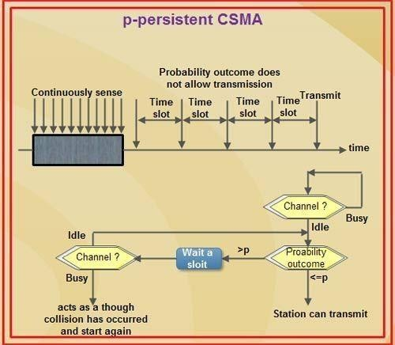

*Fig 2.25 p-persistent CSMA*

### Advantage of p-persistent

* It reduces the chance of collision and improves the efficiency of the network.

[**Carrier Sense Multiple Access with Collision Detection (CSMA/CD)**](http://ecomputernotes.com/computernetworkingnotes/multiple-access/carrier-sense-multiple-access-with-collision-detection)**:**

To reduce the impact of collisions on the network performance, Ethernet uses an algorithm called CSMA with Collision Detection (CSMA / CD): CSMA/CD is a [protocol](http://ecomputernotes.com/computernetworkingnotes/computer-network/protocol) in which the station senses the carrier or channel before transmitting frame just as in persistent and non-persistent CSMA. If the channel is busy, the station waits. it listens at the same time on communication media to ensure that there is no collision with a packet sent by another station. In a collision, the issuer immediately cancel the sending of the package. This allows to limit the duration of collisions: we do not waste time to send a packet complete if it detects a collision. After a

collision, the transmitter waits again silence and again, he continued his hold for a random number; but this time the random number is nearly double the previous one: it is this called back- off (that is to say, the "decline") exponential. In fact, the window collision is simply doubled (unless it has already reached a maximum). From a packet is transmitted successfully, the window will return to its original size.

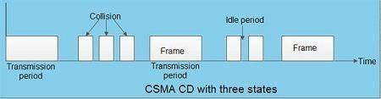

The entire scheme of CSMA/CD is depicted in the fig.

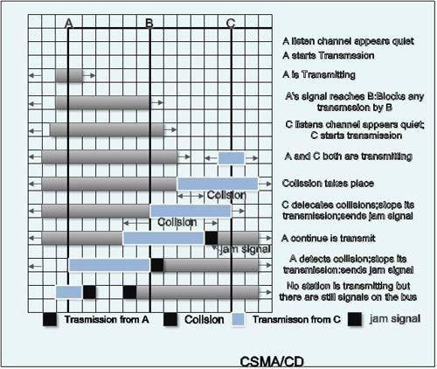

*Fig 2.26* CSMA/CD

### format of CSMA/CD

The frame format specified by IEEE 802.3 standard contains following fields.

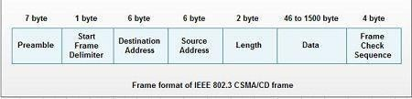

*Fig 2.27* ***format of CSMA/CD***

### CSMA/CD Procedure:

Fig.2.28 Shows a flow chart for the *CSMA/CD* protocol.

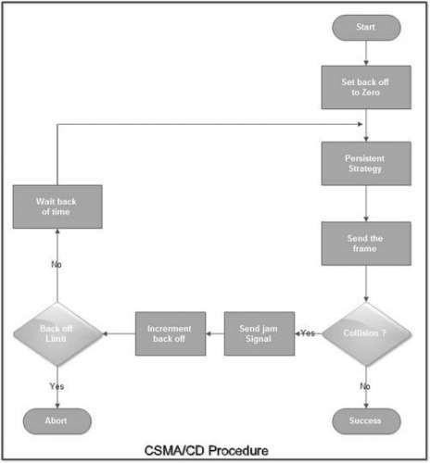

### Explanation:

* The station that has a ready frame sets the back off parameter to zero.
* Then it senses the line using one of the persistent strategies.
* If then sends the frame. If there is no collision for a period corresponding to one complete frame, then the transmission is successful.
* Otherwise the station sends the jam signal to inform the other stations about the collision.
* The station then increments the back off time and waits for a random back off time and sends the frame again.
* If the back off has reached its limit then the station aborts the transmission.
* *CSMA/CD* is used for the traditional Ethernet.
* *CSMA/CD* is an important protocol. IEEE 802.3 (Ethernet) is an example of *CSMNCD.* It is an international standard.
* The MAC sublayer protocol does not guarantee reliable delivery. Even in absence of collision the receiver may not have copied the frame correctly.

### IEEE 802.3(Ethernet)

**IEEE 802.3 Local Area Network (LAN) Protocols (**Ethernet [protocol](http://ecomputernotes.com/computernetworkingnotes/computer-network/protocol)) refer to the family of local-area network (LAN) technology covered by the I**EEE 802.3**. It is working example of the more general carrier sense multiple access with collision detect (CSMA/CD). In the Ethernet Computer Network standard, there are two modes of operation: **half-duplex and full-duplex modes**. In the half duplex mode, data are transmitted using the popular Carrier-Sense Multiple Access/Collision Detection (CSMA/CD) protocol on as shared medium.

The main disadvantages of the half-duplex are the efficiency and distance limitation, in which the link distance is limited by the minimum MAC frame size. This restriction reduces the efficiency drastically for high-rate transmission. Therefore, the carrier extension technique is used to ensure the minimum frame size of 512 bytes in Gigabit Ethernet to achieve a reasonable link distance. Four data rates are currently defined for operation over optical fiber and twisted-pair cables:

* 10 Mbps - 10Base-T Ethernet (IEEE 802.3)
* 100 Mbps - Fast Ethernet (IEEE 802.3u)
* 1000 Mbps - Gigabit Ethernet (IEEE 802.3z)
* 10-Gigabit - 10 Gbps Ethernet (IEEE 802.3ae).

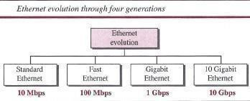

The Ethernet is a multi-access network, meaning that a set of nodes send and receive frames over a shared link you can, therefore, think of an Ethernet or being like a bus that has multiple stations plugged into it. The "**carrier sense**" in CSMA/CD means that all the nodes can distinguish between an idle and a busy link and "**collision detect**" means that a node listens as it transmits and can therefore detect when a frame it is transmitting has collided with a frame transmitted by another node.

The Ethernet has its root in an early packet radio network, called ALOHA, like, the ALOHA, the problem faced by the Ethernet is how to mediate access to a shared medium fairly and efficiently. In ALOHA, the medium was the atmosphere, while in Ethernet the medium is coax cable.

In the earliest days, 10-Mbps Ethernet war used, but now it has been extended to include a 100- Mbps version called Fast Ethernet and a 1000-Mbps version called Gigabit Ethernet.

### The Ethernet System consists of three basic elements

1. The physical medium used to carry Ethernet signals between computers,
2. a set of medium access control rules embedded in each Ethernet interface that allow multiple computers to fairly arbitrate access to the shared Ethernet channel, and
3. An Ethernet frame that consists of a standardized set of bits used to carry data over the system.

### IEEE 802.5 (Token Ring)

IEEE 802.5 Token Ring: Token ring is the IEEE 802.5 standard for a token-passing ring in Communication networks. A ring consists of a collection of ring interfaces connected by point- to-point lines *i.e.* ring interface of one station is connected to the ring interfaces of its left station as well as right station. Internally, signals travel around the Communication network from one station to the next in a ring.

These point-to-point links can be created with twisted pair, coaxial cable or fiber optics. Each bit arriving at an interface is copied into a 1-bit buffer. In this buffer the bit is checked and may be modified and is then copied out to the ring again. This copying of bit in the buffer introduces a 1-bit delay at each interface.

Token Ring is a LAN [protocol](http://ecomputernotes.com/computernetworkingnotes/computer-network/protocol) defined in the IEEE 802.5 where all stations are connected in a ring and each station can directly hear transmissions only from its immediate neighbor. Permission to transmit is granted by a message (token) that circulates around the ring. A token is a special bit pattern (3 bytes long). There is only one token in the network.

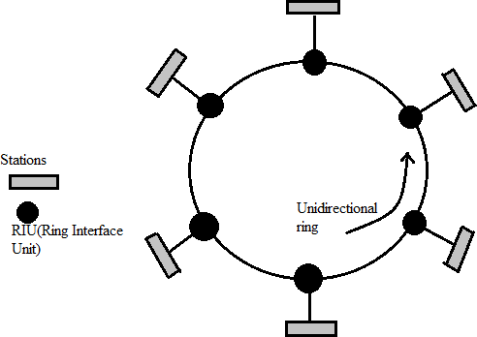

*Fig 2.30 IEEE 802.5 (Token Ring)*

Token-passing networks move a small frame, called a token, around the network. Possession of the token grants the right to transmit. If a node receiving the token in order to transmit data, it seizes the token, alters 1 bit of the token (which turns the token into a start-of-frame sequence), appends the [information](http://ecomputernotes.com/fundamental/information-technology/what-do-you-mean-by-data-and-information) that it wants to transmit, and sends this information to the next station on the ring. Since only one station can possess the token and transmit data at any given time, there are no collisions.

There are two operating modes of ring interfaces. There are listen and transmit. In listen mode, the input bits are simply copied to output with a delay of 1- bit time. In transmit mode the connection between input and output is broken by the interface so that is can insert its own data. The station comes in transmit mode when it captures the token.

The frames are acknowledged by the destination in a very simple manner. The sender sends frames to receiver with ACK bit 0. The receiver on receiving frames, copies data into its buffer, verifies the checksum and set the ACK bit to 1. The verified frames come back to sender, where they are removed from the ring.

The information frame circulates the ring until it reaches the intended destination station, which copies the information for further processing. The information frame continues to circle the ring and is finally removed when it reaches the sending station. The sending station can check the returning frame to see whether the frame was seen and subsequently copied by the destination.

A station can hold a token for a specific duration of time. During this time, it has to complete its transmission and regenerates the token in ring. Whenever a station finishes its transmissions, the other station grabs the token and starts its own transmission.

### IEEE 802.11(wireless LAN)

* IEEE 802.11 is a set of media access control (MAC) and physical layer (PHY) specifications for implementing wireless local area network(WLAN) computer communication in the 900 MHz and 2.4, 3.6, 5, and 60 GHz frequency bands
* The IEEE developed an international standard for WLANs. The 802.11 standard focuses on the bottom two layers of the OSI model, the physical layer (PHY) and data link layer (DLL).
* The objective of the IEEE 802.11 standard was to define a medium access control (MAC) sublayer, MAC management protocols and services, and three PHYs for wireless connectivity of fixed, portable, and moving devices within a local area.
* The three physical layers are an IR baseband PHY, an FHSS radio in the 2.4 GHz band, and a DSSS radio in the 2.4 GHz.

**802.11 Features:**

* CSMA/CA based MAC protocol
* DCF (Distributed Coordination Function)
* Support for both time-critical
* PCF( Point Coordination Function) and non-critical traffic (DCF)
* Support multiple priority levels
* Spread spectrum technology (no licensing) power management allows a node to doze off

**IEEE 802.11 Architecture:**

The architecture of the IEEE 802.11 WLAN is designed to support a network where most decision making is distributed to mobile stations. Two network architectures are defined in the IEEE 802.11 standard:

* **Infrastructure network:** An infrastructure network is the network architecture for providing communication between wireless clients and wired network resources. The transition of data from the wireless to wired medium occurs via an AP. An AP and its associated wireless clients define the coverage area. Together all the devices form a basic service set (see Figure 2.31).
* **Point-to-point (ad hoc) network:** An ad hoc network is the architecture that is used to support mutual communication between wireless clients. Typically, an ad hoc network is created spontaneously and does not support access to wired networks. An ad hoc network does not require an AP.

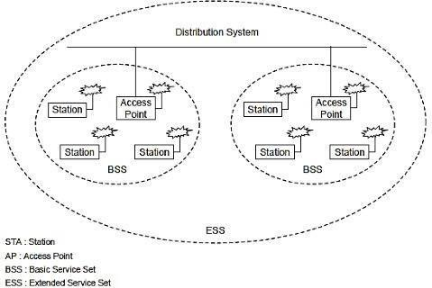

*Fig.2.31 IEEE 802.11 Architecture*

**802.11 Physical Layer (PHY):**

* At the physical layer, IEEE 802.11 defines three physical characteristics for WLANs:
* Diffused infrared (baseband), DSSS, and FHSS. All three support a 1 to 2 Mbps data rate. Both DSSS and FHSS use the 2.4 GHz ISM band (2.4–2.4835 GHz). The physical layer provides three levels of functionality.
* These include: (1) frame exchange between the MAC and PHY under the control of the physical layer convergence procedure (PLCP) sublayer; (2) use of signal carrier and spread spectrum (SS) modulation to transmit data frames over the media under the control of the physical medium dependent (PMD) sublayer; and (3) providing a carrier sense indication back to the MAC to verify activity on the media (see Figure 2.32).

**DSSS PHY:**

* In the DSSS PHY, data transmission over the media is controlled by the PMD sublayer as directed by the PLCP sublayer. The PMD sublayer takes the binary information bits from the PLCP protocol data unit (PPDU) and converts them into RF signals by using modulation and DSSS techniques (see Figure 2).
* In the PPDU frame, which consists of a PLCP preamble, PLCP header, and MAC protocol data unit (MPDU). The PLCP preamble and PLCP header are always transmitted at 1 Mbps, and the MPDU can be sent at 1 or 2 Mbps.
* The start of frame delimiter (SFD) contains information that marks the start of the PPDU frame. The SFD specified is common for all IEEE 802.11 DSSS radios.
* The signal field indicates which modulation scheme should be used to receive the incoming MPDU. The binary value in this field is equal to the data rate multiplied by 100 kbps.
* The service field is reserved for future use. The length field indicates the number of microseconds necessary to transmit the MPDU. The MAC layer uses this field to determine the end of a PPDU frame.
* The CRC field contains the results of a calculated frame check sequence from the sending station.

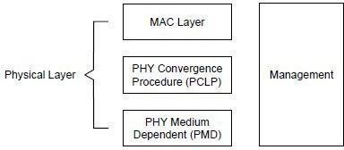

*Fig.2.32 OSI Model IEEE 802.11 Architecture*

**FHSS PHY:**

* In FHSS PHY, data transmission over media is controlled by the FHSS PMD sublayer as directed by the FHSS PLCP sublayer. The FHSS PMD takes the binary information bits from the whitened PSDU and converts them into RF signals by using carrier modulation and FHSS techniques.
* The format of the PPDU is shown in Figure 3. It is consists of the PLCP preamble, PLCP header, and PLCP service data unit (PSDU). The PLCP preamble is used to acquire the incoming signal and synchronize the receiver’s demodulator.
* The PLCP header contains information about PSDU from the sending physical layer. The PLCP preamble and header are transmitted at 1 Mbps.

### 2.13 Random access, Controlled access

When nodes or stations are connected and use a common link, called a *multipoint* or *broadcast link,* we need a multiple-access protocol to coordinate access to the link.

Many protocols have been devised to handle access to a shared link. All of these protocols belong to a sub layer in the data-link layer called *media access control (MAC).*

We categorize them into three groups:

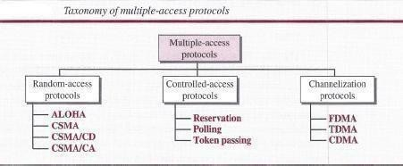

1. The first section discusses random-access protocols. Four protocols, ALOHA, CSMA, *CSMA/CD,* and *CSMA/CA,* are described in this section. These protocols are mostly used in LANs and WANs.
2. The second section discusses controlled-access protocols. Three protocols, reservation, polling, and token-passing, are described in this section. Some of these protocols are used in LANs, but others have some historical value.
3. The third section discusses channelization protocols. Three protocols, FDMA, TDMA, and CDMA are described in this section. These protocols are used in cellular telephony.

**RANDOM ACCESS**: In random-access or contention methods, no station is superior to another station and none is assigned control over another. At each instance, a station that has data to send uses a procedure defined by the protocol to make a decision on whether or not to send. This decision depends on the state of the medium (idle or busy). In other words, each station can transmit when it desires on the condition that it follows the predefined procedure, including testing the state of the medium.

Two features give this method its name:

**First**, there is no scheduled time for a station to transmit. Transmission is random among the stations. That is why these methods are called *random access.*

**Second**, no rules specify which station should send next. Stations compete with one another to access the medium. That is why these methods are also called *contention* methods.

In a random-access method, each station has the right to the medium without being controlled by any other station. However, if more than one station tries to send, there is an access conflict- collision-and the frames will be either destroyed or modified.

**Note**: For **Random Access methods** refer **2.8,2.9** in same notes

### CONTROLLED ACCESS:

In controlled access, the stations consult one another to find which station has the right to send. A station cannot send unless it has been authorized by other stations. We discuss three controlled- access methods.

**Reservation:** In the reservation method, a station needs to make a reservation before sending data. Time is divided into intervals. In each interval, a reservation frame precedes the data frames sent in that interval. If there are *N* stations in the system, there are exactly *N* reservation minislots in the reservation frame. Each minislot belongs to a station. When a station needs to send a data frame, it makes a reservation in its own minislot. The stations that have made reservations can send their data frames after the reservation frame. Below figure shows a situation with five stations and a five-minislot reservation frame. In the first interval, only stations 1, 3, and 4 have made reservations. In the second interval, only station 1 has made a reservation.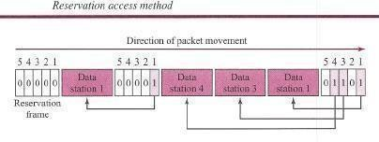

Fig.2.33 Reservation

**Polling:** Polling works with topologies in which one device is designated as a *primary station* and the other devices are *secondary stations.* All data exchanges must be made through the primary device even when the ultimate destination is a secondary device. The primary device controls the link; the secondary devices follow its instructions. It is up to the primary device to determine which device is allowed to use the channel at a given time. The primary device, therefore, is always the initiator of a session This method uses poll and select functions to prevent collisions. However, the drawback is if the primary station fails, the system goes down.

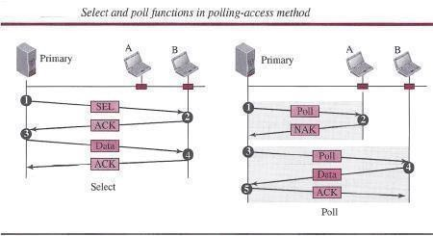

***Select:*** The *select* function is used whenever the primary device has something to send. Remember that the primary controls the link. If the primary is neither sending nor receiving data, it knows the link is available. If it has something to send, the primary device sends it. What it does not know, however, is whether the target device is prepared to receive. So the primary must alert the secondary to the upcoming transmission and wait for an acknowledgment of the secondary's ready status. Before sending data, the primary creates and transmits a select (SEL) frame, one field of which includes the address of the intended secondary.

***Poll:*** The *poll* function is used by the primary device to solicit transmissions from the secondary devices. When the primary is ready to receive data, it must ask (poll) each device in turn if it has anything to send. When the first secondary is approached, it responds either with a NAK frame if it has nothing to send or with data (in the form of a data frame) if it does. If the response is negative (a NAK frame), then the primary polls the next secondary in the same manner until it finds one with data to send. When the response is positive (a data frame), the primary reads the frame and returns an acknowledgment (ACK frame), verifying its receipt.

**Token Passing:** In the token-passing method, the stations in a network are organized in a logical ring. In other words, for each station, there is a *predecessor* and a *successor.* The predecessor is the station which is logically before the station in the ring; the successor is the station which is after the station in the ring. The current station is the one that is accessing the channel now. The right to this access has been passed from the predecessor to the current station. The right will be passed to the successor when the current station has no more data to send.

But how is the right to access the channel passed from one station to another? In this method, a special packet called a *token* circulates through the ring. The possession of the token gives the

station the right to access the channel and send its data. When a station has some data to send, it waits until it receives the token from its predecessor. It then holds the token and sends its data. When the station has no more data to send, it releases the token, passing it to the next logical station in the ring. The station cannot send data until it receives the token again in the next round. In this process, when a station receives the token and has no data to send, it just passes the data to the next station.

Token management is needed for this access method. Stations must be limited in the time they can have possession of the token. The token must be monitored to ensure it has not been lost or destroyed. For example, if a station that is holding the token fails, the token will disappear from the network. Another function of token management is to assign priorities to the stations and to the types of data being transmitted. And finally, token management is needed to make low-priority stations release the token to high-priority stations.

***Logical Ring:*** In a token-passing network, stations do not have to be physically connected in a ring; the ring can be a logical one. Below figure shows four different physical topologies that can create a logical ring.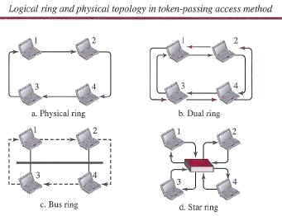

*Fig.2.34 Logical Ring*

In the physical ring topology, when a station sends the token to its successor, the token cannot be seen by other stations; the successor is the next one in line. This means that the token does not have to have the address of the next successor. The problem with this topology is that if one of the links-the medium between two adjacent stations-fails, the whole system fails. The dual ring topology uses a second (auxiliary) ring which operates in the reverse direction compared with the main ring. The second ring is for emergencies only (such as a spare tire for a car).

If one of the links in the main ring fails, the system automatically combines the two rings to form a temporary ring. After the failed link is restored, the auxiliary ring becomes idle again. Note that for this topology to work, each station needs to have two transmitter ports and two receiver ports. The high-speed Token Ring networks called *FDDI (Fiber Distributed Data Interface]* and *CDDI (Copper Distributed Data Interface]* use this topology. In the bus ring topology, also called a token bus, the stations are connected to a single cable called a *bus.* They, however, make a logical ring, because each station knows the address of its successor (and also predecessor for token management purposes). When a station has finished sending its data, it releases the token and inserts the address of its successor in the token.

Only the station with the address matching the destination address of the token gets the token to access the shared media. The Token Bus LAN, standardized by IEEE, uses this topology. In a star and ring topology, the physical topology is a star. There is a hub, however, that acts as the connector. The wiring inside the hub makes the ring; the stations are connected to this ring through the two wire connections. This topology makes the network less prone to failure because if a link goes down, it will be bypassed by the hub and the rest of the stations can operate. Also adding and removing stations from the ring is easier. This topology is still used in the Token Ring LAN designed by IBM.

#### TUTORIAL QUESTIONS

* 1. Demonstrate the access method and frame format used in Ethernet and token ring?
  2. Discuss the working of carrier sense multiple access protocol?
  3. Discuss the MAC layer functions of IEEE 802.11?
  4. What is frame format, operation and ring maintenance feature of IEEE 802.5 MAC protocol?
  5. Elaborate the Working procedure of Stop and wait protocol.
  6. Briefly Discuss Hamming codes and HDLC.

#### ASSIGNMENT QUESTIONS

1. List out the types of Framing.
2. Demonstrate the Types of Errors in detail.
3. State the procedure how errors will detect by using CRC?
4. How performance is improved in CSMA/CD protocol compared to CSMA protocol? Explain?
5. How CSMA/CA differs from CSMA/CD. Explain in brief?

#### IMPORTANT QUESTIONS

***PART-A-UNIT-II* (2 or 3 marks)**

1. Sketch the Manchester encoding for the bit stream: 0001110101.
2. Give the classification of multiple access protocols.
3. Difference between Pure ALOHA and slotted ALOHA.
4. Describe in brief about Types of Ethernet cabling.
5. Briefly discuss about Hamming Codes.
6. What are the two types of errors occurred during data transmission?
7. What is piggybacking?

***PART-B-UNIT-II* (5-10 marks)**

1. What are the functions of medium access control layers protocol? Explain IEEE 802.3 standard for Ethernet with the help of frame format.
2. What is the purpose of CSMA/CD? And Explain it.
3. Write and explain about various multiple access protocols.
4. What are the different types of error detection methods? Explain the CRC error detection technique using generator polynomial x4+x3+1 and data 11100011.
5. Describe Flow and Error Control in detail. Explain sliding window flow control and stop and wait flow control in detail.
6. Discuss the principle of stop and wait flow control algorithm. Draw time line diagrams and explain how loss of a frame and loss of an ACK are handled.
7. How frame order and flow control is achieved using the data link layer?
8. Illustrate the frame structure of IEEE 802.3

#### OBJECTIVE QUESTIONS

* 1. Checksums use arithmetic.

1. one’s complementarithmetic
2. two’s complementarithmetic
3. either (a) or (b)
4. none of the above

### Option A

* 1. In modulo-11 arithmetic, we use only the integers in the range , inclusive.

1. 1 to 10
2. 0 to 10
3. 1 to 11
4. none of the above

### Option B

* 1. In cyclic redundancy checking, thedivisor is the CRC.

1. one bit less than
2. one bit more than
3. The same size as
4. none of the above

### Option B

* 1. The between two words is the number of differences between corresponding bits.

1. Hamming rule
2. Hamming code
3. Hamming distance
4. none of the above

### Option C

* 1. In cyclic redundancy checking, what is the CRC?

1. The quotient
2. The dividend
3. The divisor
4. The remainder

### Option D

* 1. If the Hamming distance between a dataword and the corresponding codeword is three, there are bits in error.

A) 5 B) 4 C) 3 D) none of the above

### Option C

* 1. To guarantee correction of up to 5 errors in all cases, the minimum Hamming distance in a block code must be .

A) 11 B) 6 C) 5 D) none of the above

### Option A

* 1. In block coding, if k = 2 and n = 3, we have invalid code words.

A) 4 B) 8 C) 2 D) none of the above

### Option A

* 1. If an Ethernet destination address is 07:01:02:03:04:05, then this is a address.

A) broadcast B) unicast C) multicast D) any of the above

### Option C

* 1. Gigabit Ethernet has a datarate of Mbps. A) 10,000 B)1000 C)100 D10

### Option B

#### FILL IN THE BLANKS

1. In IEEE 802.11, a station with mobility is either stationary (not moving) or moving only inside a BSS.

**Answer:** no-transition

1. A Bluetooth network consists of primary device(s) and up to _ secondary devices.

**Answer:** one; seven

1. In IEEE 802.11, a BSS with an AP is sometimes referred to as .

**Answer:** an infrastructure network

1. In IEEE 802.11, the _ is a timer used for collision avoidance.

**Answer:** BSS

1. IEEE has defined the specifications for a wireless LAN, called , which covers the physical and data link layers.

**Answer:** IEEE 802.11

### UNIT -III

**Network layer**

### Logical Addressing:

**ADDRESSING:** Four levels of addresses are used in an internet employing the TCP/IP protocols: physical address, logical address, port address, and application-specific address. Each address is related to a one layer in the TCP/IP architecture, as shown in the following Figure3.1.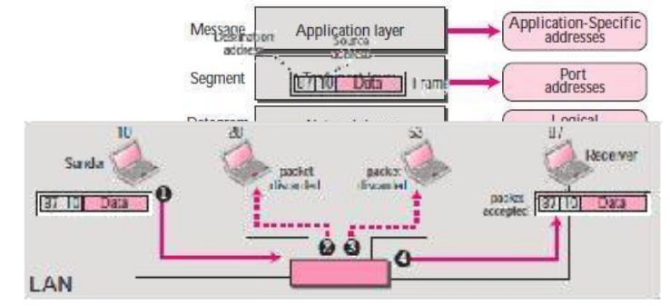

*Fig 3.1 Addressing*

**Physical Addresses:** The physical address, also known as the link address, is the address of a node as defined by its LAN or WAN. It is included in the frame used by the data link layer. It is the lowest-level address. The size and format of these addresses vary depending on the network. For example, Ethernet uses a 6-byte (48-bit) physical address that is imprinted on the network interface card (NIC).

Most local area networks use a 48-bit (6-byte) physical address written as 12 hexadecimal digits; every byte (2 hexadecimal digits) is separated by a colon, as shown below.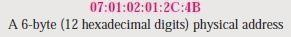

Example (1)

In Figure below a node with physical address 10 sends a frame to a node with physical address The two nodes are connected by a link (a LAN). At the data link layer, this frame contains physical (link) addresses in the header. These are the only addresses needed. The rest of the header contains other information needed at this level. The trailer usually contains extra bits needed for error detection. The data link layer at the sender receives data from an upper layer. It encapsulates the data in a frame, adding a header and a trailer. The header, among other pieces of information, carries the receiver and the sender physical (link) addresses.

Note that in most data link protocols, the destination address 87 in this case, comes before the source address (10 in this case). The frame is propagated through the LAN. Each station with a physical address other than 87 drops the frame because the destination address in the frame does not match its own physical address. The intended destination computer, however, finds a match between the destination address in the frame and its own physical address. The frame is checked, the header and trailer are dropped, and the data part is decapsulated and delivered to the upper layer.

### Unicast, Multicast, and Broadcast Physical Addresses:

Physical addresses can be either unicast (one single recipient), multicast (a group of recipients), or broadcast (to be received by all systems in the network). Some networks support all three addresses.

A source address is always a unicast address—the frame comes from only one station. The destination address, however, can be unicast, multicast, or broadcast. The least significant bit of the first byte defines the type of address.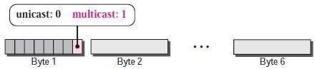

Define the type of the following destination addresses:

1) 4A:30:10:21:10:1A 2)47:20:1B:2E:08:EE 3)FF:FF:FF:FF:FF:FF

**Logical Addresses:** Logical addresses are necessary for universal communications that are independent of underlying physical networks. Physical addresses are not adequate in an internetwork environment where different networks can have different address formats. A universal addressing system is needed in which each host can be identified uniquely, regardless of the underlying physical network. The logical addresses are designed for this purpose. A logical address in the Internet is currently a 32-bit address that can uniquely define a host connected to the Internet. No two publicly addressed and visible hosts on the Internet can have the same IP address.

Example (2)

The Figure below shows a part of an internet with two routers connecting three LANs. Each device (computer or router) has a pair of addresses (logical and physical) for each connection. In this case, each computer is connected to only one link and therefore has only one pair of

addresses. Each router, however, is connected to three networks (only two are shown in the figure). So each router has three pairs of addresses, one for each connection. Although it may be obvious that each router must have a separate physical address for each connection, it may. The computer with logical address

A and physical address 10 needs to send a packet to the computer with logical address P and physical address 95. The sender encapsulates its data in a packet at the network layer and adds two logical addresses (A and P). Note that in most protocols, the logical source address comes before the logical destination address (contrary to the order of physical addresses). The network layer, however, needs to find the physical address of the next hop before the packet can be delivered. The network layer consults its routing table and finds the logical address of the next hop (router 1) to be F.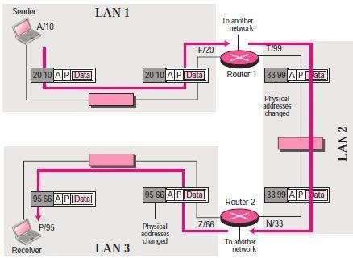

Another protocol, Address Resolution Protocol (ARP) finds the physical address of router 1 that corresponds to its logical address (20). Now the network layer passes this address to the data link layer, which in turn, encapsulates the packet with physical destination address 20 and physical source address 10. The router decapsulates the packet from the frame to read the logical destination address P. Since the logical destination address does not match the router’s logical address, the router knows that the packet needs to be forwarded. The router consults its routing table and ARP to find the physical destination address of the next hop (router 2), creates a new frame, encapsulates the packet, and sends it to router 2.

Note the physical addresses in the frame. The source physical address changes from 10 to

99. The destination physical address changes from 20 (router 1 physical address) to 33 (router 2 physical address). The logical source and destination addresses must remain the same; otherwise the packet will be lost. At router 2 we have a similar scenario. The physical addresses are

changed, and a new frame is sent to the destination computer. When the frame reaches the destination, the packet is decapsulated. The destination logical address P matches the logical address of the computer. The data are decapsulated from the packet and delivered to the upper layer. Note that although physical addresses will change from hop to hop, logical addresses remain the same from the source to destination.

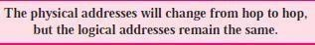

### Unicast, Multicast, and Broadcast Addresses:

The logical addresses can be either unicast (one single recipient), multicast (a group of recipients), or broadcast (all systems in the network).

In order to provide [computer](http://ecomputernotes.com/fundamental/introduction-to-computer/what-is-computer) to computer communication via Internet, we need a global addressing scheme. Such an addressing is provided by Internet Protocol (IP) at the network layer. It is a 32-bit address This is called an **IP address or logical address.** Which is made up of the network ID, plus a unique host ID. This address is typically represented with the decimal value of each octet separated by a period (for example, 192.168.7.27). Every Host and router on

the [internet](http://ecomputernotes.com/computernetworkingnotes/services-and-applications/what-is-internet) has an IP Address. This IP address is unique and no two devices on the Internet can have the same address at the same time.

These numbers are assigned by ISP (Internet Service Provider), and IP address can be used to identify the country or region from which a computer is connecting to the WEB. The IP address can either be Static or dynamic.

In static address is to be given manually. But in dynamic a DHCP server is to be configured to give ip address to the connected hosts automatically. This address is used to uniquely identify each Network host over the network. p address is divided into 5 category usually called classes. This allocation has come to be called class full addressing.

Following are the classes of ip:-

Class A 1.0.0.0 to 127.255.255.255

Class B 128.0.0.0 to 191.255.255.255

Class C 192.0.0.0 to 223.255.255.255

Class D 224.0.0.0 to 239.255.255.255

Class E 240.0.0.0 to 255.255.255.255

Router has more than one IP address because router connects two or more different networks. But A computer or host can only have one and a unique ip address. A routers function is to inspect incoming packet and determine whether it belongs to local network or to a Remote

Network, if a local packet is determined then there is no need of routing and if a Remote packet is determined then it will route that packet according to the routing table, otherwise the packet will be discarded.

In the virtual hosting environment, a single machine can act like multiple machines (with multiple domain names and IP addresses.

IP address format

* The 32-bit IP address is grouped eight bits at a time, separated by dots and represented in decimal format. This is known as dotted decimal notation as shown in fig.
* Each bit in the octet has a binary weight (128,64,32, 16,8,4,2, 1).
* The minimum value for an octet is 0, and the maximum value for an octet is 255.

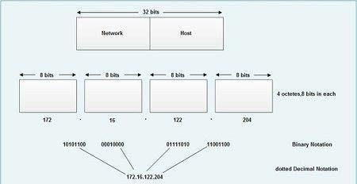

*Fig 3.2 IP Address Format*

### Internetworking

**Internetworking** started as a way to connect disparate types of computer networking technology. Computer network term is used to describe two or more computers that are linked to each other. When two or more computer LANs or WANs or computer network segments are connected using devices such as a *router* and configure by logical addressing scheme with a protocol such as IP, then it is called as **computer internetworking**.

**Internetworking** is a term used by Cisco. Any interconnection among or between public, private, commercial, industrial, or governmental computer networks may also be defined as an internetwork or "**Internetworking**".

In modern practice, the interconnected computer networks or **Internetworking** use the Internet Protocol. Two architectural models are commonly used to describe the protocols and methods used in **internetworking**. The standard reference model for **internetworking** is Open Systems Interconnection (**OSI)**.

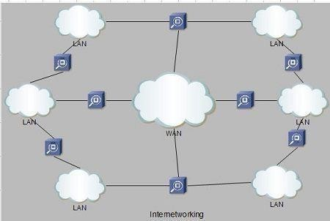

*Fig 3.3 Internetworking*

Type of Internetworking

**Internetworking** is implemented in Layer 3 (Network Layer) of this model The most notable example of internetworking is the Internet (capitalized). There are three variants of internetwork or **Internetworking**, depending on who administers and who participates in them :

* + Extranet **•** Intranet **•** Internet

Intranets and extranets may or may not have connections to the Internet. If connected to the Internet, the intranet or extranet is normally protected from being accessed from the Internet without proper authorization. The Internet is not considered to be a part of the intranet or extranet, although it may serve as a portal for access to portions of an extranet.

### Extranet:

An extranet is a **network of internetwork or Internetworking** that is limited in scope to a **single organization or entity** but which also has **limited connections** to the networks of one or more other usually, but not necessarily, trusted organizations or entities .Technically, an **extranet may also be categorized as a MAN, WAN**, or other type of network, although, by definition, an extranet cannot consist of a single LAN; it must have at least one connection with an external network.

### Intranet:

An intranet is a set of **interconnected networks or Internetworking**, using the I**nternet Protocol** and uses **IP-based tools** such as **web browsers** and **ftp tools**, that is under the control of a **single administrative entity.** That administrative entity closes the intranet to the rest of the world, and allows only specific users. Most commonly, an intranet is the internal network of a company or other enterprise. A large intranet will typically have its **own web server** to provide users with browsable [information.](http://ecomputernotes.com/fundamental/information-technology/what-do-you-mean-by-data-and-information)

### Internet:

A specific **Internetworking**, consisting of a **worldwide interconnection** of governmental, academic, public, and private networks based upon the Advanced Research Projects Agency Network (**ARPANET)** developed by ARPA of the U.S. **Department of Defense** also **home** to the **World Wide Web (WWW)** and referred to as the '**Internet**' with a capital 'I' to distinguish it from other generic internetworks. Participants in the Internet, or their service providers, use IP Addresses obtained from address registries that control assignments.

### Tunneling

* Tunneling is an internetworking strategy that is used when source and destination networks of same type are connected through a network of different type.
* In such a case, the packet from one network reaches the other network via different kind pf network that interconnects them.
* To understand tunneling, let an Ethernet is to be connected to another Ethernet via a WAN.
* The IP packets are to be sent from host 1 of Ethernet 1 to host 2 of Ethernet 2 via a WAN.
* To send an IP packet to host 2, host 1 constructs the packet containing the IP address of host 2.
* It then inserts this packet into an Ethernet frame. This frame is addressed to the multi- [protocol](http://ecomputernotes.com/computernetworkingnotes/computer-network/protocol) router M1 and is placed on Ethernet.
* When this packet reaches, multiprotocol router MI, it removes the IP packet and insert it in the payload field of the WAN network layer packet.
* This WAN network layer packet is then addressed to multi-protocol router M2.
* When this packet reaches M2, it removes the IP packet and inserts it into the Ethernet frame and sends it to host 2.
* In the above process, IP packets do not have to deal with WAN, they just travel from one end 0f the tunnel to the other end. The host 1 and host 2 on two Ethernet also do not have to deal with WAN.
* The multi-protocol routers M1 & M2 understand about IP and WAN packets.

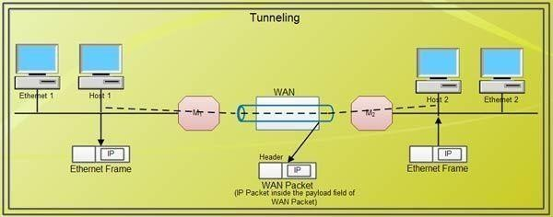

*Fig 3.4 Tunneling*

### Address mapping

IP addresses are assigned independently of the hardware addresses of the machines. To send a datagram on the Internet, the network software must convert the IP address into a physical address, used to transmit the frame.

Address resolution refers to the determination of the address of a device from the address of that equipment to another [protocol](http://ecomputernotes.com/computernetworkingnotes/computer-network/protocol) level. We solve, for example, an IP address in an Ethernet address or an ATM address.

It's **ARP** (*Address Resolution Protocol*) performing this translation between the IP world and Ethernet based on the physical network. ARP enables machines to resolve addresses without using static table that lists all addresses of both worlds. A machine uses ARP to determine the recipient's physical address by broadcasting an ARP request to the subnet containing the IP address to be translated. The machine with the relevant IP address responds with its physical address. To make ARP more efficient, each machine maintains in memory a table of addresses resolved and thus reduces the number of Broadcast emissions.

At the time of initialization (bootstrap), a mass storage without the machine (diskless) should contact their server to determine its IP address and to use the TCP / IP services. **RARP** (*Reverse ARP*) allows a machine to use its physical address to determine its logical address on the Internet. The RARP mechanism allows a [computer](http://ecomputernotes.com/fundamental/introduction-to-computer/what-is-computer) to be identified as a target on the network by broadcasting a RARP request. The servers receiving the message examine their table and meet. Once the IP address obtained, the machine stores it in memory and no longer uses RARP until it is reset.

The ARP protocol is based on the physical network to perform address translation. To determine the recipient's physical address, a machine broadcasts an ARP request on the subnet that contains

the IP address to be translated. The machine with the relevant IP address responds with its physical address. This process is illustrated in Figure.

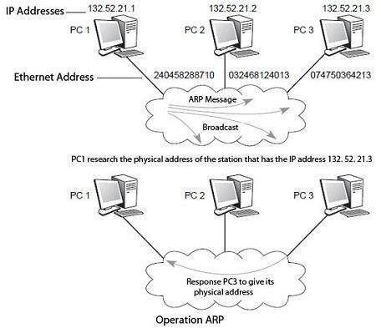

*Fig 3.5* ARP

Inversely, a station that connects to the network can know its own physical address without an IP address. Upon initialization, the machine will contact the server to determine its IP address and can use the TCP / IP services. RARP allows him to use his physical address to obtain its logical address on the Internet. Through the RARP mechanism, a station can be identified as a target on the network by broadcasting a RARP request. The servers receiving the message examine their table and meet. Once the IP address obtained, the machine stores it in memory and no longer uses RARP until it is reset.

In IPv6, ARP and RARP are replaced by a neighbor discovery protocol called Neighbor Discovery (ND), which is a subset of the control protocol ICMP (Internet Control Message Protocol).

### Internet Control Message Protocol (ICMP)

The **Internet Control Message Protocol** (**ICMP**) is an error reporting [protocol](http://ecomputernotes.com/computernetworkingnotes/computer-network/protocol) that is an integral part of the IP protocol. ICMP communicate control data, [information](http://ecomputernotes.com/fundamental/information-technology/what-do-you-mean-by-data-and-information) data, and error recovery data across the network. Problems that are less severe than transmission errors result in error conditions that can be reported. For example, suppose some of the physical paths in Internet fail causing the Internet to be partitioned into two sets of networks with no path between the sets. A datagram sent from a host in one set to a host in other cannot be delivered.

The TCP/IP suite includes a protocol called ICMP that IP uses to send error messages when condition such as the one described above arises. The protocol is required for a standard implementation of IP. We will see that the two protocols are co-dependent. IP uses ICMP when it sends an error message, and ICMP uses IP to transport messages.

**Following is a brief description of some of the error messages defined by ICMP protocol: Source quench message:** Source quench message is request to decrease traffic rate for messages sending to the host(destination). Or we can say, when receiving host detects that rate of sending packets (traffic rate) to it is too fast it sends the source quench message to the source to slow the pace down so that no packet can be lost.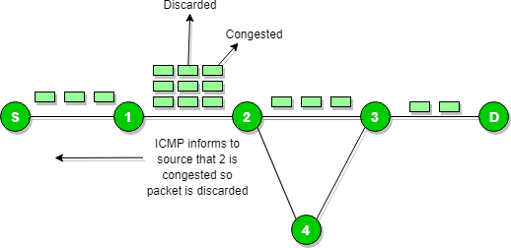

ICMP will take source IP from the discarded packet and informs to source by sending source quench message.

Then source will reduce the speed of transmission so that router will free for congestion.

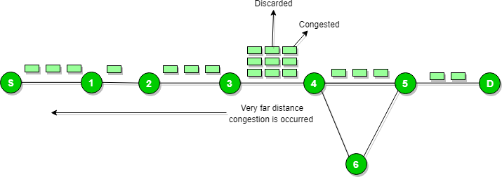

When the congestion router is far away from the source the ICMP will send hop by hop source quench message so that every router will reduce the speed of transmission.

**Parameter problem:** Whenever packets come to the router then calculated header checksum should be equal to received header checksum then only packet is accepted by the router.

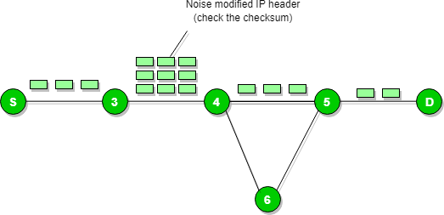

If there is mismatch packet will be dropped by the router.

ICMP will take the source IP from the discarded packet and informs to source by sending parameter problem message.

### Time exceeded message:

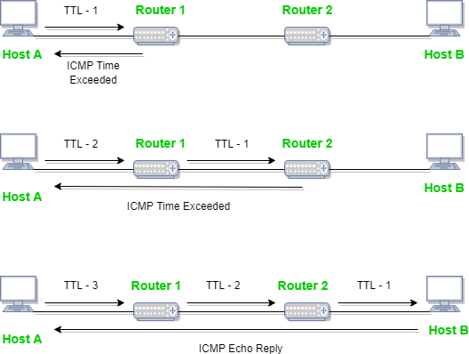

When some fragments are lost in a network then the holding fragment by the router will be dropped then ICMP will take source IP from discarded packet and informs to the source, of discarded datagram due to time to live field reaches to zero, by sending time exceeded message.

**Destination un-reachable:** Destination unreachable is generated by the host or its inbound gateway to inform the client that the destination is unreachable for some reason.

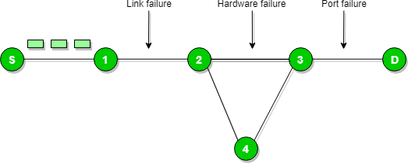

There is no necessary condition that only router give the ICMP error message some time destination host send ICMP error message when any type of failure (link failure, hardware failure, port failure etc.) happen in the network.

**Redirection message:** Redirect requests data packets be sent on an alternate route. The message informs to a host to update its routing information (to send packets on an alternate route).

**Ex.** If host tries to send data through a router R1 and R1 sends data on a router R2 and there is a direct way from host to R2. Then R1 will send a redirect message to inform the host that there is a best way to the destination directly through R2 available. The host then sends data packets for the destination directly to R2.The router R2 will send the original datagram to the intended destination.

But if datagram contains routing information then this message will not be sent even if a better route is available as redirects should only be sent by gateways and should not be sent by Internet hosts.

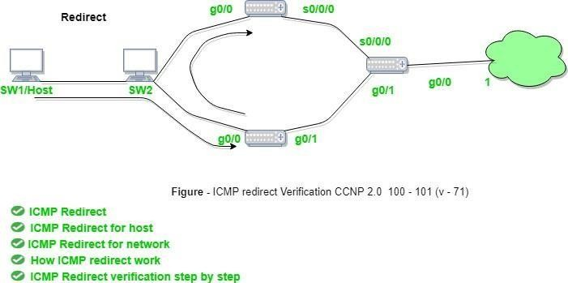

*Fig 3.6* ICMP

Whenever a packet is forwarded in a wrong direction later it is re-directed in a current direction then ICMP will send re-directed message.

### ICMP Message Transport

ICMP uses IP to transport each error message. When a router has an ICMP message to send, it creates datagram and encapsulates the ICMP message in the datagram. It means that the ICMP

message placed in the data area of the IP data gram. The· datagram is forwarded as usual with the complete data gram being encapsulated in a frame for transmission.

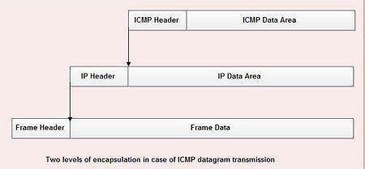

Fig 3.7 ICMP Message Transport

[**Internet Group Management Protocol (IGMP)**](http://ecomputernotes.com/computernetworkingnotes/routing/igmp)

* Internet Group Management Protocol is a group management [protocol](http://ecomputernotes.com/computernetworkingnotes/computer-network/protocol) that mainly manages the group membership in a multicast network.
* In a multicast network, multicast routers are used to route packets to all the computers that are having membership of a particular group.
* The multicast routers use the [information](http://ecomputernotes.com/fundamental/information-technology/what-do-you-mean-by-data-and-information) from IGMP to determine which hosts are having membership of which group.
* A multicast router generally receives thousands of multicast packets that have to be transmitted to various groups. If a router has no knowledge about the group membership, it will broadcast packet to every host and this will increase the load on the network.
* In order to save the network from such a problem, a list of groups IS maintained when members of the group are present in the network.
* Thus, IGMP helps the multicast router to create and update this list.
* This protocol uses three different messages: query message, membership report and leave report.

### Working of IGMP

* The multicast router of the network has a list of multicast address for which the network is having any member.
* There is one multicast router for each group that distributes multicast packet to members of that group. It means the network will have two multicast routers, if there are two multicast groups.
* A host or a multicast router can be a member of the group.
* When a host is having membership, it means that any process running on that host is a member of the group and when a router is having membership of group, it means one of the networks connected to the router is having membership of the group.

### Joining a Group

* Both the host and a router can join a group.
* When a process on the host wants to join a group it sends the request to the host.
* The host adds the name of the process and group name to its list.
* If this is the first entry for that particular group, the host sends *membership report* message to the multicast router of the group.
* If it is not the first entry for the requested group there is no need of sending such amessage.

### Leaving a Group

* Whenever a host sees no process interested in a group, it sends a *leave report* message.
* The membership is not purged by the multicast router of the group, rather it immediately transmits query packets repeatedly to see if anyone still interested.
* If the response comes in the form of membership report message, the membership of the host or network is preserved.

Following diagram shows the architecture of the network for delivering a multicast service using IGMP. IGMP is used by the client computer and the neighbouring switches to connect a client and a local router that implements a multicast. Then between the local and remote routers is used the Protocol Independent Multicast (PIM). With its help the group traffic is routed from the video server to numerous clients of the group transfer.

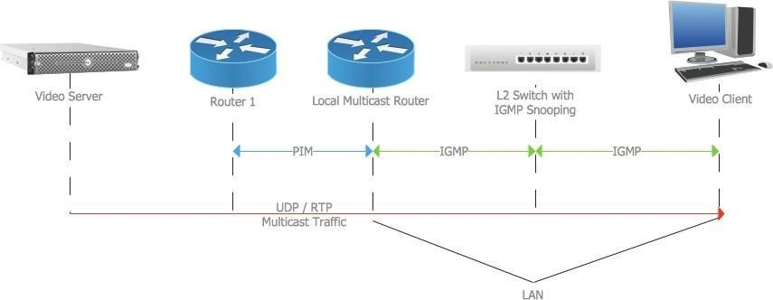

### Forwarding

When a packet arrives at a router’s input link, the router must move the packet to the appropriate output link. For example, a packet arriving from Host H1 to Router R1 must be forwarded to the next router on a path to H2.

**Routing:** The network layer must determine the route or path taken by packets as they flow from a sender to a receiver. The algorithms that calculate these paths are referred to as routing algorithms. A routing algorithm would determine, for example, the path along which packets flow from H1 to H2.

The terms forwarding and routing are often used interchangeably by writers discussing network layers. We’ll use these terms more precisely in this book.

**Forwarding** refers to the router-local action of transferring packet from an input link interface to the appropriate output link interface.

**Routing** refers to the network-wide process that determines the end-to-end paths that packets take from source to destination.

Every router has a **forwarding table**. A router forward a packet by examining the value of a field in the arriving packet’s header, and then using this header value to index into the router’s forwarding table. The value stored in the forwarding table entry for that header indicates the router’s outgoing link interface to which the packet is to be forwarded.

Depending on the network layer protocol, the header value could be the destination address of the packet or an indication of the connection to which the packet belongs. Figure below provides an example.

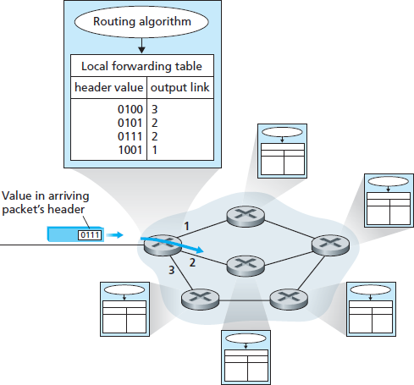

Fig 3.8 Router Forwarding Table

In the above figure, a packet with a header field value of 0111 arrives to a router. The router indexes into its forwarding table and determines that the output link interface for this packet is interface 2. The router then internally forwards the packet to interface 2.

You might be wondering how the forwarding tables in the routers are configured. This is a critical issue, one that exposes the important interplay between routing and forwarding.

As shown in the figure above, the routing algorithm determines the values that are inserted into the routers’ forwarding tables. The routing algorithm may be centralized (e.g. with an algorithm executing on a central site and downloading routing information to each of the routers) or decentralized (i.e. with a piece of the distributed routing algorithm running in each router). In either case, a router receives routing protocol messages, which are used to configure its forwarding table. The distinct and different purposes of the forwarding and routing functions can be further illustrated by considering the hypothetical (and unrealistic, but technically feasible) case of a network in which all forwarding tables are configures directly by human operators physically present at the routers. In this case, no routing protocols would be required! Of course, the human operators would need to interact with each other to ensure that the forwarding tables were configured in such a way that packets reached their intended destinations. It’s also likely that human configuration would be more error-prone and much slower to respond to changes in the network topology than a routing protocol. We’re thus fortunate that all networks have both a forwarding and a routing function!

### Uni-Cast Routing Protocols

A routing table can be either static or dynamic. A static table is one with manual entries. A dynamic table*,* on the other hand, is one that is updated automatically when there is a change somewhere in the internet. Today, an internet needs dynamic routing tables. The tables need to be updated as soon as there is a change in the internet. For instance, they need to be updated when a router is down, and they need to be updated whenever a better route has been found.

1. **Optimization:** A router receives a packet from a network and passes it to another network. A router is usually attached to several networks. One approach is to assign a cost for passing through a network. We call this cost a metric. However, the metric assigned to each network depends on the type of protocol. Some simple protocols, such as the Routing Information Protocol (RIP), treat all networks as equals. The cost of passing through a network is the same; it is one hop count. So if a packet passes through 10 networks to reach the destination, the total cost is 10 hop counts.
2. **Intra- and Inter-domain Routing:** An internet can be so large that one routing protocol cannot handle the task of updating the routing tables of all routers. For this reason, an internet is divided into autonomous systems. An autonomous system (AS) is a group of networks androuters

under the authority of a single administration. Routing inside an autonomous system is referred to as intradomain routing. Routing between autonomous systems is referred to as interdomain routing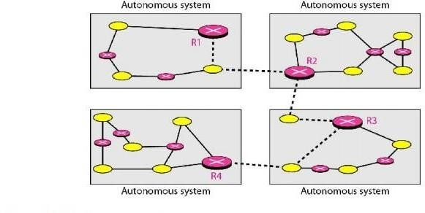

*Fig 3.10 Intra- and Inter-domain Routing*

Several intradomain and interdomain routing protocols are in use.

O Two intradomain routing protocols: Distance vector and link state. O One interdomain routing protocol: path vector.

Routing Information Protocol (RIP) is an implementation of the distance vector protocol. Open Shortest Path First (OSPF) is an implementation of the link state protocol. Border Gateway Protocol (BGP) is an implementation of the path vector protocol.

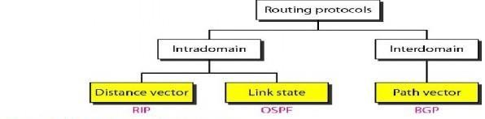

### Distance Vector Routing

In distance vector routing, the least-cost route between any two nodes is the route with minimum distance. In this protocol, as the name implies, each node maintains a vector (table) of minimum distances to every node. The table at each node also guides the packets to the desired node by showing the next stop in the route (next-hop routing).

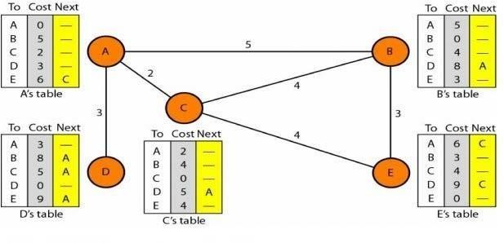

*Fig 3.11 Distance Vector Routing*

The table for node A shows how we can reach any node from this node. For example, our least cost to reach node E is 6. The route passes through C.

**Initialization:** The tables in Figure 3.45 are stable; each node knows how to reach any other node and the cost. At the beginning, however, this is not the case. Each node can know only the distance between itself and its immediate neighbors, those directly connected to it. So for the moment, we assume that each node can send a message to the immediate neighbors and find the distance between itself and these neighbors. The distance for any entry that is not a neighbor is marked as infinite (unreachable).

**Sharing:** The whole idea of distance vector routing is the sharing of information between neighbours. Although node A does not know about node E, node C does. So if node C shares its routing table with A, node A can also know how to reach node E. On the other hand, node C does not know how to reach node D, but node A does. If node A shares its routing table with node C, node C also knows how to reach node D. In other words, nodes A and C, as immediate neighbours, can improve their routing tables if they help each other.

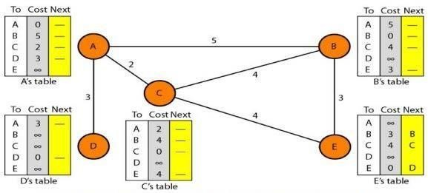

**Updating:** When a node receives a two-column table from a neighbor, it needs to update its routing table. Updating takes three steps:

1. The receiving node needs to add the cost between itself and the sending node to each value in the second column. The logic is clear. If node C claims that its distance to a destination is *x* mi, and the distance between A and C is *y* mi, then the distance between A and that destination, via C, is *x* + *y* mi.
2. The receiving node needs to add the name of the sending node to each row as the third column if the receiving node uses information from any row. The sending node is the next node in the route.
3. The receiving node needs to compare each row of its old table with the corresponding row of the modified version of the received table.
4. If the next-node entry is different, the receiving node chooses the row with the smaller cost. If there is a tie, the old one is kept.
5. If the next-node entry is the same, the receiving node chooses the new row. For example, suppose node C has previously advertised a route to node X with distance 3.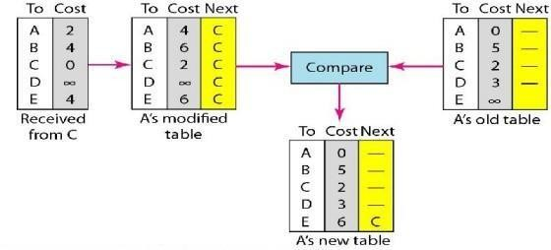

### Two-Node Loop Instability

A problem with distance vector routing is instability, which means that a network using this protocol can become unstable. To understand the problem, let us look at the scenario depicted.

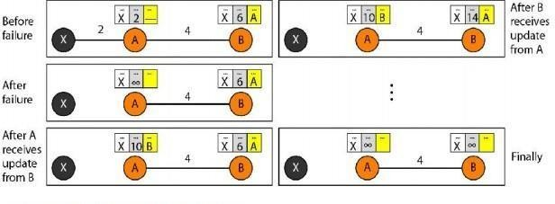

**Defining Infinity** The first obvious solution is to redefine infinity to a smaller number, such as100. For our previous scenario, the system will be stable in less than 20 update s. As a matter of fact, most implementations of the distance vector protocol define the distance between each node to be I and define 16 as infinity. However, this means that the distance vector routing cannot be used in large systems. The size of the network, in each direction, cannot exceed 15 hops.

**Split Horizon** Another solution is called split horizon. In this strategy, instead of flooding the table through each interface, each node sends only part of its table through each interface. If, according to its table, node B thinks that the optimum route to reach X is via A, it does not need to advertise this piece of information to A; the information has come from A (A already knows). Taking information from node A, modifying it, and sending it back to node A creates the confusion. In our scenario, node B eliminates the last line of its routing table before it sends it to

1. In this case, node A keeps the value of infinity as the distance to X.

### Link State Routing

Link state routing has a different philosophy from that of distance vector routing. In link state routing, if each node in the domain has the entire topology of the domain the list of nodes and links, how they are connected including the type, cost (metric), and condition of the links (up or down)-the node can use Dijkstra's algorithm to build a routing table.

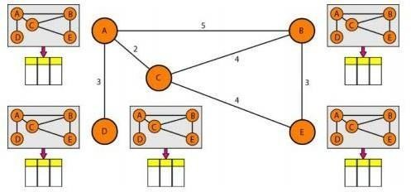

*Figure 3.12 : Concept of link state routing*

The figure2.13 shows a simple domain with five nodes. Each node uses the same topology to create a routing table, but the routing table for each node is unique because the calculations are based on different interpretations of the topology. This is analogous to a city map. While each person may have the same map, each needs to take a different route to reach her specific destination

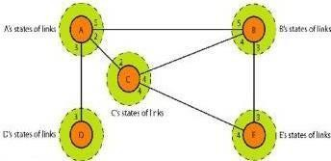

*Figure 3.13: Simple Domain With Five Nodes*

### Building Routing Tables:

**In link state routing,** four sets of actions are required to ensure that each node has the routing table showing the least-cost node to every other node.

1. Creation of the states of the links by each node, called the link state packet (LSP).
2. Dissemination of LSPs to every other router, called **flooding,** in an efficient and reliableway.
3. Formation of a shortest path tree for each node.
4. Calculation of a routing table based on the shortest path tree.

### Types of Links

In OSPF terminology, a connection is called a *link.* Four types of links have been defined: point- to-point, transient, stub, and virtual.

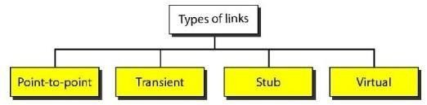

### Figure: Types of links

A point-to-point link connects two routers without any other host or router in between. In other words, the purpose of the link (network) is just to connect the two routers. An example of this type of link is two routers connected by a telephone line or a T line. There is no need to assign a network address to this type of link. Graphically, the routers are represented by nodes, and the link is represented by a bidirectional edge connecting the nodes. The metrics, which are usually the same, are shown at the two ends, one for each direction. In other words, each router has only one neighbor at the other side of the link.

### Path Vector Routing

Distance vector and link state routing are both intradomain routing protocols. They can be used inside an autonomous system, but not between autonomous systems. These two protocols are not suitable for interdomain routing mostly because of scalability. Both of these routing protocols become intractable when the domain of operation becomes large. Distance vector routing is subject to instability if there are more than a few hops in the domain of operation. Link state routing needs a huge amount of resources to calculate routing tables. It also creates heavy traffic because of flooding. There is a need for a third routing protocol which we call path vector routing. Path vector routing proved to be useful for interdomain routing. The principle of path vector routing is similar to that of distance vector routing. In path vector routing, we assume that there is one node in each autonomous system that acts on behalf of the entire autonomous system.

### Initialization

At the beginning, each speaker node can know only the reach ability of nodes inside its autonomous system

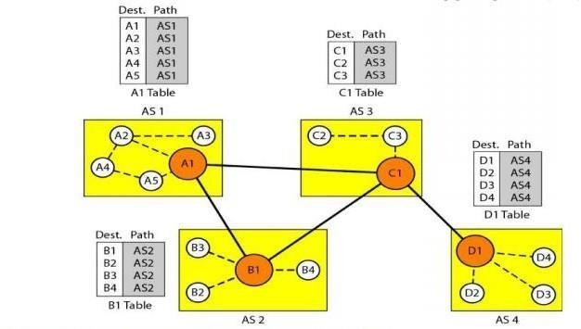

*Figure 3.14 : Initial routing tables in path vector routing*

Node Al is the speaker node for AS1, B1 for AS2, C1 for AS3, and Dl for AS4. Node Al creates an initial table that shows Al to A5 are located in ASI and can be reached through it. Node B1 advertises that Bl to B4 are located in AS2 and can be reached through Bl. And so on.

### Multicast Routing Protocols

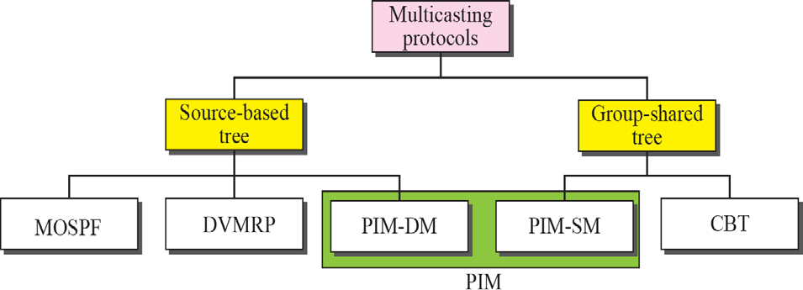

1. **Multicast Link State Routing: MOSPF**

Multicast link state routing uses the source-based tree approach. links. For multicast routing, a node needs to revise the interpretation of *state.* A node advertises every group which has any loyal member on the link. Here the meaning of state is "what groups are active on this link." The information about the group comes from IGMP. Each router running IGMP solicits the hosts on the link to find out the membership status.

**MOSPF Multicast Open Shortest Path First (MOSPF) protocol** is an extension of the OSPF protocol that uses multicast link state routing to create source-based trees. The protocol requires a new link state update packet to associate the unicast address of a host with the group address or addresses the host is sponsoring. This packet is called the group-membership LSA.

### Multicast Distance Vector: DVMRP

**Multicast Distance Vector Routing** Unicast distance vector routing is very simple; extending it to support multicast routing is complicated. Multicast routing does not allow a router to send its routing table to its neighbors. The idea is to create a table from scratch by using the information from the unicast distance vector tables.

Multicast distance vector routing uses source-based trees, but the router never actually makes a routing table. When a router receives a multicast packet, it forwards the packet as though it is consulting a routing table.

### Flooding

1. **Reverse Path Forwarding (RPF)**

### Reverse Path Broadcasting (RPB)

1. **Reverse Path Multicasting (RPM)**

**DVMRP** The Distance Vector Multicast Routing Protocol (DVMRP) is an implementation of multicast distance vector routing. It is a source-based routing protocol, based on RIP.

### CBT

The Core-Based Tree (CBT) protocol is a group-shared protocol that uses a core as the root of the tree. The autonomous system is divided into regions, and a core (center router or rendezvous router) is chosen for each region.

The Core-Based Tree (CBT) is a group-shared tree, center-based protocol using one tree per group. One of the routers in the tree is called the core. A packet is sent from the source to members of the group following this procedure:

1. The source, which may or may not be part of the tree, encapsulates the multicast packet inside a unicast packet with the unicast destination address of the core and sends it to the core. This part of delivery is done using a unicast address; the only recipient is the core router.
2. The core decapsulates the unicast packet and forwards it to all interested intetfaces.
3. Each router that receives the multicast packet, in tum, forwards it to all interested interfaces.

### PIM

**Protocol Independent Multicast (PIM)** is the name given to two independent multicast routing protocols: Protocol Independent Multicast, Dense Mode (PIM-DM) and Protocol Independent Multicast, Sparse Mode (PIM-SM). Both protocols are unicast protocol-dependent, but the similarity ends here.

**PIM-DM**: PIM-DM is used when there is a possibility that each router is involved in multicasting (dense mode). In this environment, the use of a protocol that broadcasts the packet is justified because almost all routers are involved in the process. PIM-DM is a source-based tree routing protocol that uses RPF and pruning and grafting strategies for multicasting. Its operation is like that of DVMRP.

**PIM-SM:** PIM-SM is used when there is a slight possibility that each router is involved in multicasting (sparse mode). In this environment, the use of a protocol that broadcasts the packet is not justified; a protocol such as CBT that uses a group-shared tree is more appropriate. PIM-SM is used in a sparse multicast environment such as a WAN. PIM-SM is a group-shared tree routing protocol that has a rendezvous point (RP) as the source of the tree.

#### TUTORIAL QUESTIONS

* 1. List out the types of Unicast and Multicast Routing protocols?
  2. Demonstrate the Logical addressing Procedure in Network Layer?
  3. Elaborate how mapping procedure will do in Network Layer?
  4. Discuss Internetworking process by Network Layer?
  5. What is ICMP and IGMP? Explain these Protocols?

#### ASSIGNMENT QUESTIONS

1. Describe Internet Protocol with the neat block diagram of IP header format?
2. Discuss about Address ResolutionProtocol?
3. Define BGP Protocol. Describe its routing functionality in detail?
4. Write short notes on a) ICMP b) IGMP?
5. Explain the Datagram delivery and Forwarding in Internet Protocol?

#### IMPORTANT QUESTIONS

***PART-A-UNIT-III* (2 or 3 marks)**

1. What are the issues in routing?
2. Write about Tunneling.
3. What are the functions of ICMP?
4. What are the concepts of extension header in IPv6?
5. What is internetworking?
6. List out Internetworking devices.

***PART-B-UNIT-III* (5-10 marks)**

1. How would you describe the operation of Address resolution protocol?
2. Elucidate the special IP addresses used in internet.
3. Discuss the significance and the operation of NAT.
4. Explain about Unicast and Multicast Routing Protocols.
5. Briefly explain about Address Mapping in Network Layer.
6. Elaborate Tunneling procedure in detail.
7. Explain about ICMP and IGMP.

#### OBJECTIVE QUESTIONS

* 1. What is the first address of a block of classless addresses if one of the addresses is 12.2.2.76/10?

A) 12.0.0.0

B) 12.2.0.0

C) 12.2.2.2

D) none of the above

### Option A

* 1. In IPv6, the address is generally used by a normal host as a unicast address.

1. provider-based unicast
2. link local
3. site local
4. none of the above

### Option A

* 1. What is the result of ANDing 255 and 15?

A) 255 B) 15 C) 0 D) none of the above

### Option B

* 1. An IPv6 address can have up to colons.

A) 8 B) 7 C) 4 D) none of the above

### Option B

* 1. What is the default mask for class A in CIDR notation?

A) /9 B) /8 C) /16 D) none of the above

### Option B

* 1. What is the first address of a block of classless addresses if one of the addresses is 12.2.2.127/28?

A) 12.2.2.0

B) 12.2.2.96

C) 12.2.2.112

D) none of the above

### Option C

* 1. The number of addresses assigned to an organization in classless addressing .

1. can be any number
2. must be a multiple of 256
3. must be a power of 2
4. none of the above

### Option C

* 1. GMP is protocol.

1. an error reporting
2. a group management
3. a transmission
4. none of the above

### Option B

* 1. The target hardware address on anEthernet is in an ARP request. A) 0x000000000000

B) 0.0.0.0

1. variable
2. class dependent

### Option A

* 1. Which of the following is true about ICMP messages?

1. An ICMP error message may be generated for an ICMP error message.
2. An ICMP error message may be generated only for the first fragment.
3. An ICMP error message may be generated for a multicast datagram.
4. none is true

### Option B

#### FILL IN THE BLANKS

1. In multicast routing, each involved router needs to construct a path tree foreach group.

**Answer:** shortest

1. In , each node maintains a vector (table) of minimum distances to every node.

**Answer:** distance vector

1. RPB guarantees that eachdestination receives of the packet.

**Answer:** one copy

1. The protocol allows the administrator to assign a cost, called the metric, to each route.

**Answer:** OSPF

1. The idea of address aggregation was designed to alleviate the increase in routing table entries when using .

**Answer:** classless addressing.

### UNIT -IV

**Transport Layer**

### Process to Process Delivery

The data link layer is responsible for delivery of frames between two neighbouring nodes over a link. This is called node-to-node delivery. The network layer is responsible for delivery of datagrams between two hosts. This is called host-to-host delivery. Communication on the Internet is not defined as the exchange of data between two nodes or between two hosts. Real communication takes place between two processes. So that we need process-to-process delivery. However, at any moment, several processes may be running on the source host and several on the destination host. To complete the delivery, we need a mechanism to deliver data from one of these processes running on the source host to the corresponding process running on the destination host.

The transport layer is responsible for process-to-process delivery-the delivery of a packet, part of a message, from one process to another. The following figure shows these three types of deliveries and their domains.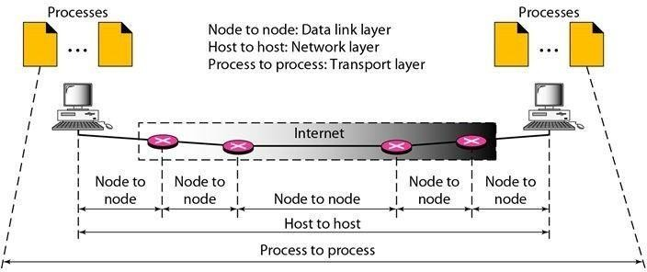

Figure: 4.1 Process to Process Delivery

#### Client/Server Paradigm:

There are several ways to achieve process-to-process communication; the most common one is through the client/server paradigm. A process on the local host, called a client, needs services from a process usually on the remote host, called a server.

Both processes (client and server) have the same name. For example, to get the day and time from a remote machine, we need a Daytime client process running on the local host and a Daytime server process running on a remote machine.

A remote computer can run several server programs at the same time, just as local computers can run one or more client programs at the same time. For communication, we must define the following:

1. Local host
2. Local process
3. Remote host
4. Remote process

#### Addressing

Whenever we need to deliver something to one specific destination among many, we need an address. At the data link layer, we need a MAC address to choose one node among several nodes if the connection is not point-to-point. A frame in the data link layer needs a destination MAC address for delivery and a source address for the next node's reply.

At the network layer, we need an IP address to choose one host among millions. A datagram in the network layer needs a destination IP address for delivery and a source IP address for the destination's reply.

At the transport layer, we need a transport layer address, called a port number, to choose among multiple processes running on the destination host. The destination port number is needed for delivery; the source port number is needed for the reply.

In the Internet model, the port numbers are 16-bit integers between 0 and 65,535. The client program defines itself with a port number, chosen randomly by the transport layer software running on the client host. This is the ephemeral port number.

The server process must also define itself with a port number. This port number, however, cannot be chosen randomly. If the computer at the server site runs a server process and assigns a random number as the port number, the process at the client site that wants to access that server and use its services will not know the port number.

Every client process knows the well-known port number of the corresponding server process. For example, while the Daytime client process, discussed above, can use an ephemeral (temporary) port number 52,000 to identify itself, the Daytime server process must use the well-known (permanent) port number 13.

It should be clear by now that the IP addresses and port numbers play different roles in selecting the final destination of data. The destination IP address defines the host among the different hosts in the world. After the host has been selected, the port number defines one of the processes on this particular host.

#### IANA Ranges:

The IANA (Internet Assigned Number Authority) has divided the port numbers into three ranges: well known, registered, and dynamic (or private).

* Well-known ports: The ports ranging from 0 to 1023 are assigned and controlled by IANA. These are the well-known ports.
* Registered ports: The ports ranging from 1024 to 49,151 are not assigned or controlled by IANA. They can only be registered with IANA to prevent duplication.
* Dynamic ports: The ports ranging from 49,152 to 65,535 are neither controlled nor registered. They can be used by any process. These are the ephemeral ports.

***Socket Addresses:*** Process-to-process delivery needs two identifiers, IP address and the port number, at each end to make a connection. The combination of an IP address and a port number is called a socket address. The client socket address defines the client process uniquely just as the server socket address defines the server process uniquely which is represented in the following figure.

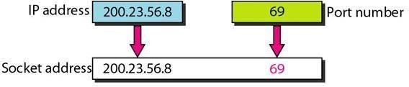

Figure: 4.2 *Socket Addresses*

**Multiplexing and De-multiplexing:** The addressing mechanism allows multiplexing and de- multiplexing by the transport layer.

**Multiplexing:** At the sender site, there may be several processes that need to send packets. However, there is only one transport layer protocol at any time. This is a many-to-one relationship

and requires multiplexing. The protocol accepts messages from different processes, differentiated by their assigned port numbers. After adding the header, the transport layer passes the packet to the network layer.

**Demultiplexing:** At the receiver site, the relationship is one-to-many and requires demultiplexing. The transport layer receives datagrams from the network layer. After error checking and dropping of the header, the transport layer delivers each message to the appropriate process based on the port number. **Connectionless Versus Connection-Oriented Service:** A transport layer protocol can either be connectionless or connection-oriented. **Connectionless Service:** In a connectionless service, the packets are sent from one party to another with no need for connection establishment or connection release. The packets are not numbered; they may be delayed or lost or may arrive out of sequence. There is no acknowledgment either. UDP, is connectionless.

**Connection-Oriented Service:** In a connection-oriented service, a connection is first established between the sender and the receiver. Data are transferred. At the end, the connection is released. The TCP and SCTP are connection-oriented protocols.

### Reliable Versus Unreliable:

The transport layer service can be reliable or unreliable. If the application layer program needs reliability, we use a reliable transport layer protocol by implementing flow and error control at the transport layer.

If the application program does not need reliability because it uses its own flow and error control mechanism or it needs fast service or the nature of the service does not demand flow and error control (real-time applications), then an unreliable protocol can be used. In the Internet, UDP is connectionless and unreliable; TCP and SCTP are connection oriented and reliable.

### UDP and TCP protocols User Datagram Protocol (UDP) :

The User Datagram Protocol (UDP) is called a connectionless, unreliable transport protocol. It does not add anything to the services of IP except to provide process-to-process communication instead of host-to-host communication. Also, it performs very limited error checking.

UDP is a very simple protocol using a minimum of overhead. If a process wants to send a small message and does not care much about reliability, it can use UDP. Sending a small message by using UDP takes much less interaction between the sender and receiver than using TCP or SCTP.

### Well-known port for UDP:

The following table shows some well-known port numbers used by UDP. Some port numbers can be used by both UDP and TCP.

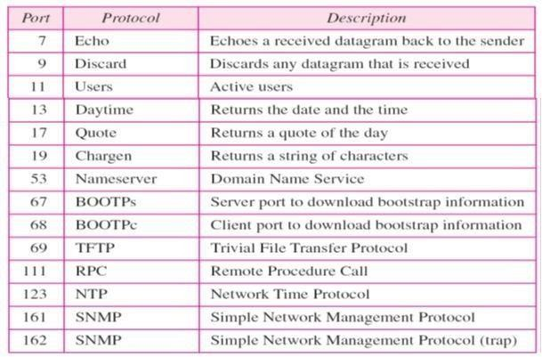

### User Datagram:

UDP packets, called user datagrams, have a fixed-size header of 8 bytes. The following figure 4.3 shows the format of a user datagram.

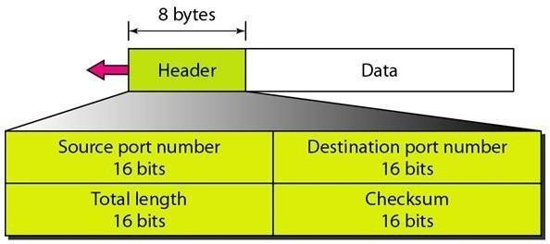

Figure: 4.3 Format Of User Datagram

### The fields are as follows:

* **Source port number:** This is the port number used by the process running on the source host. It is 16 bits long, which means that the port number can range from 0 to 65,535. If the source host is the client (a client sending a request), the port number, in most cases, is an ephemeral port number requested by the process and chosen by the UDP software running on the source host. If the source host is the server (a server sending a response), the port number, in most cases, is a well-known port number.
* **Destination port number:** This is the port number used by the process running on the destination host. It is also 16 bits long. If the destination host is the server (a client sending a request), the port number, in most cases, is a well-known port number. If the destination host is the client (a server sending a response), the port number, in most cases, is an ephemeral port number. In this case, the server copies the ephemeral port number it has received in the request packet.
* **Length:** This is a 16-bit field that defines the total length of the user datagram, header plus data.The 16 bits can define a total length of 0 to 65,535 bytes. However, the total length needs to be much less because a UDP user datagram is stored in an IP datagram with a total length of 65,535bytes.

A user datagram is encapsulated in an IP datagram. There is a field in the IP datagram that defines the total length. There is another field in the IP datagram that defines the length of the header. So, UDP length = IP length - IP header's length

* Checksum: This field is used to detect errors over the entire user datagram (header plus data). *Checksum:* The UDP checksum calculation is different from the one for IP and ICMP. Here the checksum includes three sections: a pseudoheader, the UDP header, and the data coming from the application layer.

The pseudoheader is the part of the header of the IP packet in which the user datagram is to be encapsulated with some fields filled with 0s. Consider the following figure4.4.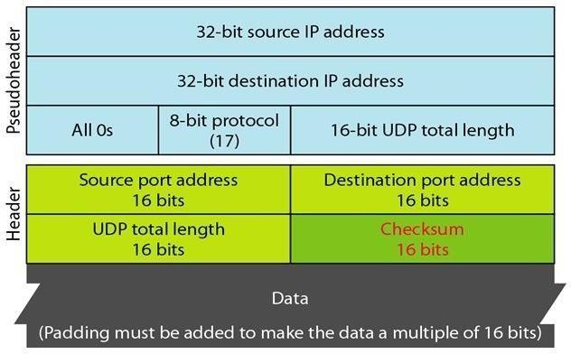

Figure: 4.4 Format IP packet Header

If the checksum does not include the pseudoheader, a user datagram may arrive safe and sound. However, if the IP header is corrupted, it may be delivered to the wrong host. The protocol field is

added to ensure that the packet belongs to UDP, and not to other transport-layer protocols.

The value of the protocol field for UDP is 17. If this value is changed during transmission, the checksum calculation at the receiver will detect it and UDP drops the packet. It is not delivered to the wrong protocol.

### UDP Operation:

The different operations of UDP are as follows:

*Connectionless Services:* UDP provides a connectionless service. This means that each user datagram sent by UDP is an independent datagram. There is no relationship between the different user datagrams even if they are coming from the same source process and going to the same destination program. The user datagrams are not numbered. Also, there is no connection establishment and no connection termination. This means that each user datagram can travel on a different path.

***Flow and Error Control****:* UDP is a very simple, unreliable transport protocol. There is no flow control and hence no window mechanism. The receiver may overflow with incoming messages. There is no error control mechanism in UDP except for the checksum. The lack of flow control and error control means that the process using UDP should provide these mechanisms.

*Encapsulation and Decapsulation:* To send a message from one process to another, the UDP protocol encapsulates and decapsulates messages in an IP datagram.

#### Queuing:

In UDP, queues are associated with ports. Consider the following figure

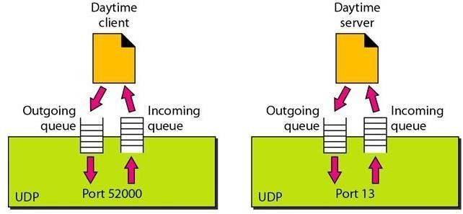

Figure: 4.5 *Queuing*

#### At the client site:

When a process starts, it requests a port number from the operating system. Some implementations create both an incoming and an outgoing queue associated with each process. Other implementations create only an incoming queue associated with each process. The queues

opened by the client are, in most cases, identified by ephemeral port numbers. The queues function as long as the process is running. When the process terminates, the queues are destroyed.

The client process can send messages to the outgoing queue by using the source port number specified in the request. UDP removes the messages one by one and, after adding the UDP header, delivers them to IP. An outgoing queue can overflow. If this happens, the operating system can ask the client process to wait before sending any more messages.

When a message arrives for a client, UDP checks to see if an incoming queue has been created for the port number specified in the destination port number field of the user datagram. If there is such a queue, UDP sends the received user datagram to the end of the queue.

If there is no such queue, UDP discards the user datagram and asks the ICMP protocol to send a port unreachable message to the server. All the incoming messages for one particular client program, whether coming from the same or a different server, are sent to the same queue. An incoming queue can overflow. If this happens, UDP drops the user datagram and asks for a port unreachable message to be sent to the server.

At the server site, the mechanism of creating queues is different. In its simplest form, a server asks for incoming and outgoing queues, using its well-known port, when it starts running. The queues remain open as long as the server is running.

When a message arrives for a server, UDP checks to see if an incoming queue has been created for the port number specified in the destination port number field of the user datagram. If there is such a queue, UDP sends the received user datagram to the end of the queue. If there is no such queue, UDP discards the user datagram and asks the ICMP protocol to send a port unreachable message to the client. All the incoming messages for one particular server, whether coming from the same or a different client, are sent to the same queue. An incoming queue can overflow. If this happens, UDP drops the user datagram and asks for a port unreachable message to be sent to the client.

When a server wants to respond to a client, it sends messages to the outgoing queue, using the source port number specified in the request. UDP removes the messages one by one and, after adding the UDP header, delivers them to IP. An outgoing queue can overflow. If this happens, the

operating system asks the server to wait before sending any more messages.

#### Uses of UDP:

The following lists some uses of the UDP protocol:

* UDP is suitable for a process that requires simple request-response communication with little concern for flow and error control. It is not usually used for a process such as FTP that needs to send bulk data.
* UDP is suitable for a process with internal flow and error control mechanisms. For example, the Trivial File Transfer Protocol (TFTP) process includes flow and error control. It can easily use UDP.
* UDP is a suitable transport protocol for multicasting. Multicasting capability is embedded in the UDP software but not in the TCP software.
* UDP is used for management processes such as SNMP.
* UDP is used for some route updating protocols such as Routing Information Protocol (RIP)

**TCP (Transmission Control Protocol)**

TCP is connection-oriented. A connection-oriented transport protocol establishes a virtual path between the source and destination. All the segments belonging to a message are then sent over this virtual path. Using a single virtual pathway for the entire message facilitates the acknowledgment process as well as retransmission of damaged or lost frames.

In TCP, connection-oriented transmission requires three phases:

1. Connection establishment
2. Data transfer 3.Connection-termination.

**Connection Establishment:** TCP transmits data in full-duplex mode. When two TCPs in two machines are connected, they are able to send segments to each other simultaneously. This implies that each party must initialize communication and get approval from the other party before any data are transferred.

#### Three-Way Handshaking:

The connection establishment in TCP is called three way handshaking. In our example, an application program, called the client, wants to make a connection with another application program, called the server, using TCP as the transport layer protocol.

The process starts with the server. The server program tells its TCP that it is ready to accept a connection. This is called a request for a passive open. Although the server TCP is ready to accept

any connection from any machine in the world, it cannot make the connection itself.

The client program issues a request for an active open. A client that wishes to connect to an open server tells its TCP that it needs to be connected to that particular server. TCP can now start the three-way handshaking process as shown in the following figure.

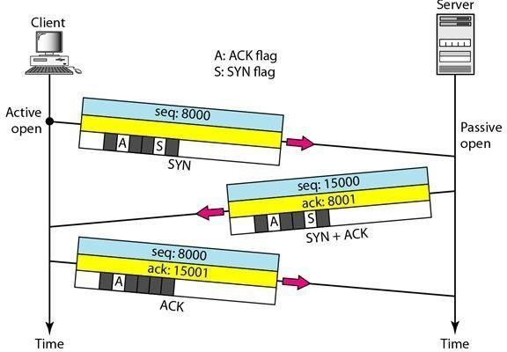

Figure: 4.6 *Three-Way Handshaking*

To show the process, we use two time lines, one at each site. Each segment has values for all its header fields and perhaps for some of its option fields, too. We show the sequence number, the acknowledgment number, the control flags (only those that are set), and the window size, if not empty. The three steps in this phase are as follows.

1. The client sends the first segment, a SYN segment, in which only the SYN flag is set. This segment is for synchronization of sequence numbers. It consumes one sequence number. When the data transfer starts, the sequence number is incremented by 1. We can say that the SYN segment carries no real data, but we can think of it as containing 1 imaginary byte.
2. The server sends the second segment, a SYN +ACK segment, with 2 flag bits set, SYN and ACK. This segment has a dual purpose. It is a SYN segment for communication in the other direction and serves as the acknowledgment for the SYN segment. It consumes one sequence number.
3. The client sends the third segment. This is just an ACK segment. It acknowledges the receipt of the second segment with the ACK flag and acknowledgment number field. Note that the sequence number in this segment is the same as the one in the SYN segment; the ACK segment does not consume any sequence numbers.

### TCP-Services:

The services offered by TCP to the processes at the application layer are as follows:

**Process-to-Process Communication:** TCP provides process-to-process communication using port numbers. The following table lists some well-known port numbers used by TCP.

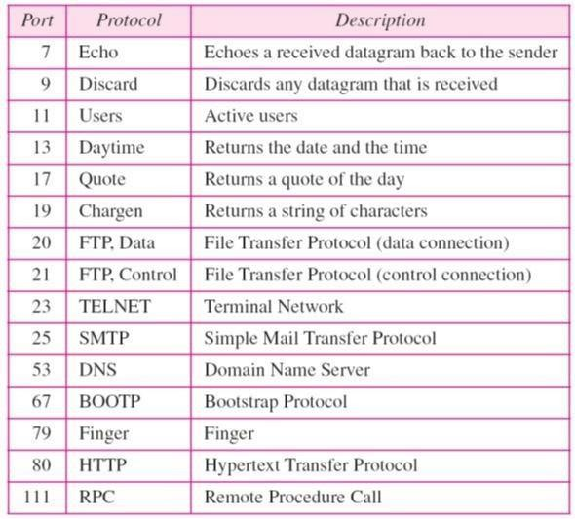

#### Stream Delivery Service:

TCP, unlike UDP, is a stream-oriented protocol. TCP, on the other hand, allows the sending process to deliver data as a stream of bytes and allows the receiving process to obtain data as a stream of bytes. TCP creates an environment in which the two processes seem to be connected by an imaginary "tube" that carries their data across the Internet. This imaginary environment is depicted in the following figure. The sending process produces (writes to) the stream of bytes, and the receiving process consumes (reads from) them.

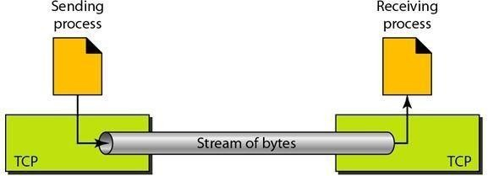

Figure: 4.7 *Stream Delivery Service*

#### Sending and Receiving Buffers:

Because the sending and the receiving processes may not write or read data at the same speed, TCP needs buffers for storage. There are two buffers, the sending buffer and the receiving buffer, one for each direction and these buffers are also necessary for flow and error control mechanisms used by TCP.) One way to implement a buffer is to use a circular array of 1-byte locations as shown in the following figure.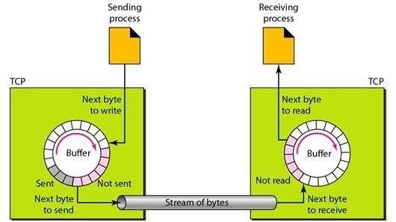

Figure4.8 Movement Of The Data In One Direction.

At the sending site, the buffer has three types of chambers. The white section contains empty chambers that can be filled by the sending process (producer). The gray area holds bytes that have been sent but not yet acknowledged. TCP keeps these bytes in the buffer until it receives an acknowledgment. The colored area contains bytes to be sent by the sending TCP. However, TCP may be able to send only part of this colored section. This could be due to the slowness of the receiving process or perhaps to congestion in the network. Also note that after the bytes in the gray chambers are acknowledged, the chambers are recycled and available for use by the sending process. This is why we show a circular buffer.

At the receiving site, the operation of the buffer at the receiver site is simpler. The circular buffer is divided into two areas (shown as white and colored). The white area contains empty chambers to be filled by bytes received from the network. The colored sections contain received bytes that can be read by the receiving process. When a byte is read by the receiving process, the chamber is recycled and added to the pool of empty chambers.

### Segments:

The buffering handles the disparity between the speed of the producing and consuming processes, we need one more step before we can send data. The IP layer, as a service provider for TCP, needs to send data in packets, not as a stream of bytes. At the transport layer, TCP groups a number of bytes together into a packet called a segment. TCP adds a header to each segment (for control purposes) and delivers the segment to the IP layer for transmission.

The segments are encapsulated in IP datagrams and transmitted. This entire operation is transparent to the receiving process. The segments may be received out of order, lost, or corrupted and resent. All these are handled by TCP with the receiving process unaware of any activities. The following figure shows how segments are created from the bytes in the buffers.

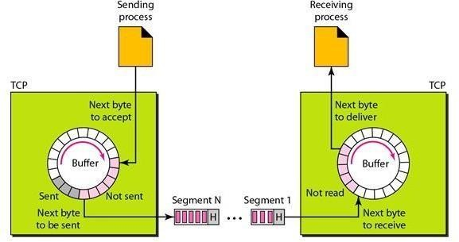

### Full-Duplex Communication:

TCP offers full-duplex service, in which data can flow in both directions at the same time. Each TCP then has a sending and receiving buffer, and segments move in both directions. Connection- Oriented Service:

TCP, unlike UDP, is a connection-oriented protocol. When a process at site A wants to send and receive data from another process at site B, the following occurs:

1. The two TCPs establish a connection between them.
2. Data are exchanged in both directions.
3. The connection is terminated.

The TCP segment is encapsulated in an IP datagram and can be sent out of order, or lost, or corrupted, and then resent. Each may use a different path to reach the destination. There is no physical connection. TCP creates a stream-oriented environment in which it accepts the

responsibility of delivering the bytes in order to the other site.

### Reliable-Service

TCP is a reliable transport protocol. It uses an acknowledgment mechanism to check the safe and sound arrival of data. We will discuss this feature further in the section on error control.

### TCP Segment

A packet in TCP is called a segment. The format of a segment is shown in the following figure. The segment consists of a 20- to 60-byte header, followed by data from the application program. The header is 20 bytes if there are no options and up to 60 bytes if it contains options. The different sections of the Header are as follows.

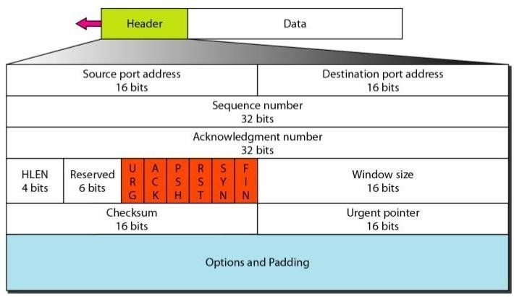

Figure 4.9 TCP Segment

**Source port address:** This is a 16-bit field that defines the port number of the application program in the host that is sending the segment.

**Destination port address:** This is a 16-bit field that defines the port number of the application program in the host that is receiving the segment.

**Sequence number:** This 32-bit field defines the number assigned to the first byte of data contained in this segment. TCP is a stream transport protocol. To ensure connectivity, each byte to be transmitted is numbered. The sequence number tells the destination which byte in this sequence comprises the first byte in the segment.

During connection establishment, each party uses a random number generator to create an initial sequence number (ISN), which is usually different in each direction.

**Acknowledgment number:** This 32-bit field defines the byte number that the receiver of the segment is expecting to receive from the other party. If the receiver of the segment has successfully received byte number x from the other party, it defines x + 1 as the acknowledgment number. Acknowledgment and data can be piggybacked together.

**Header length:** This 4-bit field indicates the number of 4-byte words in the TCP header. The length of the header can be between 20 and 60 bytes. Therefore, the value of this field can be between 5 (5 x 4 =20) and 15 (15 x 4 =60).

Reserved: This is a 6-bit field reserved for future use.

***Control:*** This field defines 6 different control bits or flags as shown in the following figure and One or more of these bits can be set at a time. These bits enable flow control, connection establishment and termination, connection abortion, and the mode of data transfer in TCP. A brief description of each bit is as follows:

URG - The value of the urgent pointer field is valid. ACK - The value of the acknowledgment field is valid. PSH - Push the data.

RST - Reset the connection.

SYN - Synchronize sequence numbers during connection. FIN - Terminate the connection.

***Window size:*** This field defines the size of the window, in bytes, that the other party must maintain. The length of this field is 16 bits, which means that the maximum size of the window is 65,535 bytes. This value is normally referred to as the receiving window (rwnd) and is determined by the receiver. The sender must obey the dictation of the receiver in this case.

***Checksum:*** This 16-bit field contains the checksum. The calculation of the checksum for TCP follows the same procedure as the one described for UDP. However, the inclusion of the checksum in the UDP datagram is optional, whereas the inclusion of the checksum for TCP is

mandatory. The same pseudo header, serving the same purpose, is added to the segment.

For the TCP pseudo header, the value for the protocol field is 6.

***Urgent pointer:*** This l6-bit field, which is valid, only if the urgent flag is set, is used when the segment contains urgent data. It defines the number that must be added to the sequence number to obtain the number of the last urgent byte in the data section of the segment. ***Options:*** There can be up to 40 bytes of optional information in the TCP header.

### Data Traffic

The main focus of congestion control and quality of service is data traffic. In congestion control we try to avoid traffic congestion. In quality of service, we try to create an appropriate environment for the traffic. So, before talking about congestion control and quality of service, we discuss the data traffic itself.

Traffic Descriptor

Traffic descriptors are qualitative values that represent a data flow. Figure 4.3 shows a traffic flow with some of these values.

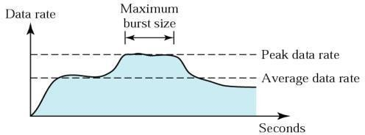

Figure 4.10 Traffic Descriptor

**Average Data Rate:** The average data rate is the number of bits sent during a period of time, divided by the number of seconds in that period. We use the following equation:

Average data rate = amount of data / time

The average data rate is a very useful characteristic of traffic because it indicates the average bandwidth needed by the traffic.

**Peak Data Rate:** The peak data rate defines the maximum data rate of the traffic. In Figure 24.1 it is the maximum y axis value. The peak data rate is a very important measurement because it indicates the peak bandwidth that the network needs for traffic to pass through without changing its data flow.

**Maximum Burst Size:** Although the peak data rate is a critical value for the network, it can usually be ignored if the duration of the peak value is very short. For example, if data are flowing steadily at the rate of 1 Mbps with a sudden peak data rate of2 Mbps for just 1 ms, the network probably can handle the situation. However, if the peak data rate lasts 60 ms, there may be a problem for the network. The maximum burst size normally refers to the maximum length of time the traffic is generated at the peak rate.

**Effective Bandwidth:** The effective bandwidth is the bandwidth that the network needs to allocate for the flow of traffic. The effective bandwidth is a function of three values: average data rate, peak data rate, and maximum burst size. The calculation of this value is very complex.

**Traffic Profiles:** For our purposes, a data flow can have one of the following traffic profiles: constant bit rate, variable bit rate, or bursty as shown in Figure

**Constant Bit Rate:**A constant-bit-rate (CBR), or a fixed-rate, traffic model has a data rate that does not change. In this type of flow, the average data rate and the peak data rate are the same. The maximum burst size is not applicable. This type of traffic is very easy for a network to handle since it is predictable. The network knows in advance how much bandwidth to allocate for this type of flow.

**Variable Bit Rate:** In the variable-bit-rate (VBR) category, the rate of the data flow changes in time, with the changes smooth instead of sudden and sharp. In this type of flow, the average data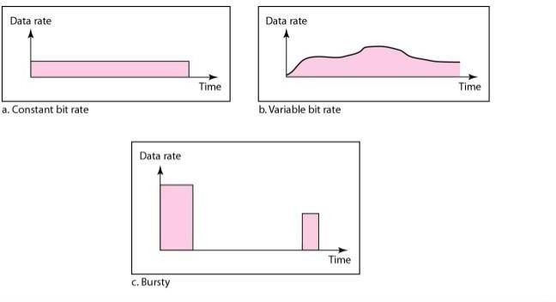

Figure 4.11 Variable Bit Rate

rate and the peak data rate are different. The maximum burst size is usually a small value. This type of traffic is more difficult to handle than constant-bit-rate traffic, but it normally does not need to be reshaped, as we will see later.

**Bursty:** In the bursty data category, the data rate changes suddenly in a very short time. It may jump from zero, for example, to 1 Mbps in a few microseconds and vice versa. It may also remain at this value for a while. The average bit rate and the peak bit rate are very different values in this type of flow. The maximum burst size is significant. This is the most difficult type of traffic for a network to handle because the profile is very unpredictable. To handle this type of traffic, the network normally needs to reshape it, using reshaping techniques, as we will see shortly. Bursty traffic is one of the main causes of congestion in a network.

### Congestion

An important issue in a packet-switched network is congestion. Congestion in a network may occur if the load on the network-the number of packets sent to the network-is greater than the capacity of the network-the number of packets a network can handle. **Congestion control** refers to the mechanisms and techniques to control the congestion and keep the load below the capacity. We may ask why there is congestion on a network. Congestion happens in any system that involves waiting. For example, congestion happens on a freeway because any abnormality in the flow, such as an accident during rush hour, creates blockage.

Congestion in a network or internetwork occurs because routers and switches have queues-buffers that hold the packets before and after processing. A router, for example, has an input queue and an output queue for each interface. When a packet arrives at the incoming interface, it undergoes three steps before departing, as shown in Figure.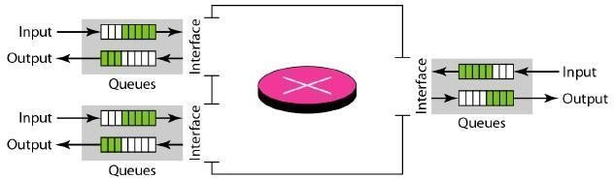

Figure 4.12 Congestion

1. The packet is put at the end of the input queue while waiting to be checked.
2. The processing module of the router removes the packet from the input queue once it reaches the front of the queue and uses its routing table and the destination address to find the route.
3. The packet is put in the appropriate output queue and waits its tum to be sent.

We need to be aware of two issues. First, if the rate of packet arrival is higher than the packet processing rate, the input queues become longer and longer. Second, if the packet departure rate is less than the packet processing rate, the output queues become longer and longer.

Network Performance

Congestion control involves two factors that measure the performance of a network: delay and throughput. these two performance measures as function of load.

**Throughput** is the actual rate that information is transferred.

Jitter is **delay** when the packet has different time every next data transfer.

### Congestion Control

Congestion control refers to techniques and mechanisms that can either prevent congestion, before it happens, or remove congestion, after it has happened. In general, we can divide congestion control mechanisms into two broad categories: open-loop congestion control (prevention) and closed-loop congestion control (removal) as shown in Figure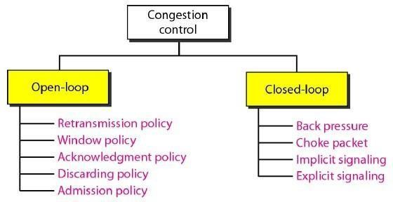

4.13 Congestion control categories

### Open-Loop Congestion Control

In open-loop congestion control, policies are applied to prevent congestion before it happens. In these mechanisms, congestion control is handled by either the source or the destination. We give a brief list of policies that can prevent congestion.

**Retransmission Policy:** Retransmission is sometimes unavoidable. If the sender feels that a sent packet is lost or corrupted, the packet needs to be retransmitted. Retransmission in general may increase congestion in the network. However, a good retransmission policy can prevent congestion. The retransmission policy and the retransmission timers must be designed to optimize efficiency and at the same time prevent congestion. For example, the retransmission policy used by TCP (explained later) is designed to prevent or alleviate congestion.

**Window Policy:** The type of window at the sender may also affect congestion. The Selective Repeat window is better than the Go-Back-N window for congestion control. In the Go-Back-N

window, when the timer for a packet times out, several packets may be resent, although some may have arrived safe and sound at the receiver. This duplication may make the congestion worse. The Selective Repeat window, on the other hand, tries to send the specific packets that have been lost or corrupted.

**Acknowledgment Policy:** The acknowledgment policy imposed by the receiver may also affect congestion. If the receiver does not acknowledge every packet it receives, it may slow down the sender and help prevent congestion. Several approaches are used in this case. A receiver may send an acknowledgment only if it has a packet to be sent or a special timer expires. A receiver may decide to acknowledge only N packets at a time. We need to know that the acknowledgments are also part of the load in a network. Sending fewer acknowledgments means imposing less load on the network.

**Discarding Policy:** A good discarding policy by the routers may prevent congestion and at the same time may not harm the integrity of the transmission. For example, in audio transmission, if the policy is to discard less sensitive packets when congestion is likely to happen, the quality of sound is still preserved and congestion is prevented or alleviated.

**Admission Policy:** An admission policy, which is a quality-of-service mechanism, can also prevent congestion in virtual-circuit networks. Switches in a flow first check the resource requirement of a flow before admitting it to the network. A router can deny establishing a virtual circuit connection if there is congestion in the network or if there is a possibility of future congestion.

### Closed-Loop Congestion Control

Closed-loop congestion control mechanisms try to alleviate congestion after it happens. Several mechanisms have been used by different protocols. We describe a few of them here.

**Backpressure:** The technique of backpressure refers to a congestion control mechanism in which a congested node stops receiving data from the immediate upstream node or nodes. This may cause the upstream node or nodes to become congested, and they, in turn, reject data from their upstream nodes or nodes. And so on. Backpressure is a node-to-node congestion control that starts with a node and propagates, in the opposite direction of data flow, to the source. The backpressure technique can be applied only to virtual circuit networks, in which each node knows the upstream node from which a flow of data is corning. Figure shows the idea of backpressure.

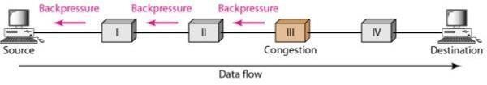

Fig 4.14 Backpressure method for alleviating congestion

Node III in the figure has more input data than it can handle. It drops some packets in its input buffer and informs node II to slow down. Node II, in turn, may be congested because it is slowing down the output flow of data. If node II is congested, it informs node I to slow down, which in turn may create congestion. If so, node I informs the source of data to slow down. This, in time, alleviates the congestion. Note that the pressure on node III is moved backward to the source to remove the congestion. None of the virtual-circuit networks we studied in this book use backpressure. It was, however, implemented in the first virtual-circuit network, X.25. The technique cannot be implemented in a datagram network because in this type of network, a node (router) does not have the slightest knowledge of the upstream router.

**Choke Packet:** A choke packet is a packet sent by a node to the source to inform it of congestion. Note the difference between the backpressure and choke packet methods. In backpressure, the warning is from one node to its upstream node, although the warning may eventually reach the source station. In the choke packet method, the warning is from the router, which has encountered congestion, to the source station directly. The intermediate nodes through which the packet has traveled are not warned. We have seen an example of this type of control in ICMP. When a router in the Internet is over when need with IP datagram, it may discard some of them; but it informs the source host, using a source quench ICMP message. The warning message goes directly to the source station; the intermediate routers, and does not take any action. Figure shows the idea of a choke packet.

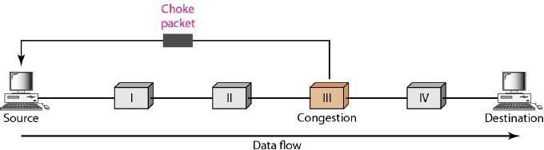

4.15 Choke Packet

**Implicit Signaling:** In implicit signaling, there is no communication between the congested node or nodes and the source. The source guesses that there is a congestion somewhere in the network from other symptoms. For example, when a source sends several packets and there is no acknowledgment for a while, one assumption is that the network is congested. The delay in receiving an acknowledgment is interpreted as congestion in the network; the source should slow down. We will see this type of signaling when we discuss TCP congestion control later in the chapter.

**Explicit Signaling:** The node that experiences congestion can explicitly send a signal to the source or destination. The explicit signaling method, however, is different from the choke packet method. In the choke packet method, a separate packet is used for this purpose; in the explicit signaling method, the signal is included in the packets that carry data. Explicit signaling, as we will see in Frame Relay congestion control, can occur in either the forward or the backward direction.

### Quality of service (QoS)

Quality of service (QoS) is an internetworking issue that has been discussed more than defined. We can informally define quality of service as something a flow seeks to attain.

### Flow Characteristics

Traditionally, four types of characteristics are attributed to a flow: reliability, delay, jitter, and bandwidth, as shown in Figure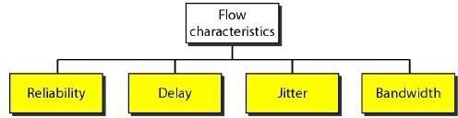

**Reliability:** Reliability is a characteristic that a flow needs. Lack of reliability means losing a packet or acknowledgment, which entails retransmission. However, the sensitivity of application programs to reliability is not the same. For example, it is more important that electronic mail, file transfer, and Internet access have reliable transmissions than telephony or audio conferencing.

**Delay:** Source-to-destination delay is another flow characteristic. Again applications can tolerate delay in different degrees. In this case, telephony, audio conferencing, video conferencing, and remote log-in need minimum delay, while delay in file transfer or e-mail is less important.

**Jitter:** Jitter is the variation in delay for packets belonging to the same flow. For example, if four packets depart at times 0, 1, 2, 3 and arrive at 20, 21, 22, 23, all have the same delay, 20 units of

time. On the other hand, if the above four packets arrive at 21, 23, 21, and 28, they will have different delays: 21,22, 19, and 24. For applications such as audio and video, the first case is completely acceptable; the second case is not. For these applications, it does not matter if the packets arrive with a short or long delay as long as the delay is the same for all packets. For this application, the second case is not acceptable. Jitter is defined as the variation in the packet delay. High jitter means the difference between delays is large; low jitter means the variation is small.

**Bandwidth:** Different applications need different bandwidths. In video conferencing we need to send millions of bits per second to refresh a color screen while the total number of bits in an e- mail may not reach even a million.

### Integrated Services

Integrated Services and Differentiated Services. Both models emphasize the use of quality of service at the network layer (IP), although the model can also be used in other layers such as the data line We discuss Integrated Services in this section

IP was originally designed for best-effort delivery. This means that every user receives the same level of services. This type of delivery does not guarantee the minimum of a service, such as bandwidth, to applications such as real-time audio and video. If such an application accidentally gets extra bandwidth, it may be detrimental to other applications, resulting in congestion. Integrated Services, sometimes called IntServ, is a flow-based QoS model, which means that a user needs to create a flow, a kind of virtual circuit, from the source to the destination and inform all routers of the resource requirement.

### Integrated Services is a flow based QoS model designed for IP.

**Signaling :** The reader may remember that IP is a connectionless, datagram, packet-switching protocol. How can we implement a flow-based model over a connectionless protocol? The solution is a signaling protocol to run over IP that provides the signaling mechanism for making a reservation. This protocol is called Resource Reservation Protocol (RSVP) and will be discussed shortly.

**Flow Specification:** When a source makes a reservation, it needs to define a flow specification. A flow specification has two parts: Rspec (resource specification) and Tspec (traffic specification). Rspec defines the resource that the flow needs to reserve (buffer, bandwidth, etc.). Tspec defines the traffic characterization of the flow.

Admission

After a router receives the flow specification from an application, it decides to admit or deny the service. The decision is based on the previous commitments of the router and the current availability of the resource.

**Service Classes:** Two classes of services have been defined for Integrated Services: guaranteed service and controlled-load service.

**Guaranteed Service Class:** This type of service is designed for real-time traffic that needs a guaranteed minimum end-to-end delay. The end-to-end delay is the sum of the delays in the routers, the propagation delay in the media, and the setup mechanism. Only the first, the sum of the delays in the routers, can be guaranteed by the router. This type of service guarantees that the packets will arrive within a certain delivery time and are not discarded if flow traffic stays within the boundary of Tspec. We can say that guaranteed services are quantitative services, in which the amount of end-to-end delay and the data rate must be defined by the application.

**Controlled-Load Service Class:** This type of service is designed for applications that can accept some delays, but are sensitive to an overloaded network and to the danger of losing packets. Good examples of these types of applications are file transfer, e-mail, and Internet access. The controlled load service is a qualitative type of service in that the application requests the possibility of low-loss or no-loss packets.

### RSVP (Resource Reservation Protocol):

In the Integrated Services model, an application program needs resource reservation. As we learned in the discussion of the IntServ model, the resource reservation is for a flow. This means that if we want to use IntServ at the IP level, we need to create a flow, a kind of virtual-circuit network, out of the IP, which was originally designed as a datagram packet-switched network. A virtual-circuit network needs a signaling system to set up the virtual circuit before data traffic can start. The Resource Reservation Protocol (RSVP) is a signaling protocol to help IP create a flow and consequently make a resource reservation. Before discussing RSVP, we need to mention that it is an independent protocol separate from the Integrated Services model. It may be used in other models in the future.

**Multicast Trees :** RSVP is different from some other signaling systems we have seen before in that it is a signaling system designed for multicasting. However, RSVP can be also used for unicasting because unicasting is just a special case of multicasting with only one member in the multicast group. The reason for this design is to enable RSVP to provide resource reservations for all kinds of traffic including multimedia which often uses multicasting.

**Receiver-Based Reservation:** In RSVP, the receivers, not the sender, make the reservation. This strategy matches the other multicasting protocols. For example, in multicast routing protocols, the receivers, not the sender, make a decision to join or leave a multicast group.

**RSVP Messages:** RSVP has several types of messages. However, for our purposes, we discuss only two of them: Path and Resv.

**Path Messages** Recall that the receivers in a flow make the reservation in RSVP. However, the receivers do not know the path traveled by packets before the reservation is made. The path is needed for the reservation. To solve the problem, RSVP uses Path messages. A Path message travels from the sender and reaches all receivers in the multicast path. On the way, a Path message stores the necessary information for the receivers. A Path message is sent in a multicast environment; a new message is created when the path diverges. Figure shows path messages.

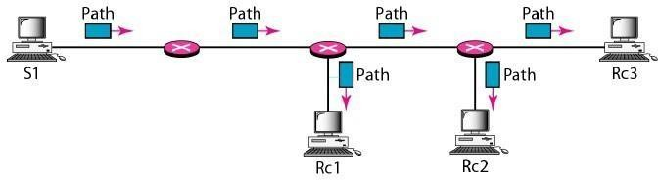

Fig 4.16 Path messages

Resv Messages After a receiver has received a Path message, it sends a Resv message. The Resv message travels toward the sender (upstream) and makes a resource reservation on the routers that support RSVP. Ifa router does not support RSVP on the path, it routes the packet based on the best-effort delivery methods we discussed before. Figure shows the Resv messages.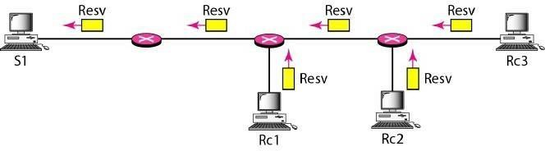

Fig 4.17 Resv messages

### Differentiated Services

Differentiated Services (DS or Diffserv) was introduced by the IETF (Internet Engineering Task Force) to handle the shortcomings of Integrated Services. Two fundamental changes were made:

1. The main processing was moved from the core of the network to the edge of the network. This solves the scalability problem. The routers do not have to store information about flows. The applications, or hosts, define the type of service they need each time they send apacket.
2. The per-flow service is changed to per-class service. The router routes the packet based on the class of service defined in the packet, not the flow. This solves the service-type limitation problem. We can define different types of classes based on the needs of applications.

### Differentiated Services is a class-based QoS model designed for IP.

**DS Field:** In Diffserv, each packet contains a field called the DS field. The value of this field is set at the boundary of the network by the host or the first router designated as the boundary router. IETF proposes to replace the existing TOS (type of service) field in IPv4 or the class field in IPv6 by the DS field,

**Traffic Conditioner:** To implement Oiffserv, the OS node uses traffic conditioners such as meters, markers, shapers, and droppers, as shown in Figure .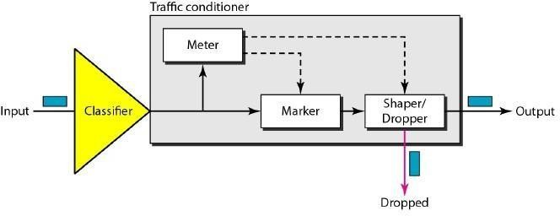

Fig 4.18 Traffic Conditioner

### QoS in Switched Networks

We discussed the proposed models for QoS in the IP protocols. Let us now discuss QoS as used in two switched networks: Frame Relay and ATM. These two networks are virtual-circuit networks that need a signaling protocol such as RSVP.

### QoS in Frame Relay

Four different attributes to control traffic have been devised in Frame Relay: access rate, committed burst size Be' committed information rate (CIR), and excess burst size Be' These are set during the negotiation between the user and the network. For PVC connections, they are negotiated once; for SVC connections, they are negotiated for each connection during connection setup. Figure shows the relationships between these four measurements.

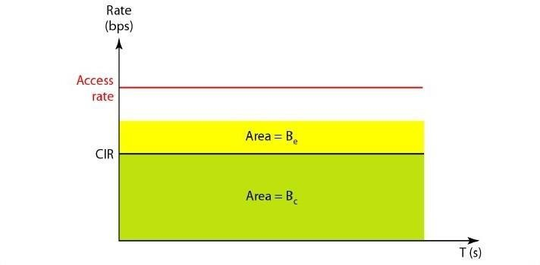

**Access Rate:** For every connection, an access rate (in bits per second) is defined. The access rate actually depends on the bandwidth of the channel connecting the user to the network. The user can never exceed this rate. For example, if the user is connected to a Frame Relay network by a T- l line, the access rate is 1.544 Mbps and can never be exceeded.

**Committed Burst Size:** For every connection, Frame Relay defines a committed burst size Be. This is the maximum number of bits in a predefined time that the network is committed to transfer without discarding any frame or setting the DE bit. For example, if a Be of400 k bits for a period of4s is granted, the user can send up to 400 k bits during a 4-s interval without worrying about any frame loss. Note that this is not a rate defined for each second. It is a cumulative measurement. The user can send 300 k bits during the first second, no data during the second and the third seconds, and finally 100 k bits during the fourth second.

**Committed Information Rate:** The committed information rate (CIR) is similar in concept to committed burst size except that it defines an average rate in bits per second. If the user follows this rate continuously, the network is committed to deliver the frames. However, because it is an average measurement, a user may send data at a higher rate than the CIR at times or at a lower rate other times. As long as the average for the predefined period is met, the frames will be delivered.

**Excess Burst Size:** For every connection, Frame Relay defines an excess burst size Be" This is the maximum number of bits in excess of Be that a user can send during a predefined time. The network is committed to transfer these bits if there is no congestion. Note that there is less commitment here than in the case of Be The network is committing itself conditionally.

### QoS in ATM

The QoS inATM is based on the class, user-related attributes, and network-related attributes.

### Classes

The ATM Forum defines four service classes: CBR, VBR, ABR, and UBR (see Figure)

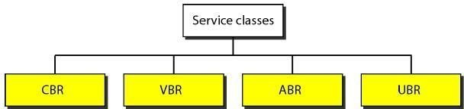

CBR The constant-bit-rate (CBR) class is designed for customers who need real time audio or video services. The service is similar to that provided by a dedicated line such as a T line.

VBR The variable-bit-rate (VBR) class is divided into two subclasses: real-time (VBR-RT) and non-real-time (VBR-NRT). VBR-RT is designed for those users who need real-time services (such as voice and video transmission) and use compression techniques to create a variable bit rate. VBR-NRT is designed for those users who do not need real-time services but use compression techniques to create a variable bit rate.

ABR The available-bit-rate (ABR) class delivers cells at a minimum rate. If more network capacity is available, this minimum rate can be exceeded. ABR is particularly suitable for applications that are bursty.

UBR The unspecified-bit-rate (UBR) class is a best-effort delivery service that does not guarantee anything.

#### TUTORIAL QUESTIONS

* 1. Describe the Adaptive retransmission policy indetail?
  2. Elaborate the CP Connection establishment and termination using timelinediagram?
  3. Describe the three wayhandshake protocol to establish the transport level connection?
  4. Discuss about the CP sliding window algorithm for flow control?
  5. Describe congestion control algorithms in detail?
  6. State the leaky bucket and token bucket algorithm?
  7. Differentiate UDP &TCP?
  8. Describe Distance vector routing protocol and Link State routing algorithm with an example?

#### ASSIGNMENT QUESTIONS

1. Describe how packets delivery mechanism from process to process in Transport Layer?
2. Explain the real transport protocol of UDP and how will you calculate checksum in UDP?
3. Explain the various congestion control mechanism in detail?
4. Explain the TCP segment format?
5. Write short notes on Wrap around time

#### IMPORTANT QUESTIONS

***PART-A-UNIT-IV* (2 or 3 marks*)***

1. List out the socket primitives for TCP.
2. How does a persistence timer is useful in TCP?
3. What is the role of UDP in internet transport protocol?
4. What is meant by Congestion control?
5. List out the QOS in Circuit switched Networks.

***PART-B-UNIT-IV* (5-10 marks)**

1. Explain in brief about TCP connection establishment and Release
2. Write briefly about Congestion control in datagram subnets.
3. Describe in brief about TCP segment Header.
4. What happens when large packet wants to travel through network with smaller maximum packet size? Explain.
5. Explain the general principles of congestion control.
6. Elaborate the Process to process delivery mechanism.
7. Briefly explain about Integrated Services, Differentiated Services.
8. Explain UDP packet format in detail.

#### OBJECTIVE QUESTIONS

1. Urgent data requires the urgent pointer field as well as the URG bit in the field.

A) control B) offset C) sequence number D) none of the above

### Option A

1. To accomplish flow control, TCP uses a window protocol.

A) limited-size B) sliding C) fixed-size D) none of the above

### Option B

1. UDP and TCP are both layer protocols.

A) data link B) network C) transport D) none of the above

### Option C

1. In SCTP, the acknowledgment number and window size are part of each .

A) data chunk B) control chunk C) a or b D) none of the above

### Option B

1. A connection in SCTP is called an .

A) negotiation B) association C) transmission D) none of the above

### Option B

1. The bytes of data being transferred in each connection are numbered by TCP. The numbering starts with a .

A) 0 B) 1 C) randomly generated number D) none of the above

### Option C

1. SCTP allows service in each association.

A) single stream B) multistream C) double stream D) none of the above **Option B**

1. UDP uses to handle outgoing user datagrams from multiple processes on one host.

A) flow control B) multiplexing C) demultiplexing D) none of the above **Option B**

1. TCP delivers out-of-order segments to the process.

A) all B) no C) some D) none of the above

### Option B

1. The ports ranging from 49,152 to 65,535 can be used as temporary or private port numbers. They are called the ports.

A) well-known B) registered C) dynamic D) none of the above

### Option C

#### FILL IN THE BLANKS

1. In queuing, the packets are assigned to different classes and admitted to different queues. The queues, however, are weighted based on the priority of the queues; higher priority means a higher weight. The system processes packets in each queue in a round-robin fashion with the number of packets selected from each queue based on the corresponding weight.

**Answer:** weighted fair

1. In ATM, the class is a best-effort delivery service that does not guarantee anything.

**Answer:** UBR

1. In congestion control, mechanisms are used to alleviate congestion after it happens.

**Answer:** closed-loop

1. happens in any system that involves waiting.

**Answer:** Congestion

1. In Frame Relay, the user can never exceed the_ .

**Answer:** access rate

### UNIT -V

**Application Layer**

The application layer enables the user, whether human or software, to access the network. It provides user interfaces and support for services such as electronic mail, file access and transfer, access to system resources, surfing the world wide web, and network management.

### The application layer is responsible for providing services to the user.

**Domain name space**

To have a hierarchical name space, a domain name space was designed. In this design the names are defined in an inverted-tree structure with the root at the top. The tree can have only 128 levels: level 0 (root) to level 127 (see Figure).

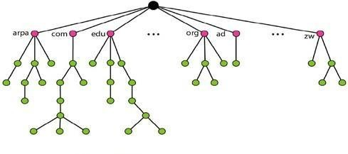

Fig 5.1 Domain name space

**Label:** Each node in the tree has a label, which is a string with a maximum of 63 characters. The root label is a null string (empty string). DNS requires that children of a node (nodes that branch from the same node) have different labels, which guarantees the uniqueness of the domain names. **Domain Name:** Each node in the tree has a domain name. A full domain name is a sequence of labels separated by dots (.). The domain names are always read from the node up to the root. The last label is the label of the root (null). This means that a full domain name always ends in a null label, which means the last character is a dot because the null string is nothing. Figure shows some domain names.

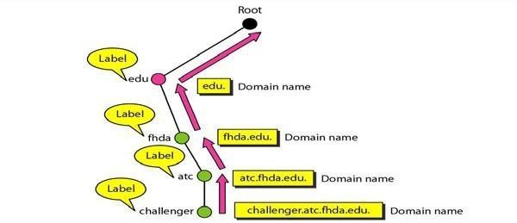

*Fig 5.2 Domain names and labels*

**Fully Qualified Domain Name:** If a label is terminated by a null string, it is called a fully qualified domain name (FQDN). An FQDN is a domain name that contains the full name of a host. It contains all labels, from the most specific to the most general, that uniquely define the name of the host. For example, the domain name is the FQDN of a computer named challenger installed at the Advanced Technology Center (ATC) at De Anza College. A DNS server can only match an FQDN to an address. Note that the name must end with a null label, but because null means nothing, the label ends with a dot (.).

challenger.ate.tbda.edu.

**Partially Qualified Domain Name:** If a label is not terminated by a null string, it is called a partially qualified domain name (PQDN). A PQDN starts from a node, but it does not reach the root. It is used when the name to be resolved belongs to the same site as the client. Here the resolver can supply the missing part, called the suffix, to create an FQDN. For example, if a user at the jhda.edu. site wants to get the IP address of the challenger computer, he or she can define the partial name

challenger

The DNS client adds the suffix atc.jhda.edu. before passing the address to the DNS server. The DNS client normally holds a list of suffixes. The following can be the list of suffixes at De Anza College. The null suffix defines nothing. This suffix is added when the user defines an FQDN.

atc.fhda.edu fhda.edu null Figure shows some FQDNs and PQDNs.

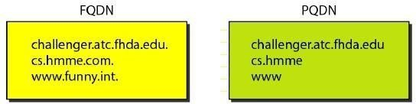

**Domain:** A domain is a subtree of the domain name space. The name of the domain is the domain name of the node at the top of the subtree. Figure shows some domains. Note that a domain may itself be divided into domains (or subdomains as they are sometimes called).

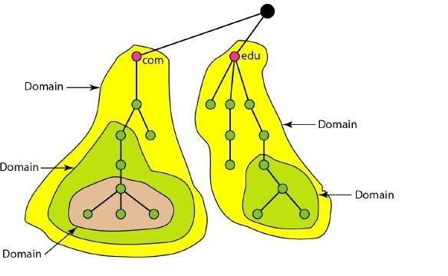

Fig 5.3 Domains

### DNS in internet

DNS is a protocol that can be used in different platforms. In the Internet, the domain name space (tree) is divided into three different sections: generic domains, country domains, and the inverse domain (see Figure).

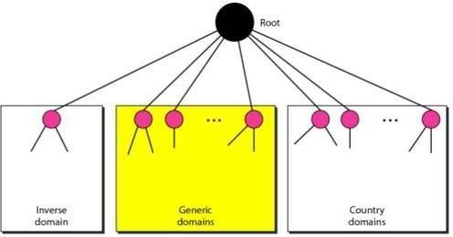

Fig 5.4 DNS used in the Internet

**Generic Domains:** The generic domains define registered hosts according to their generic behavior. Each node in the tree defines a domain, which is an index to the domain name space database (see Figure).

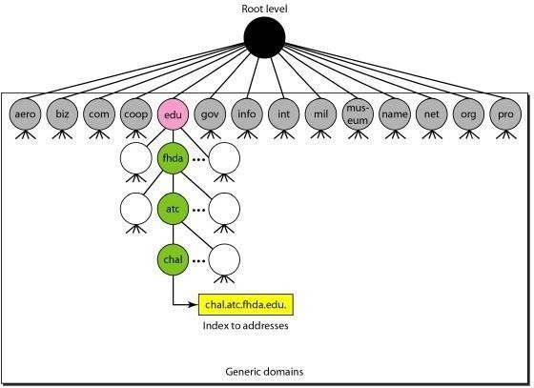

Fig 5.5 Generic Domains

Looking at the tree, we see that the first level in the generic domains section allows 14 possible labels. These labels describe the organization types as listed in Table 5.1.

Table 5.1 Generic domain labels

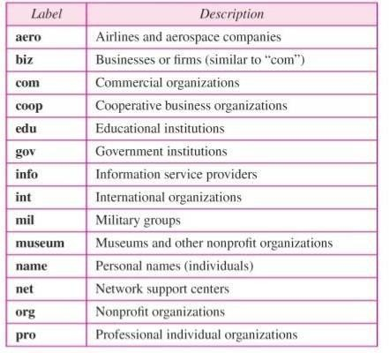

**Country Domains:** The country domains section uses two-character country abbreviations (e.g., us for United States). Second labels can be organizational, or they can be more specific, national designations. The United States, for example, uses state abbreviations as a subdivision of us (e.g., ca.us.).The address anza.cup.ca.us can be translated to De Anza College in Cupertino, California, in the United States.

**Inverse Domain:** The inverse domain is used to map an address to a name. This may happen, for example, when a server has received a request from a client to do a task. Although the server has a file that contains a list of authorized clients, only the IP address of the client (extracted from the received IP packet) is listed. The server asks its resolver to send a query to the DNS server to map an address to a name to determine if the client is on the authorized list. This type of query is called an inverse or pointer (PTR) query. To handle a pointer query, the inverse domain is added to the domain name space with the first-level node called **arpa** (for historical reasons). The second level is also one single node named in-addr (for inverse address). The rest of the domain defines IP addresses. The servers that handle the inverse domain are also hierarchical. This means the netid part of the address should be at a higher level than the subnetid part, and the subnetid part higher than the hostid part. In this way, a server serving the whole site is at a higher level

than the servers serving each subnet. This configuration makes the domain look inverted when compared to a generic or country domain. To follow the convention of reading the domain labels from the bottom to the top, an IF address such as 132.34.45.121 (a class B address with net id 132.34) is read as 121.45.34.132.in-addr. arpa. See Figure 25.11 for an illustration of the inverse domain configuration.

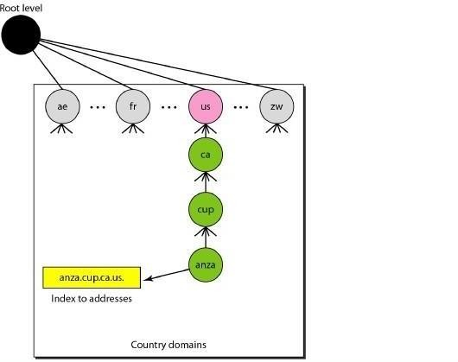

Fig 5.6 Inverse Domain

### Electronic Mail

One of the most popular Internet services is electronic mail (e-mail). The designers of the Internet probably never imagined the popularity of this application program. Its architecture consists of several components that we discuss in this chapter.

At the beginning of the Internet era, the messages sent by electronic mail were short and consisted of text only; they let people exchange quick memos. Today, electronic mail is much more complex. It allows a message to include text, audio, and video. It also allows one message to be sent to one or more recipients.

**Architecture:** To explain the architecture of e-mail, we give four scenarios. We begin with the simplest situation and add complexity as we proceed. The fourth scenario is the most common in the exchange of email.

### First Scenario

In the first scenario, the sender and the receiver of the e-mail are users (or application programs) on the same system; they are directly connected to a shared system. The administrator has created one mailbox for each user where the received messages are stored. A mailbox is part of a local hard drive, a special file with permission restrictions. Only the owner of the mailbox has access to

it. When Alice, a user, needs to send a message to Bob, another user, Alice runs a user agent (VA) program to prepare the message and store it in Bob's mailbox. The message has the sender and recipient mailbox addresses (names of files). Bob can retrieve and read the contents of his mailbox at his convenience, using a user agent. Figure shows the concept.

This is similar to the traditional memo exchange between employees in an office. There is a mailroom where each employee has a mailbox with his or her name on it.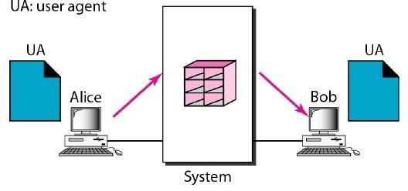

Fig 5.7 First scenario in electronic mail

When Alice needs to send a memo to Bob, she writes the memo and inserts it into Bob's mailbox. When Bob checks his mailbox, he finds Alice's memo and reads it.

When the sender and the receiver of an e-mail are on the same system, we need only two user agents.

### Second Scenario

In the second scenario, the sender and the receiver of the e-mail are users (or application programs) on two different systems. The message needs to be sent over the Internet. Here we need user agents (VAs) and message transfer agents (MTAs), as shown in Figure

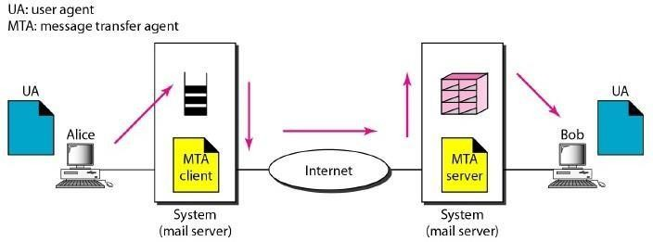

Fig 5.8 Second scenario in electronic mail

Alice needs to use a user agent program to send her message to the system at her own site. The system (sometimes called the mail server) at her site uses a queue to store messages waiting to be sent. Bob also needs a user agent program to retrieve messages stored in the mailbox of the

system at his site. The message, however, needs to be sent through the Internet from Alice's site to Bob's site. Here two message transfer agents are needed: one client and one server. Like most client/server programs on the Internet, the server needs to run all the time because it does not know when a client will ask for a connection. The client, on the other hand, can be alerted by the system when there is a message in the queue to be sent.

When the sender and the receiver of an e-mail are on different systems, we need two VAs and a pair of MTAs (client and server).

### Third Scenario

In the third scenario, Bob, as in the second scenario, is directly connected to his system. Alice, however, is separated from her system. Either Alice is connected to the system via a point-to- point WAN, such as a dial-up modem, a DSL, or a cable modem; or she is connected to a LAN in an organization that uses one mail server for handling e-mails-all users need to send their messages to this mail server. Figure shows the situation.

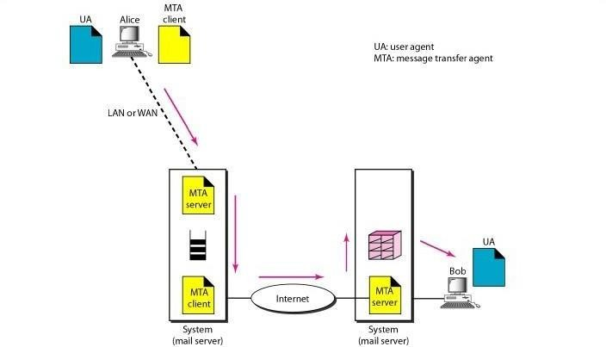

Fig 5.9 Third scenario in electronic mail

Alice still needs a user agent to prepare her message. She then needs to send the message through the LAN or WAN. This can be done through a pair of message transfer agents (client and server). Whenever Alice has a message to send, she calls the user agent which, in tum, calls the MTA client. The MTA client establishes a connection with the MTA server on the system, which is running all the time. The system at Alice's site queues all messages received. It then uses an MTA client to send the messages to the system at Bob's site; the system receives the message and stores it in Bob's mailbox.

At his convenience, Bob uses his user agent to retrieve the message and reads it. Note that we need two pairs of MTA client/server programs.

When the sender is connected to the mail server via a LAN or a WAN, we need two VAs and two pairs of MTAs (client and server).

### Fourth Scenario

In the fourth and most common scenario, Bob is also connected to his mail server by a WAN or a LAN. After the message has arrived at Bob's mail server, Bob needs to retrieve it. Here, we need another set of client/server agents, which we call message access agents (MAAs). Bob uses an MAA client to retrieve his messages. The client sends a request to the MAA server, which is running all the time, and requests the transfer of the messages.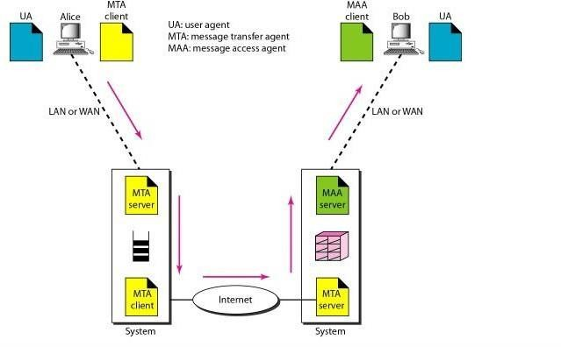

Fig 5.10 Fourth scenario in electronic mail

When both sender and receiver are connected to the mail server via a LAN or a WAN, we need two VAs, two pairs of MTAs (client and server), and a pair of MAAs (client and server). This is the most common situation today.

### User Agent

The first component of an electronic mail system is the user agent (VA). It provides service to the user to make the process of sending and receiving a message easier.

*Services Provided by a User Agent:* A user agent is a software package (program) that composes, reads, replies to, and forwards messages. It also handles mailboxes. Figure 26.11 shows the services of a typical user agent.

### Services of user agent

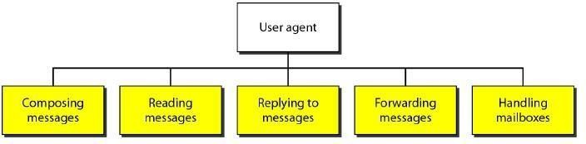

**Composing Messages**: A user agent helps the user compose the e-mail message to be sent out. Most user agents provide a template on the screen to be filled in by the user. Some even have a built-in editor that can do spell checking, grammar checking, and other tasks expected from a sophisticated word processor. A user, of course, could alternatively use his or her favorite text editor or word processor to create the message and import it, or cut and paste it, into the user agent template.

**Reading Messages:** The second duty of the user agent is to read the incoming messages. When a user invokes a user agent, it first checks the mail in the incoming mailbox. Most user agents show a one-line summary of each received mail. Each e-mail contains the following fields.

1. A number field.
2. A flag field that shows the status of the mail such as new, already read but not replied to, or read and replied to. :).
3. The size of the message.
4. The sender.
5. The optional subject field.

**Replying to Messages**: After reading a message, a user can use the user agent to reply to a message. A user agent usually allows the user to reply to the original sender or to reply to all recipients of the message. The reply message may contain the original message (for quick reference) and the new message.

**Forwarding Messages:** Replying is defined as sending a message to the sender or recipients of the copy. Forwarding is defined as sending the message to a third party. A user agent allows the receiver to forward the message, with or without extra comments, to a third party.

**Handling Mailboxes:** A user agent normally creates two mailboxes: an inbox and an outbox. Each box is a file with a special format that can be handled by the user agent. The inbox keeps all the received e-mails until they are deleted by the user. The outbox keeps all the sent e-mails until the user deletes them. Most user agents today are capable of creating customized mailboxes.

### Sending Mail

To send mail, the user, through the UA, creates mail that looks very similar to postal mail. It has an envelope and a message (see Figure ).

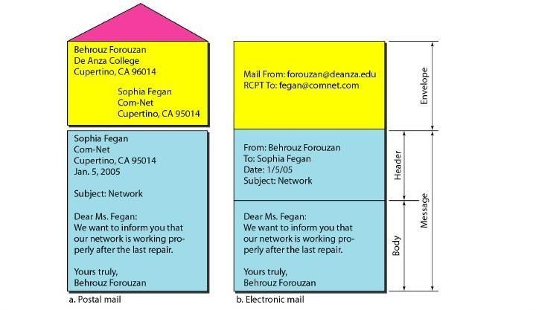

Fig 5.11 Format of an e-mail

Envelope The envelope usually contains the sender and the receiver addresses.

**Message** : The message contains the header and the body. The header of the message defines the sender, the receiver, the subject of the message, and some other information (such as encoding type, as we see shortly). The body of the message contains the actual information to be read by the recipient.

### Receiving Mail

The user agent is triggered by the user (or a timer). If a user has mail, the VA informs the user with a notice. If the user is ready to read the mail. A list is displayed in which each line contains a summary of the information about a particular message in the mailbox. The summary usually includes the sender mail address, the subject, and the time the mail was sent or received. The user can select any of the messages and display its contents on the screen.

### Addresses

To deliver mail, a mail handling system must use an addressing system with unique addresses. In the Internet, the address consists of two parts: a local part and a domain name, separated by an @ sign (see Figure ).

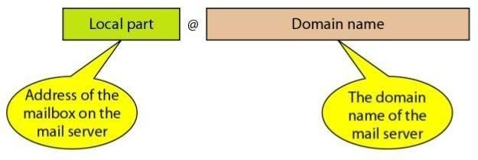

Fig 5.12 E-mail address

**Local Part** The local part defines the name of a special file, called the user mailbox, where all the mail received for a user is stored for retrieval by the message access agent.

**Domain Name** The second part of the address is the domain name. An organization usually selects one or more hosts to receive and send e-mail; the hosts are sometimes called mail servers or exchangers. The domain name assigned to each mail exchanger either comes from the DNS database or is a logical name (for example, the name of the organization).

### Mailing List

Electronic mail allows one name, an alias, to represent several different e-mail addresses; this is called a mailing list. Every time a message is to be sent, the system checks the recipient's name against the alias database; if there is a mailing list for the defined alias, separate messages, one for each entry in the list, must be prepared and handed to the MTA. If there is no mailing list for the alias, the name itself is the receiving address and a single message is delivered to the mail transfer entity.

### Simple Mail Transfer Protocol (SMTP)

The actual mail transfer is done through message transfer agents. To send mail, a system must have the client MTA, and to receive mail, a system must have a server MTA. The formal protocol that defines the MTA client and server in the Internet is called the Simple Mail Transfer Protocol (SMTP). As we said before, two pairs of MTA client/server programs are used in the most common situation (fourth scenario).

SMTP is used two times, between the sender and the sender's mail server and between the two mail servers. As we will see shortly, another protocol is needed between the mail server and the receiver.

Figure shows the range of the SMTP protocol in this scenario.

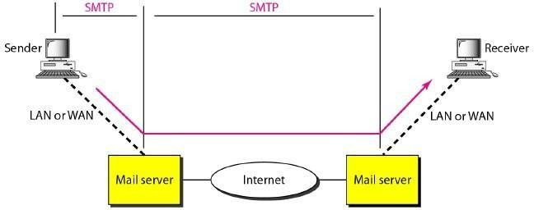

Fig 5.13 SMTP range

SMTP simply defines how commands and responses must be sent back and forth. Each network is free to choose a software package for implementation. We discuss the mechanism of mail transfer by SMTP in the remainder of the section.

### Commands and Responses

SMTP uses commands and responses to transfer messages between an MTA client and an MTA server (see Figure).

### Commands and response

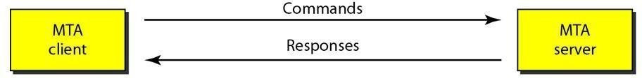

Each command or reply is terminated by a two-character (carriage return and line feed) end-of- line token.

Commands are sent from the client to the server. The format of a command is shown in Figure. It consists of a keyword followed by zero or more arguments. SMTP defines 14 commands. The first five are mandatory; every implementation must support these five commands. The next three are often used and highly recommended. The last six are seldom used.

Command format : **Keyword: argument(s)**

The commands are listed in Table

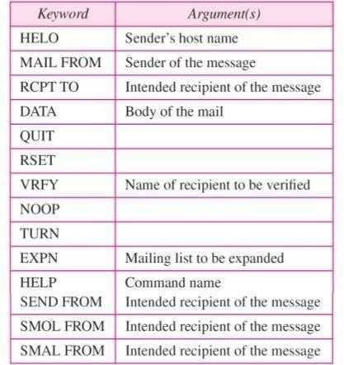

### File Transfer Protocol (FTP)

File Transfer Protocol (FTP) is the standard mechanism provided by TCP/IP for copying a file from one host to another. Although transferring files from one system to another seems simple and straightforward, some problems must be dealt with first. For example, two systems may use

different file name conventions. Two systems may have different ways to represent text and data. Two systems may have different directory structures. All these problems have been solved by FTP in a very simple and elegant approach.

FTP differs from other client/server applications in that it establishes two connections between the hosts. One connection is used for data transfer, the other for control information (commands and responses). Separation of commands and data transfer makes FTP more efficient. The control connection uses very simple rules of communication. We need to transfer only a line of command or a line of response at a time. The data connection, on the other hand, needs more complex rules due to the variety of data types transferred. However, the difference in complexity is at the FTP level, not TCP. For TCP, both connections are treated the same.

FTP uses two well-known TCP ports: Port 21 is used for the control connection, and port 20 is used for the data connection.

FTP uses the services of TCP. It needs two TCP connections. The well-known port 21 is used for the control connection and the well-known port 20 for the data connection.

Figure shows the basic model of FTP. The client has three components: user interface, client control process, and the client data transfer process. The server has two components: the server control process and the server data transfer process. The control connection is made between the control processes. The data connection is made between the data transfer processes.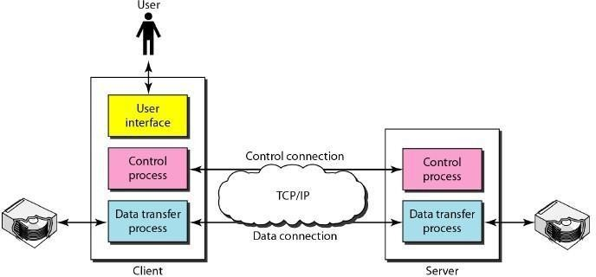

Fig 5.13 FTP

The control connection remains connected during the entire interactive FTP session. The data connection is opened and then closed for each file transferred. It opens each time commands that involve transferring files are used, and it closes when the file is transferred. In other words, when a user starts an FTP session, the control connection opens. While the control connection is open, the data connection can be opened and closed multiple times if several files are transferred.

### Communication over Control Connection

FTP uses the same approach as SMTP to communicate across the control connection. It uses the 7-bit ASCII character set (see Figure). Communication is achieved through commands and responses. This simple method is adequate for the control connection because we send one command (or response) at a time. Each command or response is only one short line, so we need not worry about file format or file structure. Each line is terminated with a two-character (carriage return and line feed) end-of-line token.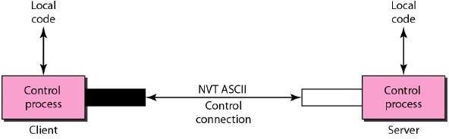

Figure 5.14: Using the control connection

### Communication over Data Connection

The purpose of the data connection is different from that of the control connection. We want to transfer files through the data connection. File transfer occurs over the data connection under the control of the commands sent over the control connection. However, we should remember that file transfer in FTP means one of three things:

* A file is to be copied from the server to the client. This is called retrieving aft/e. It is done under the supervision of the RETR command,
* A file is to be copied from the client to the server. This is called storing aft/e. It is done under the supervision of the STOR command.
* A list of directory or file names is to be sent from the server to the client. This is done under the supervision of the LIST command. Note that FTP treats a list of directory or file names as a file. It is sent over the data connection.

The client must define the type of file to be transferred, the structure of the data, and the transmission mode. Before sending the file through the data connection, we prepare for transmission through the control connection. The heterogeneity problem is resolved by defining three attributes of communication: file type, data structure, and transmission mode (see Figure).

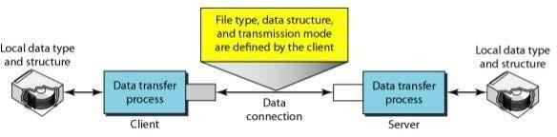

Figure 5.15: Using the data connection

### World Wide Web (WWW)

The World Wide Web (WWW) is a repository of information linked together from points all over the world. The WWW has a unique combination of flexibility, portability, and user-friendly features that distinguish it from other services provided by the Internet. The WWW project was initiated by CERN (European Laboratory for Particle Physics) to create a system to handle distributed resources necessary for scientific research. In this chapter we first discuss issues related to the Web. We then discuss a protocol, HTT, that is used to retrieve information from the Web.

### ARCHITECTURE

The WWW today is a distributed client-server service, in which a client using a browser can access a service using a server. However, the service provided is distributed over many locations called sites, as shown in Figure.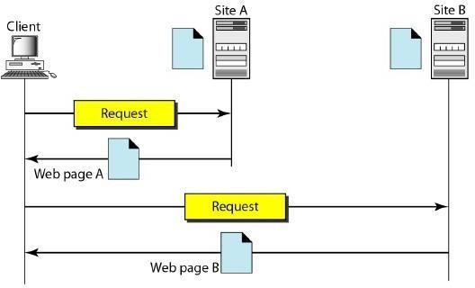

Figure 5.16: Architecture of WWW

Each site holds one or more documents, referred to as Web pages. Each Web page can contain a link to other pages in the same site or at other sites. The pages can be retrieved and viewed by using browsers. Let us go through the scenario shown in Figure 27.1. The client needs to see some information that it knows belongs to site A. It sends a request through its browser, a program that is designed to fetch Web documents. The request, among other information, includes the address of the site and the Web page, called the URL, which we will discuss shortly. The server at site A finds the document and sends it to the client. When the user views the document, she finds some references to other documents, including a Web page at site B. The reference has the URL for the new site. The user is also interested in seeing this document. The client sends another request to the new site, and the new page is retrieved.

**Client (Browser) :** A variety of vendors offer commercial browsers that interpret and display a Web document, and all use nearly the same architecture. Each browser usually consists of three parts: a controller, client protocol, and interpreters. The controller receives input from the keyboard or the mouse and uses the client programs to access the document. After the document has been accessed, the controller uses one of the interpreters to display the document on the screen. The client protocol can be one of the protocols described previously such as FTP or HTIP (described later in the chapter). The interpreter can be HTML, Java, or JavaScript, depending on the type of document. We discuss the use of these interpreters based on the document type later in the chapter (see Figure).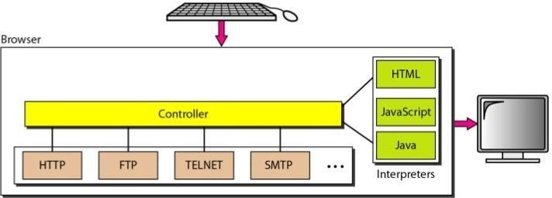

Figure 5.17 : Browser

**Server:** The Web page is stored at the server. Each time a client request arrives, the corresponding document is sent to the client. To improve efficiency, servers normally store requested files in a cache in memory; memory is faster to access than disk. A server can also become more efficient through multithreading or multiprocessing. In this case, a server can answer more than one request at a time.

### Uniform Resource Locator

A client that wants to access a Web page needs the address. To facilitate the access of documents distributed throughout the world, HTTP uses locators. The uniform resource locator (URL) is a standard for specifying any kind of information on the Internet. The URL defines four things: protocol, host computer, port, and path (see Figure 27.3).

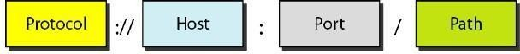

Figure 5.18: URL

The protocol is the client/server program used to retrieve the document. Many different protocols can retrieve a document; among them are FTP or HTTP. The most common today is HTTP.

The host is the computer on which the information is located, although the name of the computer can be an alias. Web pages are usually stored in computers, and computers are given alias names that usually begin with the characters "www". This is not mandatory, however, as the host can be any name given to the computer that hosts the Web page.

The URL can optionally contain the port number of the server. If the port is included, it is inserted between the host and the path, and it is separated from the host by a colon.

Path is the pathname of the file where the information is located. Note that the path can itself contain slashes that, in the UNIX operating system, separate the directories from the subdirectories and files.

### Cookies

The World Wide Web was originally designed as a stateless entity. A client sends a request; a server responds. Their relationship is over. The original design ofWWW, retrieving publicly available documents, exactly fits this purpose. Today the Web has other functions; some are listed here.

1. Some websites need to allow access to registered clients only.
2. Websites are being used as electronic stores that allow users to browse through the store, select wanted items, put them in an electronic cart, and pay at the end with a credit card.
3. Some websites are used as portals: the user selects the Web pages he wants to see.
4. Some websites are just advertising.

### Hypertext Transfer Protocol (HTTP)

The Hypertext Transfer Protocol (HTTP) is a protocol used mainly to access data on the World Wide Web. HTTP functions as a combination of FTP and SMTP. It is similar to FTP because it transfers files and uses the services of TCP. However, it is much simpler than FTP because it uses only one TCP connection. There is no separate control connection; only data are transferred between the client and the server.

HTTP is like SMTP because the data transferred between the client and the server look like SMTP messages. In addition, the format of the messages is controlled by MIME-like headers. Unlike SMTP, the HTTP messages are not destined to be read by humans; they are read and interpreted by the HTTP server and HTTP client (browser). SMTP messages are stored and forwarded, but HTTP messages are delivered immediately. The commands from the client to the

server are embedded in a request message. The contents of the requested file or other information are embedded in a response message. HTTP uses the services of TCP on well-known port 80.

### HTTP uses the services of TCP on well-known port80.

**HTTP Transaction**

Figure illustrates the HTTP transaction between the client and server. Although HTTP uses the services of TCP, HTTP itself is a stateless protocol. The client initializes the transaction by sending a request message. The server replies by sending a response.

### Messages

The formats of the request and response messages are similar; both are shown in Figure . A request message consists of a request line, a header, and sometimes a body. A response message consists of a status line, a header, and sometimes a body.

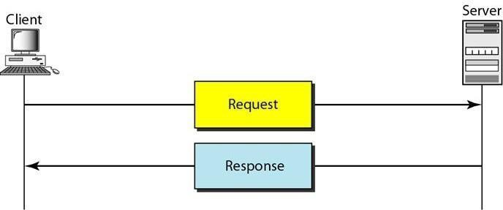

Figure 5.19: HTTP transaction

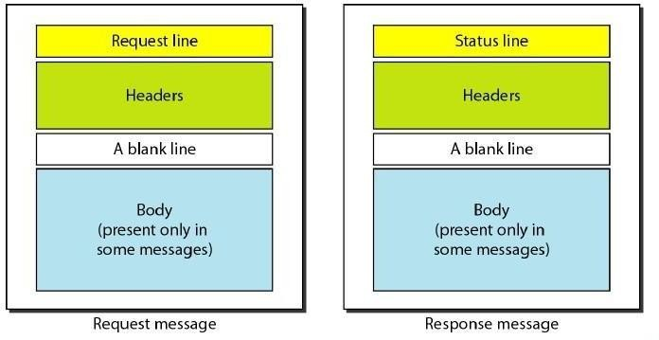

Figure 5.20 : Request and response messages

**Request and Status Lines**: The first line in a request message is called a request line; the first line in the response message is called the status line. There is one common field, as shown in Figure.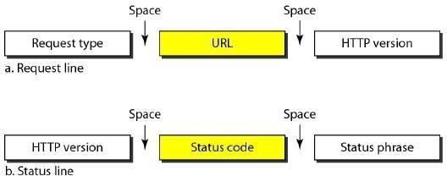

Figure 5.21: Request and status lines

**Request type**: This field is used in the request message. In version 1.1 of HTTP, several request types are defined. The request type is categorized into methods as defined in Table.

### Table: Methods

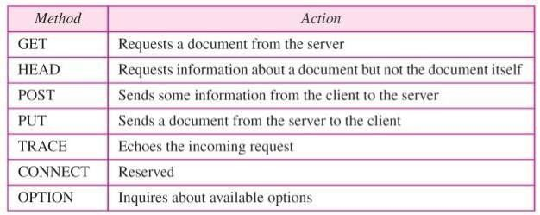

* *URL.* We discussed the URL earlier in the chapter.
* *Version.* The most current version of HTTP is 1.1.
* *Status code*. This field is used in the response message. The status code field is similar to those in the FTP and the SMTP protocols. It consists of three digits. Whereas the codes in the 100 range are only informational, the codes in the 200 range indicate a successful request. The codes in the 300 range redirect the client to another URL, and the codes in the 400 range indicate an error at the client site. Finally, the codes in the 500 range indicate an error at the server site.
* *Status phrase*. This field is used in the response message. It explains the status code in text form.

**Header**: The header exchanges additional information between the client and the server. For example, the client can request that the document be sent in a special format, or the server can send extra information about the document. The header can consist of one or more header lines. Each header line has a header name, a colon, a space, and a header value.

### Simple Network Management Protocol (SNMP)

The Simple Network Management Protocol (SNMP) is a framework for managing devices in an internet using the TCPIIP protocol suite. It provides a set of fundamental operations for monitoring and maintaining an internet.

### Concept

SNMP uses the concept of manager and agent. That is, a manager, usually a host, controls and monitors a set of agents, usually routers (see Figure 28.2).

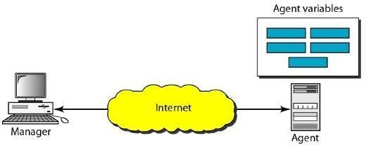

Figure 5.22: SNMP concept

SNMP is an application-level protocol in which a few manager stations control a set of agents. The protocol is designed at the application level so that it can monitor devices made by different manufacturers and installed on different physical networks. In other words, SNMP frees management tasks from both the physical characteristics of the managed devices and the underlying networking technology. It can be used in a heterogeneous internet made of different LANs and WANs connected by routers made by different manufacturers.

### Managers and Agents

A management station, called a manager, is a host that runs the SNMP client program. A managed station, called an agent, is a router (or a host) that runs the SNMP server program. Management is achieved through simple interaction between a manager and an agent.

The agent keeps performance information in a database. The manager has access to the values in the database. For example, a router can store in appropriate variables the number of packets received and forwarded. The manager can fetch and compare the values of these two variables to see if the router is congested or not. The manager can also make the router perform certain actions. For example, a router periodically checks the value of a reboot counter to see when it

should reboot itself. It reboots itself, for example, if the value of the counter is O. The manager can use this feature to reboot the agent remotely at any time. It simply sends a packet to force a 0 value in the counter.

Agents can also contribute to the management process. The server program running on the agent can check the environment, and if it notices something unusual, it can send a warning message, called a trap, to the manager.

In other words, management with SNMP is based on three basic ideas:

1. A manager checks an agent by requesting information that reflects the behavior of the agent. 2. A manager forces an agent to perform a task by resetting values in the agent database. 3. An agent contributes to the management process by warning the manager of an unusual situation. **Management Components**

To do management tasks, SNMP uses two other protocols: Structure of Management Information (SMI) and Management Information Base (MIB). In other words, management on the Internet is done through the cooperation of the three protocols SNMP, SMI, and MIB, as shown in Figure.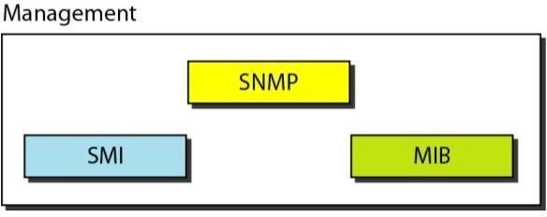

Figure 5.23: Components of network management on the Internet

## Security Services

**PGP:** Pretty Good Privacy (PGP) is a data encryption and decryption computer program that provides cryptographic privacy and authentication for data communication. PGP is often used for signing, encrypting and decrypting e-mails to increase the security of e-mail communications. PGP and similar products follow the Open PGP standard for encrypting and decrypting data.

PGP encryption uses a serial combination of hashing, data compression, symmetric-key cryptography, and, finally, public-key cryptography; each step uses one of several supported algorithms. Each public key is bound to a user name and/or an e-mail address, which uses a hierarchical approach based on certificate authority and which was added to PGP implementations later. Current versions of PGP encryption include both options through an automated key management server.



Compatibility

As PGP evolves, PGP systems that support newer features and algorithms are able to create encrypted messages that older PGP systems cannot decrypt, even with a valid private key. Thus, it is essential that partners in PGP communication understand each other's capabilities or at least agree on PGP settings.

### Digital signatures:

PGP supports message authentication and integrity checking. The latter is used to detect whether a message has been altered since it was completed (the message integrity property), and the former to determine whether it was actually sent by the person/entity claimed to be the sender (a digital signature). In PGP, these are used by default in conjunction with encryption, but can be applied to plaintext as well. The sender uses PGP to create a digital signature for the message with either the RSA or DSA signature algorithms. To do so, PGP computes a hash (also called a message digest) from the plaintext, and then creates the digital signature from that hash using the sender's private keys.

### Security quality:

To the best of publicly available information, there is no known method which will allow a person or group to break PGP encryption by cryptographic or computational means. , cryptographer Bruce Schneier characterized an early version as being "the closest you're likely to get to military- grade encryption." Early versions of PGP have been found to have theoretical vulnerabilities and so current versions are recommended. In addition to protecting data in transit over a network, PGP encryption can also be used to protect data in long-term data storage such as disk files.

The cryptographic security of PGP encryption depends on the assumption that the algorithms used are unbreakable by direct cryptanalysis with current equipment and techniques. For instance, in the original version, the RSA algorithm was used to encrypt session keys; RSA's security depends upon the one-way function nature of mathematical integer factoring. Likewise, the secret key algorithm used in PGP version 2 was IDEA, which might, at some future time, be found to have a previously unsuspected cryptanalytic flaw. Specific instances of current PGP, or IDEA, insecurities—if they exist—are not publicly known. As current versions of PGP have added additional encryption algorithms, the degree of their cryptographic vulnerability varies with the algorithm used. In practice, each of the algorithms in current use is not publicly known to have cryptanalytic weaknesses.

New versions of PGP are released periodically and vulnerabilities that developers are aware of are progressively fixed. Any agency wanting to read PGP messages would probably use easier means than standard cryptanalysis, e.g. rubber-hose cryptanalysis or black-bag cryptanalysis i.e. installing some form of trojan horse or keystroke logging software/hardware on the target computer to capture encrypted keyrings and their passwords. The FBI has already used this attack against PGP in its investigations. However, any such vulnerabilities apply not just to PGP, but to all encryption software.

**SSH**:

Secure Shell or SSH is a network protocol that allows data to be exchanged using a secure channel between two networked devices. Used primarily on Linux and Unix based systems to access shell accounts, SSH was designed as a replacement for Telnet and other insecure remote shells, which send information, notably passwords, in plaintext, rendering them susceptible to packet analysis. The encryption used by SSH provides confidentiality and integrity of data over an insecure network, such as the Internet SSH uses public-key cryptography to authenticate the remote computer and allow the remote computer to authenticate the user, if necessary. SSH is typically used to log into a remote machine and execute commands, but it also supports tunneling, forwarding TCP ports and X11 connections; it can transfer files using the associated SFTP or SCP protocols. SSH uses the client-server model.

The standard TCP port has been assigned for contacting SSH servers.

An SSH client program is typically used for establishing connections to an SSH daemon accepting remote connections. Both are commonly present on most modern operating systems, including Mac OS X, Linux, FreeBSD, Solaris and OpenVMS. Proprietary, freeware and open source versions of various levels of complexity and completeness exist. The SSH-2 protocol has an internal architecture with well-separated layers. These are: The transport layer: This layer handles initial key exchange and server authentication and sets up encryption, compression and integrity verification. It exposes to the upper layer an interface for sending and receiving plaintext packets of up to 32,768 bytes each (more can be allowed by the implementation). The transport layer also arranges for key re-exchange, usually after 1 GB of data has been transferred or after 1 hour has passed, whichever is sooner. The user authentication layer: This layer handles client authentication and provides a number of authentication methods. Authentication is client-driven:

when one is prompted for a password, it may be the SSH client prompting, not the server. The server merely responds to client's authentication requests. Widely used user authentication methods include the following:

*password: a method for straightforward password authentication, including a facility allowing a password to be changed. This method is not implemented by all programs.

*public key: a method for public key-based authentication, usually supporting at least DSA or RSA key pairs

*keyboard-interactive :a versatile method where the server sends one or more prompts to enter information and the client displays them and sends back responses keyed-in by the user. Used to provide one-time password authentication such as S/Key or Secure ID. Used by some Open SSH configurations when PAM is the underlying host authentication provider to effectively provide password authentication, sometimes leading to inability to log in with a client that supports just the plain password authentication method.

*GSSAPI authentication methods which provide an extensible scheme to perform SSH authentication using external mechanisms such as Kerberos 5 or NTLM, providing single sign on capability to SSH sessions. These methods are usually implemented by commercial SSH implementations for use in organizations, though Open SSH does have a working GSSAPI implementation. The connection layer: This layer defines the concept of channels, channel requests and global requests using which SSH services are provided. A single SSH connection can host multiple channels simultaneously, each transferring data in both directions. Channel requests are used to relay out-of-band channel specific data, such as the changed size of a terminal window or the exit code of a server-side process. The SSH client requests a server-side port to be forwarded using a global request. Standard channel types include:

*shell for terminal shells, SFTP and exec requests (including SCP transfers)

*direct-tcpip for client-to-server forwarded connections

*forwarded-tcpip for server-to-client forwarded connections The SSHFP DNS record provides the public host key fingerprints in order to aid in verifying the authenticity of the host.

This open architecture provides considerable flexibility, allowing SSH to be used for a variety of purposes beyond secure shell. The functionality of the transport layer alone is comparable to

Transport Layer Security (TLS); the user authentication layer is highly extensible with custom authentication methods; and the connection layer provides the ability to multiplex many secondary sessions into a single SSH connection, a feature comparable to BEEP and not available in TLS.

Since SSH-1 has inherent design flaws which make it vulnerable (e.g., man-in-the-middle attacks), it is now generally considered obsolete and should be avoided by explicitly disabling fallback to SSH-1. While most modern servers and clients support SSH-2, some organizations still use software with no support for SSH-2, and thus SSH-1 cannot always be avoided. Security Issues:

In all versions of SSH, it is important to verify unknown public keys before accepting them as valid. Accepting an attacker's public key as a valid public key has the effect of disclosing the transmitted password and allowing man-in-the-middle attacks

#### TUTORIALSHEETS

* 1. Discuss how the Simple Mail Transfer Protocol (SMTP) is useful in electronic mail?
  2. Describe in detail about the World Wide Web (WWW)?
  3. With neat diagram explain the working principle of FTP and in detail.
  4. Differentiate between ARP and RARP?
  5. State the specific purposes of the DNS, HTTP, SMB, and SMTP/POP application layer protocols?

#### ASSIGNMENT QUESTIONS

1. List different Data types used for Presentation formatting?
2. Define two methods of HTTP?
3. Define Big-endian format and little-endian format?
4. Describe the role of the local name server and the authoritative name serverin DNS?
5. Define Domain Name Service (DNS) and explain in detail about the domain hierarchy and name servers?
6. What are working principles of Simple Network Management Protocol (SNMP)?

#### IMPORTANT QUESTIONS

***PART-A-UNIT-V* (2 or 3 marks)**

1. Define URL.
2. What is TELENET?
3. What is the architecture of WWW?
4. Explain the differences between POP3 and IMAP.
5. Explain about SMTP and SNMP.
6. What is DNS?200
7. What is Electronic Mail?

***PART-B-UNIT-V* (5-10 marks)**

1. Define HTML? Discuss in brief about Common HTML Tags.
2. What is HTTP? Describe in brief about HTTP request methods?
3. What is DNS? What are the services provided by DNS and explain how it works.
4. Write short notes on the following:
   1. MIME (b) Audio compression (c) DNS (d) Voice over IP.
5. Explain about FTP with neat diagram.
6. Briefly discuss about WWW and Electronic Mail.

#### OBJECTIVE QUESTIONS

1. piece of icon or image on a web page associated with another webpage is called

1. url B) hyperlink C) plugin D) none of the mentioned

### Option D

1. E-mail is
   1. Loss-tolerant application
   2. Bandwidth-sensitive application
   3. Elastic application
   4. None of the mentioned

### Option C

1. Which of the following is an application layer service ?
   1. Network virtual terminal
   2. File transfer, access, and management
   3. Mail service
   4. All of the mentioned

### Option D

1. To deliver a message to the correct application program running on a host, the address must be consulted **Option C**
   1. IP
   2. MAC
   3. Port
   4. None of the mentioned
2. This is a time-sensitive service: **Option D**
   1. File transfer
   2. File download
   3. E-mail
   4. Internet telephony
3. Electronic mail uses this Application layer protocol **Option A**
   1. SMTP
   2. HTTP
   3. FTP
   4. SIP

#### FILL IN THE BLANKS

1… is not an application layer protocol?

**Answer:** resource reservation protocol

2… protocol is a signaling communication protocol used for controlling multimedia

Communication sessions?

**Answer:** session initiation protocol

1. protocols are used by both source and destination devices during a communication Session

**Answer:** application layer

1. Consider different activities related to email:

m1: Send an email from a mail client to a mail server

m2: Download an email from mailbox server to a mail client m3: Checking email in a web browser

……………….application level protocol used in each activity?

| **Answer:** | m1: SMTP m2: POP m3: HTTP |
| --- | --- |

1. is the maximum size of data that the application layer can pass on to the TCP layer below?

| **Answer:** | Any size |
| --- | --- |

### MALLA REDDY ENGINEERING COLLEGE FOR WOMEN

**Permanently Affiliated to JNTUH, Approved by AICTE, ISO 9001:2015 Certified Institution**

### Accredited by NBA & NAAC with ‘A’ Grade DEPARTMENT OF COMPUTER SCIENCE AND ENGINEERING

**COMPUTER NETWORKS**

#### INTERNAL QUESTION PAPER-I

SUB: **DCCN** CLASS/SEM/BRACH*:* ***III-I C*SE/IT**

DATE**:** SECTION**: *A, B, C and D and IT***

TIME**: *90 MIN*** MARKS**: 4*0 marks***

#### PART-A

*Answer All the following Questions (5*2=10 M)*

* 1. Define the following terms:
     1. Computer Network ii) Peer Process iii) Protocol iv) Interface
  2. What are the Concepts of Extension Header in IPV6?
  3. Mention the Standard Organizations for communication Standards?
  4. What is Frame Relay?
  5. Differentiate between Pure Aloha and Slotted Aloha?

#### PART-B

***Answer the following Questions (3*10=30 M)***

1. A) Explain OSI Reference model with neat diagram?

### (OR)

1. List and briefly discuss the two different transmission mediums?
2. A) Explain the working of ALOHA protocol?

### (OR)

B) How performance is improved in CSMA/CD protocol compared to CSMA protocol?

1. A) Describe about sliding window protocol?

### (OR)

B) How would you describe the operation of Address resolution protocol?

## MALLA REDDY ENGINEERING COLLEGE FOR WOMEN

### (Autonomous Institution – UGC Govt. of India)

***(Permanently Affiliated to JNTUH, Approved by AICTE, Accredited by NBA and NAAC with A grade– ISO 9001-2015Certified)***

**NIRF India Ranking 2018, Accepted by MHRD, GOVT. of India, AAA+ Rated by CAREER 360**

## Tech Sem – I (R-18) MID - II Question Paper A.Y:2020-2021



**Branch: CSE Subject Name: Computer Networks**

**YEAR/SEC: III/ A, B, C&D Max Marks: 20**

**Date of Exam: 04/02/21 Time of Exam: 10.00AM to 12.00PM**



## Answer FOUR of following Questions

| 1 | a. What is purpose of ICMP? Explain its messages in detail. | 5M |
| --- | --- | --- |
| b. Explain briefly about tunneling | 5M |
| 2 | a. Describe in brief about TCP segment Header. | 5M |
| b. Explain in brief about TCP connection establishment and Release | 5M |
| 3 | Compare and contrast between integrated services and Differential Services. | 10M |
| 4 | a. Elucidate congestion prevention polices. | 5M |
| b. Explain the architecture of WWW? | 5M |
| 5 | How would you summarize the concepts of E-mail, its architecture and services? | 10M |
| 6 | a. What is the use of DNS? Explain how it works? | 5M |
| b. What is SNMP? Briefly discuss the SNMP model components. | 5M |

Accredited by NBA & NAAC with ‘A’ Grade, ISO 9001:2015 Certified Institution

### Common to CSE and IT

**III B.Tech I Sem Mid – 2 Examination**

### Sub: Computer Networks Date: 27-10-2020

**Answer any 5 of the following. 5 x 5M = 20M**

1. With a neat diagram explain the OSI reference model in detail? Explain the functions performed in each layer.
2. Briefly explain about different transmission media used in computer networking.
3. Elaborate switching methods. What are the most common today?
4. Discuss about Error-Correcting Codes (Hamming code)?
5. Demonstrate CRC error detection method with an example.
6. Illustrate how flow and error control performed in Stop and Wait ARQ protocol with flow diagram?
7. What is high level data link control (HDLC)? Explain HDLC frame format in detail.
8. What is classful addressing? Discuss class A, class B, class C, class D, class E address with its range in decimal dotted notation and example.

### MALLA REDDY ENGINEERING COLLEGE FOR WOMEN

**Permanently Affiliated to JNTUH, Approved by AICTE, ISO 9001:2015 Certified Institution**

### Accredited by NBA & NAAC with ‘A’ Grade DEPARTMENT OF COMPUTER SCIENCE AND ENGINEERING

**DATA COMMUNICATION AND COMPUTER NETWORKS**

***EXTERNAL QUESTION PAPERS***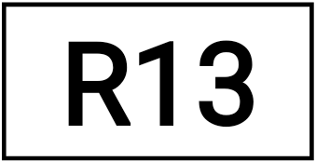

### Code No: 115DT

**JAWAHARLAL NEHRU TECHNOLOGICAL UNIVERSITY HYDERABAD**

### B. Tech III Year I Semester Examinations, February/March - 2016 COMPUTER NETWORKS

**(Common to CSE, IT)**

### Time: 3 hours Max. Marks: 75

**Note:** This question paper contains two parts A and B.

Part A is compulsory which carries 25 marks. Answer all questions in Part A. Part B consists of 5 Units. Answer any one full question from each unit. Each question carries 10 marks and may have a, b, c as sub questions.

|  | **PART- A** |  |
| --- | --- | --- |
|  |  | **(25Marks)** |
| 1.a) | What is meant by protocol. | [2] |
| b) | What is piggybacking? | [3] |
| c) | Define bridge. | [2] |
| d) | Describe in brief about Types of Ethernet cabling. | [3] |
| e) | What is virtual circuit? | [2] |
| f) | What are the issues in routing? | [3] |
| g) | Define Tunneling. | [2] |
| h) | List out the socket primitives for TCP. | [3] |
| i) | Define URL. | [2] |
| j) | List out different types of HTML Tags. | [3] |

### PART-B (50 Marks)

* 1. a)Write any four reasons for using layered protocols.

b) Explain the functionality of each layer in OSI reference model. [5+5]

### OR

* 1. Explain in brief about the design issues in the data link layer. [10]
  2. Explain the functions of following devices:
     1. Hub
     2. Bridge
     3. Router
     4. Gateway [3+2+3+2]

### OR

* 1. a)What are the functions of medium access control layers protocol? Explain.

b) Explain IEEE 802.3 standard for Ethernet with the help of frame format. [5+5]

6.a) The major problem with distance vector algorithm is ‘count to infinity’. How exchange of complete path from router to destination instead of delay, helps in solving count to infinity problem.

b) What are the advantages of adaptive routing approach over non adaptive routing? [5+5]

### OR

7. Describe Dijkstra shortest path algorithm. Also show working

of Dijkstra algorithm with the help of an example [10]

8.a) Explain in brief about TCP connection establishment and Release.

b) Describe in brief about TCP segment Header. [5+5]

### OR

1. Explain the elements of a Transport protocol? [10]
2. What is electronic mail? Describe in brief about sending and receiving e-mail.[10]

### OR

11.a) Define HTML? Discuss in brief about Common HTML Tags.

b) What is HTTP? Describe in brief about HTTP request methods.[5+5]



### JAWAHARLAL NEHRU TECHNOLOGICAL UNIVERSITY HYDERABAD

**B. Tech III Year I Semester Examinations, November/December - 2016 COMPUTER NETWORKS**

### (Common to CSE, IT)

**Time: 3 hours Max. Marks:**

### 75

**Note:** This question paper contains two parts A and B.

Part A is compulsory which carries 25 marks. Answer all questions in Part A. Part B consists of 5 Units. Answer any one full question from each unit. Each question carries 10 marks and may have a, b, c as sub questions.

### PART-A

| 1.a) | What is Frame Relay? | [2] |
| --- | --- | --- |
| b) | Write about communication satellites. | [3] |
| c) | Define time domain reflectometry.. | [2] |
| d) | Difference between Pure ALOHA and slotted ALOHA. | [3] |
| e) | Write about Jitter control. | [2] |
| f) | Write down the design issue of network layers. | [3] |
| g) | Write about Tunneling. | [2] |
| h) | What are the concepts of extension header in IPv6? | [3] |
| i) | Compare RPC and RTP. | [2] |
| j) | How does persistence timer is useful in TCP ? | [3] |

**Part-B (50 Marks)**

1. a) Write short notes on Wireless Transmission.

b) Describe in detail about Light wave transmission. [3+7]

### OR

1. Explain and demonstrate Selective repeat sliding window Protocol with an example.

[10]

1. What is the purpose of CSMA CD? And Explain it. [10]

### OR

1. Explain about the following:
   1. Spanning Tree Bridge
   2. Remote bridge [5+5]

1. Write briefly about Congestion control in datagram subnets. [10]

### OR

1. Write an example, demonstrate how to make routing table using distance vector routing. And list down the limitation. [10]
2. How would you describe the operation of Address resolution protocol? [10]

### OR

1. Explain in detail about crash recovery. [10]
2. How would you summarize the concept of Email and its architecture and services [10]

### OR

1. Describe in detail about TCP segment header and connection Establishment. [10]

### ---ooOoo---

**Code No: 115DT**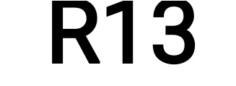

### JAWAHARLAL NEHRU TECHNOLOGICAL UNIVERSITY HYDERABAD

**B. Tech III Year I Semester Examinations, November/December - 2017 COMPUTER NETWORKS**

### (Common to CSE, IT)

**Time: 3 hours Max. Marks: 75**

**Note:** This question paper contains two parts A and B.

Part A is compulsory which carries 25 marks. Answer all questions in Part A. Part B consists of 5 Units. Answer any one full question from each unit

Each question carries 10 marks and may have a, b, c as sub questions.

|  | **PART- A** |  |
| --- | --- | --- |
|  |  | **(25 Marks)** |
| 1.a) | Write the advantages of optical fiber over twisted-pair and  coaxial cables. | [2] |
| b) | What are the advantages of having layered architecture? | [3] |
| c) | Briefly explain the difference between switch and router. | [2] |
| d) | Sketch the Manchester encoding for the bit stream: 0001110101. | [3] |
| e) | Give the advantages of hierarchical routing. | [2] |
| f) | Differences between CO and CL. | [3] |
| g) | Explain DHCP. | [2] |
| h) | What are the functions of ICMP? | [3] |
| i) | What is the architecture of WWW? | [2] |
| j) | Describe Standards. | [3] |

### PART-B (50 Marks)

1. a)Compare and contrast the OSI and TCP/IP reference models.

b) What are the different types of error detection methods? Explain the CRC error detection technique using generator polynomial x4+x3+1 and data 11100011. [5+5]

### OR

3.a) Discuss about the various transmission media available at the physical layer.

b) Explain about GBN Sliding Window Protocol. [5+5]

Explain the differences between POP3 and IMAP.

4.a) Explain the differences between the switching methods.

b) Elucidate the CSMA schemes.. [5+5]

### OR

| 5.a)  b) | Illustrate the frame structure of  IEEE 802.3. Give a detail note on the ALOHA protocols. | [5+5] |
| --- | --- | --- |
| 6.a)  b) | Elucidate Distance Vector Routing Algorithm with example. Describe the problem and solutions associated with distance vector  routing. | [5+5] |

**OR**

7.a) Explain the general principles of congestion control.

b) Describe congestion control in datagram subnets. [5+5]

8.a) Elucidate the special IP addresses used in internet.

b) Discuss the significance and the operation of NAT. [5+5]

### OR

9.a) Illustrate the connection establishment and release in transport layer.

b) How crash recovery is managed at the transport layer? [5+5]

10.a) Explain Real-time transport protocol.

b) When user clicks a hyperlink, what are the steps that occur between the user’s click and the page being displayed? [5+5]

### OR

* 1. Write short notes on the following: [10]
     1. MIME (b) Audio compression (c) DNS (d) Voice over IP.

### ---oo0oo---

**JAWAHARLAL NEHRU TECHNOLOGICAL UNIVERSITY HYDERABAD**

### B. Tech III Year I Semester Examinations, November/December - 2017

**COMPUTER NETWORKS**

### (Common to Computer Science and IT)

Time: 3 hours Max Marks: 75

Note: This question paper contains two parts A and B.

Part A is compulsory which carries 25 marks. Answer all questions in Part A. Part B consists of 5 Units. Answer any one full question from each unit. Each question carries 10 marks and may have a, b, c as sub questions.

### PART-A

| 1. | What is the use of data link layer ? | [2m] |
| --- | --- | --- |
| b) | What is ARP? Explain. | [3m] |
| c) | Explain about Broadcast link. | [2m] |
| d) | Give the classification of multiple access protocols. | [3m] |
| e) | Write any two services network layer provides to transport layer. | [2m] |
| f) | Explain about datagram and virtual circuit. | [3m] |
| g) | What is internetworking? | [2m] |
| h) | List out the internetworking devices | [3m] |
| i) | What is the role of UDP in internet transport protocol? | [2m] |
| j) | What is TELENET? | [3m] |

**PART-B**

1. Explain about various transmission media in physical layer with a neat sketch. [10]

### OR

1. Elaborate on the design issues of data link layer. [10]
2. Write in detail on Time–Division Multiplexing and Frequency-Division Multiplexing with an example for each. [10]

### OR

1. Write and explain about various multiple access protocols. [10]
2. Explain the Optimality Principle with a suitable example.[10]

### OR

1. Explain distance vector routing algorithm. [10]
2. What happens when large packet wants to travel through network with smaller maximum packet size? Explain. [10]

### OR

1. Explain tree-structured numbering scheme. [10**]**
2. Explain about RPC with a neat sketch. [10]

### OR

1. What is DNS? What are the services provided by DNS and explain how it works.[10]

Code No: 1805PC09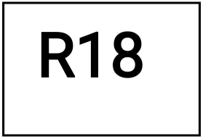

## MALLA REDDY ENGINEERING COLLEGE FOR WOMEN

### (Autonomous Institution – UGC Govt. of India)

***(Permanently Affiliated to JNTUH, Approved by AICTE, Accredited by NBA and NAAC with A grade– ISO 9001-2015Certified)***

**NIRF India Ranking 2018, Accepted by MHRD, GOVT. of India, AAA+ Rated by CAREER 360**

## B.Tech III YEAR I Semester Regular Examinations, February 2021

COMPUTER NETWORKS

(Common to CSE & IT)

Time: 3 hours Max.Marks: 70

Note: This question paper consists of 5 questions .Choosing ONE question from each Section and each question carries 14 marks.

SECTION -1

1. Explain about OSI reference model and its importance over TCP/IP reference model. (14M)

OR

1. Briefly explain the following i) Twisted pair cable ii) Co-axial cable iii) Fiber optic cable. (14M)

SECTION –II

1. Explain CRC method for error checking with example. (14M)

OR

1. Discuss about the IEEE 802.11 protocol stack. (14M)

SECTION-III

1. A) Discuss about the mapping logical to physical address (ARP) (7M)

B) What are the different types of ICMP message, explain them (7M)

OR

1. What is multicast routing explain about multicast links state routing and multicast distance vector routing.

SECTION-IV

1. A) Explain the TCP segment format (7M)

B) Define UDP and discuss the different field format of a used datagram. List out the uses of UDP protocol. (7M)

OR

1. Discuss about congestion control in frame relay with necessary cases. (14M)

SECTION-V

1. What do mean by DNS? Distinguish between fully qualified domain name and partially qualified domain name with illustrative examples. (14M)

OR

1. What is SNMP explain about the PDU format of SNMP in detail. (14M)

### REFERENCE BOOKS:

* 1. Data Communications and Networking, Behrouz A. Forouzan, Fourth Edition TMH, 2006.
  2. Computer Networks, Andrew S Tanenbaum, 4th Edition. Pearson Education, PHI.
  3. Data communications and Computer Networks, P.C .Gupta, PHI.
  4. An Engineering Approach to Computer Networks, S. Keshav, 2nd Edition, Pearson Education.
  5. Understanding communications and Networks, 3rd Edition, W.A. Shay, Cengage Learning.
  6. Computer Networking: A Top-Down Approach Featuring the Internet. James F. Kurose & Keith W. Ross, 3rd Edition, Pearson Education.
  7. Data and Computer Communication, William Stallings, Sixth Edition, Pearson Education,